CovidTracker Sprint 5

By

Andre Ibrahim - 40132881

Dan Raiu - 40108722

Daren Kafafian - 40100511

Domenic Seccareccia - 40063021

Ejazali Rezayi - 40101892

Jason Gerard - 40079266

Khagik Chris Astor - 40099665

Lucas Blanchard - 40060670

Rafi Stepanians - 40108731

A report submitted in partial fulfillment of the requirements of SOEN 390

Concordia University

April 18, 2022

**TABLE OF CONTENTS**

**LIST OF TABLES** **5**

**LIST OF FIGURES** **8**

**1.0 INTRODUCTION** **13**

1.1 Positioning 13

1.1.1 Problem Statement 13

1.1.2 Product Position Statement 14

**2.0 PROJECT DESCRIPTION** **15**

2.1 Stakeholders 16

2.1.1 Stakeholder Roles 17

**3.0 REQUIREMENTS** **20**

3.1 User Stories 20

3.2 Backlog 21

**4.0 RELEASE PLANNING** **22**

4.1. Sprint 5 22

4.1.1 Summary 22

4.1.2 Retrospective 23

4.2 Project Summary 24

**5.0 SOFTWARE ARCHITECTURE** **25**

5.1 Stakeholder Concerns 26

5.2 Viewpoints 27

5.2.1 Scenarios 27

5.2.1.1 System Context Diagram 27

5.2.1.2 Use Case Diagrams 28

5.2.1.2.1 User 28

5.2.1.2.2 Administrator 29

5.2.1.2.3 Patient 30

5.2.1.2.4 Doctor 31

5.2.1.2.5 Health Official 32

5.2.1.2.6 Immigration Officer 33

5.2.2 Development Viewpoint 33

5.2.2.1 Component Diagrams 33

5.2.3 Logical Viewpoint 36

5.2.3.1 Domain Model 36

5.2.4 Process Viewpoint 38

5.2.4.1 Status Management 38

5.2.4.2 Patient Management 41

5.2.4.3 Messaging System 44

5.2.4.4 Dashboards 47

5.2.4.5 Contact Tracing 48

5.2.4.6 Appointments 50

5.2.5 Physical Viewpoint 52

5.2.5.1 Deployment Diagram 52

5.3 Tech Stack 53

5.3.1 Presentation Tier 53

5.3.2 Application Tier 53

5.3.3 Data Tier 54

5.3.4 Deployment 54

5.4 External Libraries 55

5.4.1 Vuexy 55

**6.0 RISK ASSESSMENT AND MANAGEMENT PLAN** **57**

**7.0 USER INTERFACE DESIGN** **60**

7.1 Personas 60

7.2 Supported Devices 63

7.3 UI Mockups and Prototypes 67

7.3.1 Sign Up 68

7.3.2 Sign In 71

7.3.3 Sign Out 72

7.3.4 Add a Role 74

7.3.5 Assign Patient to Doctor 76

7.3.6 Define Status Report 78

7.3.7 Status Report 80

7.3.8 Number of Patients Assigned to a Doctor 82

7.3.9 Patient List 84

7.3.10 Status Reports 89

7.3.11 Add Test Result 92

7.3.12 Status Report Inbox 94

7.3.13 Status Report Details 96

7.3.14 Test Results 100

7.3.15 Test Result Details 107

7.3.16 Chat 114

7.3.17 Book Appointment 118

7.3.18 Appointments 121

7.3.19 Add Location 126

7.3.20 Contact Tracing 128

7.3.21 Contact Tracing Contacts 131

7.3.22 Dashboard 133

**8.0 TESTING PLAN AND REPORT** **146**

8.1 Unit Tests 146

8.1.1 Client 146

8.1.2 Server 146

8.2 Integration Tests 147

8.2.1 Client 147

8.2.2 Server 147

8.3 Acceptance Tests 147

8.4 System Tests 169

8.5 Test Code Coverage 185

8.5.1 Client 185

8.5.2 Server 185

**9.0 DEFECT TRACKING AND REPORT** **187**

**10.0 QUALITY MEASUREMENTS** **188**

10.1 Metrics Used 188

10.2 Cause of Results 188

10.3 Improving the Results 189

**APPENDIX A: TEAM COLLABORATION AND COMMUNICATION** **190**

A.1 Collaboration 190

A.2. Communication 190

A.3 Tools 191

**APPENDIX B: GLOSSARY** **192**

**REFERENCES** **193**

# 

# LIST OF TABLES

| Table 1 Problem Statement | 13 |
| --- | --- |
| Table 2 Product Position Statement | 14 |
| Table 3 Sprints Schedule | 15 |
| Table 4 Supplementary Information | 25 |
| Table 5 Stakeholder Concern Traceability Matrix | 26 |
| Table 6 User Account Credentials for CovidTracker | 55 |
| Table 7 Risk Analysis Table | 57 |
| Table 8 Acceptance Test for COV-42 | 148 |
| Table 9 Acceptance Test for COV-48 | 149 |
| Table 10 Acceptance Test for COV-52 | 150 |
| Table 11 Acceptance Test for COV-85 | 150 |
| Table 12 Acceptance Test for COV-26 | 151 |
| Table 13 Acceptance Test for COV-95 | 152 |
| Table 14 Acceptance Test for COV-25 | 153 |
| Table 15 Acceptance Test for COV-27 | 154 |
| Table 16 Acceptance Test for COV-107 | 154 |
| Table 17 Acceptance Test for COV-112 | 155 |
| Table 18 Acceptance Test for COV-124 | 156 |
| Table 19 Acceptance Test for COV-123 | 156 |
| Table 20 Acceptance Test for COV-111 | 157 |
| Table 21 Acceptance Test for COV-157 | 157 |
| Table 22 Acceptance Test for COV-113 | 158 |
| Table 23 Acceptance Test for COV-115 | 159 |
| Table 24 Acceptance Test for COV-114 | 159 |
| Table 25 Acceptance Test for COV-121 | 160 |
| Table 26 Acceptance Test for COV-122 | 161 |
| Table 27 Acceptance Test for COV-108 | 161 |
| Table 28 Acceptance Test for COV-171 | 162 |
| Table 29 Acceptance Test for COV-119 | 163 |
| Table 30 Acceptance Test for COV-116 | 163 |
| Table 31 Acceptance Test for COV-172 | 164 |
| Table 32 Acceptance Test for COV-169 | 165 |
| Table 33 Acceptance Test for COV-126 | 166 |
| Table 34 Acceptance Test for COV-120 | 166 |
| Table 35 Acceptance Test for COV-222 | 167 |
| Table 36 Acceptance Test for COV-223 | 168 |
| Table 37 Acceptance Test for COV-125 | 168 |
| Table 38 System Test for COV-42 | 170 |
| Table 39 System Test for COV-48 | 170 |
| Table 40 System Test for COV-52 | 171 |
| Table 41 System Test for COV-85 | 171 |
| Table 42 System Test for COV-26 | 172 |
| Table 43 System Test for COV-95 | 172 |
| Table 44 System Test for COV-25 | 173 |
| Table 45 System Test for COV-27 | 174 |
| Table 46: System Test for COV-107 | 174 |
| Table 47 System Test for COV-112 | 175 |
| Table 48 System Test for COV-124 | 175 |
| Table 49 System Test for COV-123 | 175 |
| Table 50 System Test for COV-111 | 176 |
| Table 51 System Test for COV-157 | 176 |
| Table 52 System Test for COV-113 | 177 |
| Table 53 System Test for COV-115 | 177 |
| Table 54 System Test for COV-114 | 178 |
| Table 55 System Test for COV-121 | 178 |
| Table 56 System Test for COV-122 | 179 |
| Table 57 System Test for COV-108 | 179 |
| Table 58 System Test for COV-171 | 180 |
| Table 59 System Test for COV-119 | 180 |
| Table 60 System Test for COV-116 | 181 |
| Table 61 System Test for COV-172 | 182 |
| Table 62 System Test for COV-169 | 182 |
| Table 63 System Test for COV-126 | 183 |
| Table 64 System Test for COV-120 | 183 |
| Table 65 System Test for COV-222 | 184 |
| Table 66 System Test for COV-223 | 184 |
| Table 67 System Test for COV-125 | 185 |
| Table 68: Test Coverage for Each Sprint | 189 |

# 

# LIST OF FIGURES

| Figure 1 Project Roadmap | 21 |
| --- | --- |
| Figure 2 Sprint 4 Burndown Chart | 22 |
| Figure 3: Sprint 4 Retrospective Report | 23 |
| Figure 4: System Context Diagram of CovidTracker | 27 |
| Figure 5 Use Case Diagram of User | 28 |
| Figure 6 Use Case Diagram of Administrator | 29 |
| Figure 7 Use Case Diagram of Patient | 30 |
| Figure 8 Use Case Diagram of Doctor | 31 |
| Figure 9 Use Case Diagram of Health Official | 32 |
| Figure 10 Use Case Diagram of Immigration Officer | 33 |
| Figure 11 Component Diagram of CovidTracker | 34 |
| Figure 12 Architecture Component Diagram of CovidTracker | 35 |
| Figure 13 UML Domain Model Class Diagram of CovidTracker | 37 |
| Figure 14 Activity Diagram of Define Status Report | 38 |
| Figure 15 Activity Diagram of View Status Report | 39 |
| Figure 16 Sequence Diagram of Submit Status Report | 40 |
| Figure 17 Activity Diagram of Add Test Result | 41 |
| Figure 18 Sequence Diagram of View Test Results | 42 |
| Figure 19 Sequence Diagram of View Patient List | 42 |
| Figure 20 Sequence Diagram of Prioritize Patient | 43 |
| Figure 21 Sequence Diagram of Send Message | 44 |
| Figure 22 Sequence Diagram of Send Prioritized Message | 45 |
| Figure 23 Sequence Diagram of View Messages | 46 |
| Figure 24 Sequence Diagram of View Dashboard | 47 |
| Figure 25 Activity Diagram of Contact Trace Patient | 48 |
| Figure 26 Sequence Diagram of Add Location Report | 49 |
| Figure 27 Sequence Diagram of Book Appointment | 50 |
| Figure 28 Sequence Diagram of View Appointments | 51 |
| Figure 29: Deployment Diagram of CovidTracker | 52 |
| Figure 30 Patient Persona | 60 |
| Figure 31 Doctor Persona | 61 |
| Figure 32 Health Official Persona | 61 |
| Figure 33 Immigration Officer Persona | 62 |
| Figure 34 Administrator Persona | 62 |
| Figure 35 Safari Web Browser Interface Elements | 63 |
| Figure 36 Google Chrome Web Browser Interface Elements | 64 |
| Figure 37 Apple iPhone 8 Buttons and Safari Web Browser Interface Elements | 65 |
| Figure 38 Apple iPhone 11 Buttons and Safari Web Browser Interface Elements | 66 |
| Figure 39 Apple iPad Pro Buttons and Safari Web Browser Interface Elements | 67 |
| Figure 40 Sign Up Desktop & Tablet UI Mockup | 69 |
| Figure 41 Sign Up Mobile UI Mockup | 70 |
| Figure 42 Sign In Desktop & Tablet UI Mockup | 71 |
| Figure 43 Sign In Mobile UI Mockup | 72 |
| Figure 44 Sign Out Desktop & Mobile UI Mockup | 73 |
| Figure 45 Sign Out Mobile UI Mockup | 73 |
| Figure 46 Add a Role Desktop & Tablet UI Mockup | 75 |
| Figure 47 Add a Role Mobile UI Mockup | 75 |
| Figure 48 Assign Patient to Doctor Desktop & Tablet UI Mockup | 76 |
| Figure 49 Assign Patient to Doctor Mobile UI Mockup | 77 |
| Figure 50 Define Status Report Desktop & Tablet UI Mockup | 79 |
| Figure 51 Define Status Report Mobile UI Mockup | 79 |
| Figure 52 Status Report Desktop & Tablet UI Mockup | 80 |
| Figure 53 Status Report Mobile UI Mockup | 81 |
| Figure 54 Number of Patients Assigned to a Doctor Desktop & Tablet UI Mockup | 82 |
| Figure 55 Number of Patients Assigned to a Doctor Mobile UI Mockup | 83 |
| Figure 56 Patient List (Doctor & Health Official) Desktop & Tablet UI Mockup | 85 |
| Figure 57 Patient List (Doctor & Health Official) Mobile UI Mockup | 86 |
| Figure 58 Patient List (Immigration Officer) Desktop & Tablet UI Mockup | 87 |
| Figure 59 Patient List (Immigration Officer) Mobile UI Mockup | 88 |
| Figure 60 Status Reports (Patient) Desktop & Tablet UI Mockup | 89 |
| Figure 61 Status Reports (Patient) Mobile UI Mockup | 90 |
| Figure 62 Status Reports (Doctor/Health Official) Desktop & Tablet UI Mockup | 91 |
| Figure 63 Status Reports (Doctor/Health Official) Mobile UI Mockup | 91 |
| Figure 64 Add Test Result Desktop & Tablet UI Mockup | 92 |
| Figure 65 Add Test Result Mobile UI Mockup | 93 |
| Figure 66 Status Report Inbox Desktop & Tablet UI Mockup | 94 |
| Figure 67 Status Report Inbox Mobile UI Mockup | 95 |
| Figure 68 Status Report Details (Patient) Desktop & Tablet UI Mockup | 97 |
| Figure 69 Status Report Details (Patient) Mobile UI Mockup | 97 |
| Figure 70 Status Report Details (Doctor/Health Official) Desktop & Tablet UI Mockup | 98 |
| Figure 71 Status Report Details (Doctor/Health Official) Mobile UI Mockup | 99 |
| Figure 72 Test Results (Patient) Desktop & Tablet UI Mockup | 101 |
| Figure 73 Test Results (Patient) Mobile UI Mockup | 102 |
| Figure 74 Test Results (Doctor/Health Official) Desktop & Tablet UI Mockup | 103 |
| Figure 75 Test Results (Doctor/Health Official) Desktop & Tablet UI Mockup | 104 |
| Figure 76 Test Results (Immigration Officer) Desktop & Tablet UI Mockup | 105 |
| Figure 77 Test Results (Immigration Officer) Mobile UI Mockup | 106 |
| Figure 78 Test Result Details (Patient) Desktop & Tablet UI Mockup | 108 |
| Figure 79 Test Result Details (Patient) Mobile UI Mockup | 109 |
| Figure 80 Test Result Details (Doctor/Health Official) Desktop & Tablet UI Mockup | 110 |
| Figure 81 Test Result Details (Doctor/Health Official) Mobile UI Mockup | 111 |
| Figure 82 Test Result Details (Immigration Officer) Desktop & Tablet UI Mockup | 112 |
| Figure 83 Test Result Details (Immigration Officer) Mobile UI Mockup | 113 |
| Figure 84 Chat (Doctor) Desktop & Tablet UI Mockup | 115 |
| Figure 85 Chat (Doctor) Mobile UI Mockup | 116 |
| Figure 85 Chat (Patient) Desktop & Tablet UI Mockup | 117 |
| Figure 86 Chat (Patient) Mobile UI Mockup | 118 |
| Figure 87 Book Appointment Desktop & Tablet UI Mockup | 119 |
| Figure 88 Book Appointment Mobile UI Mockup | 120 |
| Figure 89 Appointments (Doctor) Desktop & Tablet UI Mockup | 122 |
| Figure 90 Appointments (Doctor) Mobile UI Mockup | 123 |
| Figure 91 Appointments (Patient) Desktop & Tablet UI Mockup | 124 |
| Figure 92 Appointments (Patient) Mobile UI Mockup | 125 |
| Figure 93 Add Location Desktop & Tablet UI Mockup | 127 |
| Figure 94 Add Location Desktop & Tablet UI Mockup | 128 |
| Figure 95 Contact Tracing Desktop & Tablet UI Mockup | 129 |
| Figure 96 Contact Tracing Mobile UI Mockup | 130 |
| Figure 97 Contact Tracing Desktop & Tablet UI Mockup | 132 |
| Figure 98 Contact Tracing Mobile UI Mockup | 132 |
| Figure 99 Dashboard (User) Desktop & Tablet UI Mockup | 134 |
| Figure 100 Dashboard (User) Mobile UI Mockup | 135 |
| Figure 101 Dashboard (Administrator) Desktop & Tablet UI Mockup | 136 |
| Figure 102 Dashboard (Administrator) Mobile UI Mockup | 137 |
| Figure 103 Dashboard (Doctor) Desktop & Tablet UI Mockup | 138 |
| Figure 104 Dashboard (Doctor) Mobile UI Mockup | 139 |
| Figure 105 Dashboard (Health Official) Desktop & Tablet UI Mockup | 140 |
| Figure 106 Dashboard (Health Official) Mobile UI Mockup | 141 |
| Figure 107 Dashboard (Patient) Desktop & Tablet UI Mockup | 142 |
| Figure 108 Dashboard (Patient) Mobile UI Mockup | 143 |
| Figure 109 Dashboard (Immigration Officer) Desktop & Tablet UI Mockup | 144 |
| Figure 110 Dashboard (Immigration Officer) Mobile UI Mockup | 145 |
| Figure 111 Code Coverage Report of Server Side Code | 186 |

# 

# 1.0 INTRODUCTION

The purpose of this document is to give an overview of the problem, proposed solution, statement of scope, project description, product requirements, summary of work packages completed in sprint 5, software architecture, risk assessment and management plan, user interface design, testing plan, defect tracking, and quality measurements. This document is targeted at all stakeholders of the system: product owners and development team..

## 1.1 Positioning

### 1.1.1 Problem Statement

| The problem of | Lack of an easy to use tool to track, manage and coordinate the onset of positive COVID-19 patients on both a micro and macro level. |
| --- | --- |
| Affects | Patients, Doctors, Health Officials, Immigration Officers |
| The impact of which is | The inability for the government to properly handle and manage COVID-19 variants, hospital capacity and perform a safe reopening plan backed by data and science. |
| A successful solution would be | * A way to assign quarantine restrictions to positive COVID-19 patients * A way to monitor the status and symptoms of confirmed and unconfirmed patients with COVID-19 * Conduct contact tracing notify the people with whom COVID-19 patients have been in contact * Allow patients to update their COVID-19 status and symptoms * An easy way to arrange appointments between doctors and patients |

Table 1: Problem Statement

### 1.1.2 Product Position Statement

### 

| For | Patients, Doctors, Health Officials, Immigration Officers and Administrators |
| --- | --- |
| Who | Manage, monitor and respond to COVID-19 related events and situations |
| CovidTracker | Is a responsive web application |
| Unlike | Covid Alert, ArriveCan |
| Our product | Is designed to ease the management and monitoring of COVID-19 across the province by contact tracing and notifying patients positive with COVID-19, allowing doctors to follow patients symptoms and arrange appointments with positive patients, assign quarantine restrictions and allowing patients to daily update their status and symptoms. |

Table 2: Product Position Statement

# 2.0 PROJECT DESCRIPTION

The project has a couple of main lenses where all features are derived from such as patient management, status report management, contact tracing, a messaging system, a notification system, a QR code system, and a detailed authentication and authorization layer in front of the system to make sure sensitive info is not shown to the wrong user.

Agile is an iterative software development methodology allowing software teams to produce working software quickly, test it, get feedback on it, and then iterate in quick cycles. Agile is being used given its methodology and to ensure that the product owner’s needs -progress and requirements - are being satisfied by the development team throughout the project development lifecycle. The software itself is being developed using the Git version control system and the GitHub platform. The source code and all the documentation associated with each sprint (the documentation is located inside the “docs” directory) is publicly available through this link:

* <https://github.com/SOEN-390-Mini-Cap/CovidTracker>

Development is broken down into 5 total sprints and the schedule will be as follows:

| | **Sprint** | **Date (mm/dd/yyyy)** | | --- | --- | | 1 | 1/12/2022 - 2/2/2022 | | 2 | 2/3/2022 - 2/23/2022 | | 3 | 2/24/2022 - 3/16/2022 | | 4 | 3/17/2022 - 4/6/2022 | | 5 | 4/7/2022 - 4/18/2022 | |
| --- | --- | --- | --- | --- | --- | --- | --- | --- | --- | --- | --- | --- |
| Table 3: Sprint Schedule |

## 2.1 Stakeholders

Project stakeholders consist of users, the development team and project owners. The various roles assigned to each user, development team member and project owners are as follows and subsequently described in the following section.

* Users
  + Patients
  + Doctors
  + Health Officials
  + Immigration Officers
  + Administrators
* Product Owner
  + Yann-Gaël Guéhéneuc
  + Minani Jean Baptiste
* Project Champion
  + Jason Gerard
* Organizational Management Team
  + Andre Ibrahim
  + Ejazali Rezayi
  + Dan Raiu
  + Daren Kafafian
  + Domenic Seccareccia
  + Jason Gerard
  + Khagik Chris Astor
  + Lucas Blanchard
  + Rafi Stepanians
* Analysts
  + Andre Ibrahim
  + Ejazali Rezayi
  + Dan Raiu
  + Daren Kafafian
  + Domenic Seccareccia
  + Jason Gerard
  + Khagik Chris Astor
  + Lucas Blanchard
  + Rafi Stepanians
* Designers
  + Domenic Seccareccia
* Developers (Front end & Back end)
  + Domenic Seccareccia
  + Dan Raiu
  + Daren Kafafian
  + Ejazali Rezayi
  + Khagik Chris Astor
  + Rafi Stepanians
  + Lucas Blanchard
  + Andre Ibrahim
  + Jason Gerard
* Testers
  + Andre Ibrahim
  + Ejazali Rezayi
  + Dan Raiu
  + Daren Kafafian
  + Domenic Seccareccia
  + Jason Gerard
  + Khagik Chris Astor
  + Lucas Blanchard
  + Rafi Stepanians

### 2.1.1 Stakeholder Roles

**2.1.1.1 Users**

Users refer to anyone that uses the software for the functionality that it provides. They have an interest in this project since they use it to accomplish some of their tasks. Users consist of Patients, Doctors, Health Officials, Immigration Officers and Administrators.

**2.1.1.2 Product Owner**

The product owner is accountable for maximizing the value of the software being developed. His interest is in the delivery of the project in a timely manner with all requirements completed.

**2.1.1.3 Project Champion**

The project champion is the main driving force of the project fielding all external inquiries and responses. As such, they have one of the largest and most direct stakes in the project.

**2.1.1.4 Organization Management Team**

The organizational management team organizes and plans the activities that achieve the company’s established goals. They will do this by allocating time to build the project schedule from start to finish, allocate resources, and plan meetings to reach pre-established deadlines. They also have an interest in the project both financially and personally as they are also university students.

**2.1.1.5 Development Team**

The development team has the same interests as the organizational management team. However, their impact, contribution and stake in the project are different. The development team is primarily focused on executing the activities that result in the system being realized and in turn satisfying established goals.

**2.1.1.6 Analysts**

Analysts are responsible for accessing and researching market opportunities and gathering requirements. They translate requirements to specifications allowing designers to design a system around those needs, developers to satisfy those needs and testers to ensure all developed features work according to specifications. Their stake in the project revolves around how the data impacts the user.

**2.1.1.7 Designers**

The designers are responsible for the system design aspects such as architectural design, user interface (UI) design and user experience (UX) design. Their stake in the project revolves around system accessibility, maintainability, upgradability and usability.

**2.1.1.8 Developers**

The developers must develop a system that satisfies the specifications outlined by the analysts and follows the designs - architectural and interface - specified by the designers. Their stake revolves around the implementation of the system features.

**2.1.1.9 Testers**

The testers are responsible for quality assurance (QA) during the development and deployment phases. They ensure each developed feature within a sprint passes all associated tests and satisfies the specifications outlined by the analysts. Their stake in the project revolves around user and system QA and quality control (QC).

# 

# 

# 3.0 REQUIREMENTS

The following requirements elicited from the product owners were turned into user stories and subsequently approved by the product owner. Each user story is associated with a corresponding EPIC, has a list of subtasks and a definition of done defining what must be completed in order for said user story to be considered as complete. Furthermore, the description section of each user story is broken down with the following information:

* Definition of done
* Requirements
  + UI Prototype
  + Front end
  + API (Optional)
  + Specifications (Google document attached containing all specifications associated to the user story)
  + Personas (accessible by)
* Acceptance tests
* System tests

Once the user interface design mockups are complete, a prototype is created allowing assigned developers to interact with the designs to get a better sense of how the feature is expected to be interacted by users. Associated links and attachments are then added in the comments section of the associated user story.

## 3.1 User Stories

For Sprint 5, **2** **user stories, 1 tasks, and 0 bugs** have been elicited for a total of **9 user story points**.

See next page to view user stories for sprint 5.

## 3.2 Backlog

The following figure is the view of the project roadmap at the end of sprint 5. See the next page to view the project backlog.

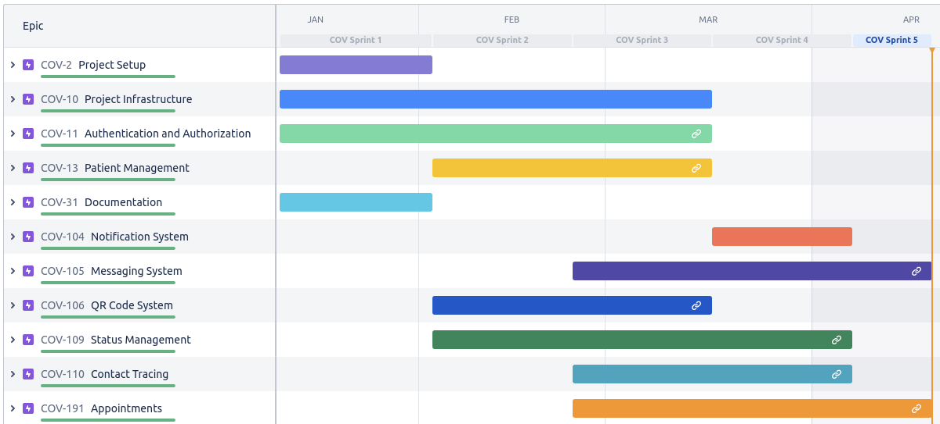

Figure 1: Project Roadmap

# 4.0 RELEASE PLANNING

This section covers a summary and retrospective for sprint 5 and the project summary.

## 4.1. Sprint 5

### 4.1.1 Summary

Sprint 5 mainly focused on UI/UX and chat improvements. Chat is now reactive allowing users to see new messages come into their inbox without having to refresh the page. This greatly increases the chat user experience resulting in a more real-time chatting experience rather than an asynchronous chatting experience similar to email. The UI/UX improvements focused on updating elements that did not match certain UI mockups such as tables (headers, pagination, filters, etc.), disallowing the invalid selection of dates in certain form/filters, and removing gradient and shadows from buttons displayed in the sidebar menu.

**Project velocity after Sprint 5: 59.4 User Story Points**

|  |
| --- |
| Figure 2: Sprint 5 Burndown Chart |

### 

### 4.1.2 Retrospective

View the report of the sprint 5 retrospective meeting below.

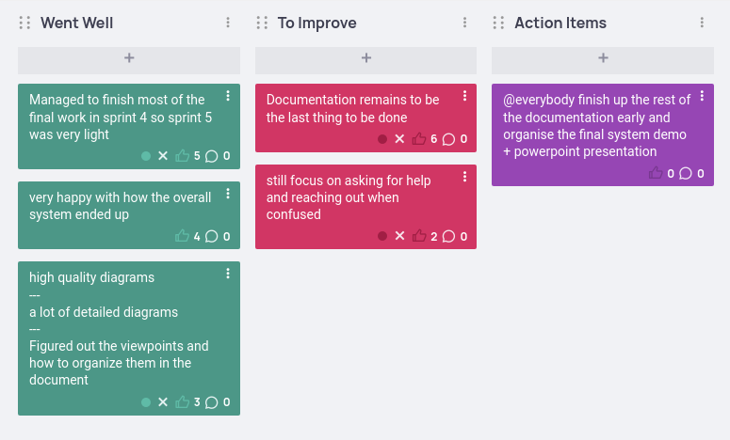

Figure 3: Sprint 5 Retrospective Report

## 4.2 Project Summary

A total of 5 sprints covering 11 epics - Authentication and Authorization, Patient Management, Notification System, Messaging System, QR Code System, Status Management, Contact Tracing, Appointments, Project Infrastructure, Project Setup, and Documentation - were completed during the development of CovidTracker. All specified project requirements have been fulfilled with a focus on a comprehensive personalized dashboard system, reactive chat page, and detailed patient and status management features. Users are able to drill down into symptoms and test results information and management as needed. Extra features were added such as QR codes to allow users to easily exchange patient status and test result information. Overall the team is very proud of CovidTracker and has learned a lot throughout the entire process.

# 5.0 SOFTWARE ARCHITECTURE

This section provides an overview of the system to be built using both a domain model and a component diagram depicting and describing the chosen design decisions of the system.

| | Date Issued | January 11, 2022 | | --- | --- | | Status | Sprint completed | | Authors | Jason Gerard, Andre Ibrahim, Domenic Seccareccia | | Reviewers | Domenic Seccareccia, Jason Gerard | | Scope | The domain model covers the domain of the application, the component diagram covers the entire system in development, the use case diagrams cover the various activities each user can accomplish. | | Context | This is the third sprint for the web application “CovidTracker”. Diagrams will be expanded and improved over each sprint iteration. | |
| --- | --- | --- | --- | --- | --- | --- | --- | --- | --- | --- | --- | --- |
| Table 4: Supplementary Information |

## 5.1 Stakeholder Concerns

Stakeholder concerns associated with CovidTracker are depicted in the following Stakeholder Concern Traceability Matrix. Only stakeholders that have a concern impacted by the systems architecture are present in this table.

| |  | **Developer** | **Project Champion** | **Testers** | **Product Owner** | **User** | | --- | --- | --- | --- | --- | --- | | **System failure** |  |  |  |  |  | | **Security breach** |  |  |  |  |  | | **Unscalable**  **architecture** |  |  |  |  |  | | **Tightly coupled layers** |  |  |  |  |  | | **System complexity** |  |  |  |  |  | | **Longer development time** |  |  |  |  |  | |
| --- | --- | --- | --- | --- | --- | --- | --- | --- | --- | --- | --- | --- | --- | --- | --- | --- | --- | --- | --- | --- | --- | --- | --- | --- | --- | --- | --- | --- | --- | --- | --- | --- | --- | --- | --- | --- | --- | --- | --- | --- | --- | --- |
| Table 5: Stakeholder Concern Traceability Matrix |

## 5.2 Viewpoints

This section will use the 4+1 view model to describe the CovidTracker system with the following views:

* Scenarios
* Development View
* Logical View
* Process View
* Physical View

Each section below explains what each viewpoint covers and how it relates to the system as well as the stakeholders that should be concerned with each viewpoint. Diagrams are used to depict how the system looks from each viewpoint.

### 5.2.1 Scenarios

The scenarios describe the relationships, dependencies, and interactions between the system and its environment (people, systems, and external entities with which it interacts). This viewpoint concerns all project stakeholders.

#### 5.2.1.1 System Context Diagram

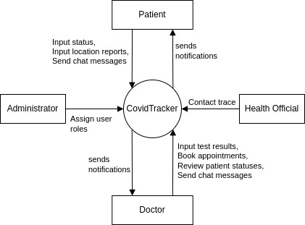

Figure 4: System Context Diagram of CovidTracker

#### 5.2.1.2 Use Case Diagrams

The use case diagrams representing all users that can access CovidTracker and their associated activities are represented in the following sections. The diagrams can be viewed in draw.io through this link:

* [Use Case Diagrams of CovidTracker](https://drive.google.com/file/d/12jsnXCe8cH3rX3jNB4C0lMUai9AX3Hnh/view?usp=sharing)

##### 5.2.1.2.1 User

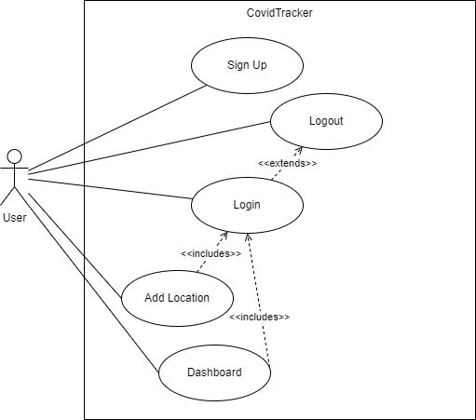

Figure 5: Use Case Diagram of User

##### 

##### 5.2.1.2.2 Administrator

#### 

Figure 6: Use Case Diagram of Administrator

##### 5.2.1.2.3 Patient

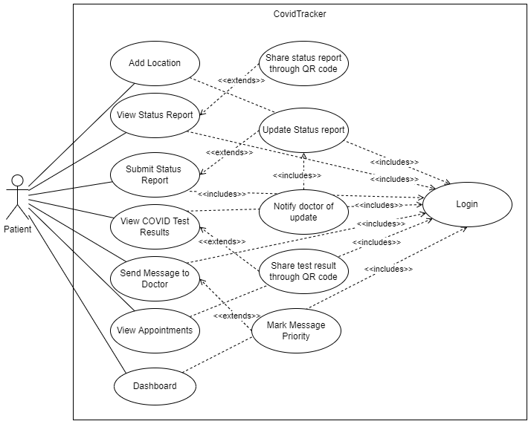

Figure 7: Use Case Diagram of Patient

#### 

#### 

##### 5.2.1.2.4 Doctor

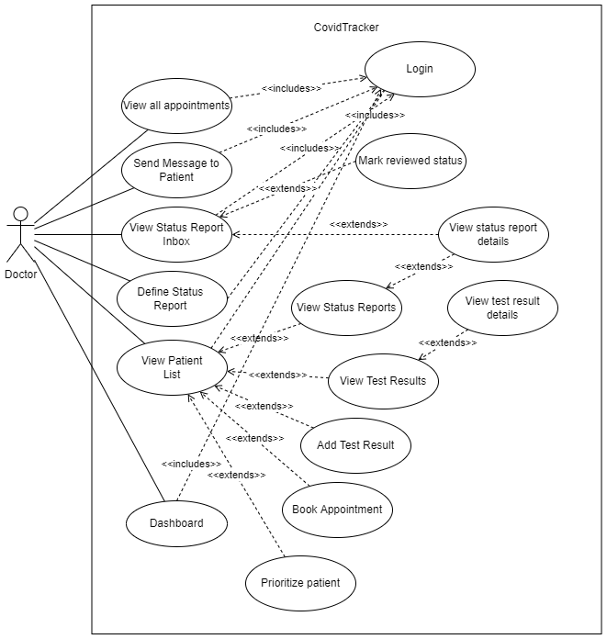

Figure 8: Use Case Diagram of Doctor

#### 

##### 5.2.1.2.5 Health Official

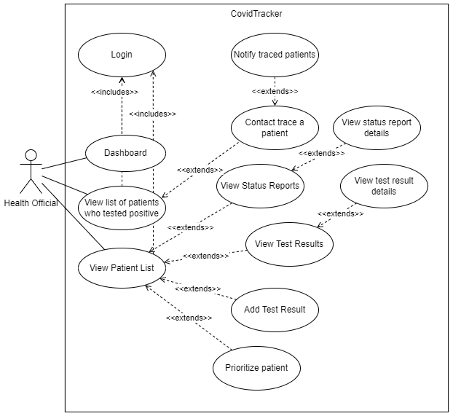

Figure 9: Use Case Diagram of Health Official

##### 5.2.1.2.6 Immigration Officer

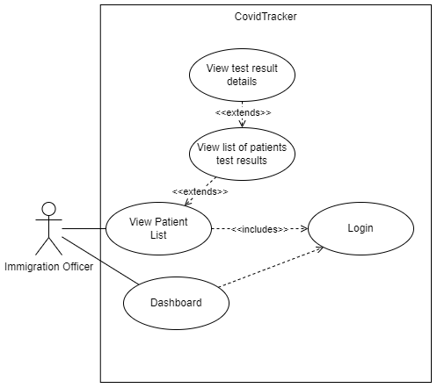

Figure 10: Use Case Diagram of Immigration Officer

### 5.2.2 Development Viewpoint

The development viewpoint describes the system’s architectural elements and their associated responsibilities, interfaces, and primary interactions. This viewpoint concerns all the project's stakeholders.

#### 5.2.2.1 Component Diagrams

There are two UML component diagrams for CovidTracker (see Figures 11 and 12) each describing the layers of the system at a different level of abstraction as well as the components within each layer and their relationships. The component diagram (Figure 11) shows the service level components, their required and provided interfaces, and how they interact. The architecture component diagram (Figure 12) displays the general architecture of the monolithic server and thin client. The diagrams can be viewed in draw.io through this link:

* [Component Diagram of CovidTracker](https://drive.google.com/file/d/12iKdkB5sOOqflkbyF5n1bY1xFr58-gT1/view?usp=sharing)

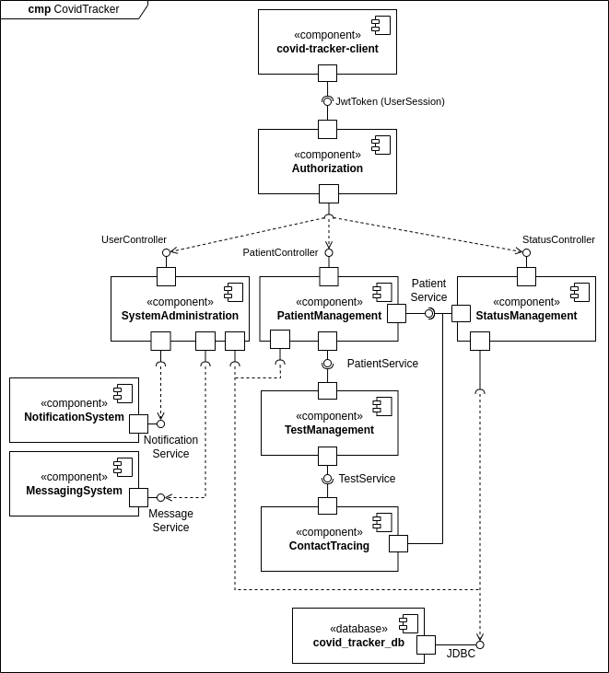

Figure 11: Component Diagram of CovidTracker

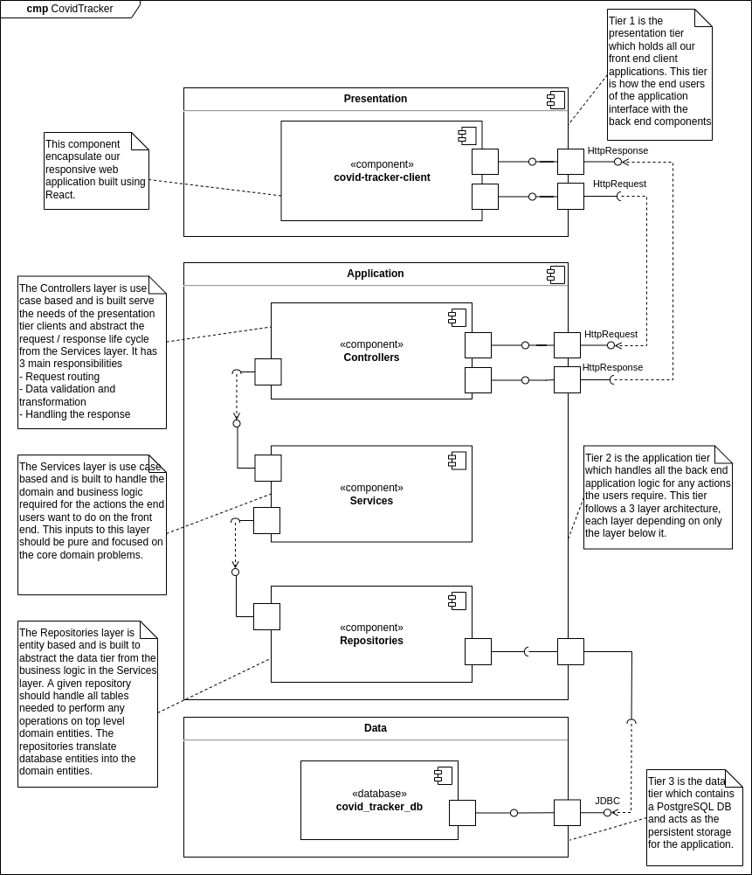

Figure 12: Architecture Component Diagram of CovidTracker

The architecture of the system follows a 3-Tier architecture with the middle application tier using a layered architecture. The 3 tiers include the presentation tier, application tier and data tier. The presentation tier is the front end of the application. The application tier contains our web server which handles all the business logic of our application. Lastly, the data tier is the persistent storage layer for the application. The application tier has 3 layers which include: controller, service, and repository layers that allows the system to have low coupling and high cohesion. We utilize dependency injection to further separate the concerns between our layers. The standard flow of data starts at the presentation tier (the frontend) where a HTTP request is made to the application tier. The controller layer handles all routing, passing the data to the service layer, then to the repository layer to convert to schema form and make the JDBC connection with the database tier to persist the data.

### 5.2.3 Logical Viewpoint

The information viewpoint describes the way that the system stores, manipulates, and manages the interactions between the complex data structures that form the domain of the system. The stakeholders for this viewpoint are developers, testers, and system analysts.

#### 5.2.3.1 Domain Model

The UML domain model for CovidTracker describing all system entities, relationships and associations is represented by the UML domain model diagram seen in Figure 13. The diagram can be viewed in draw.io through this link:

* [UML Domain Model Class Diagram of CovidTracker](https://drive.google.com/file/d/1dmbNVKywLPckfShuGJHM9J-3GodmuJS2/view?usp=sharing)

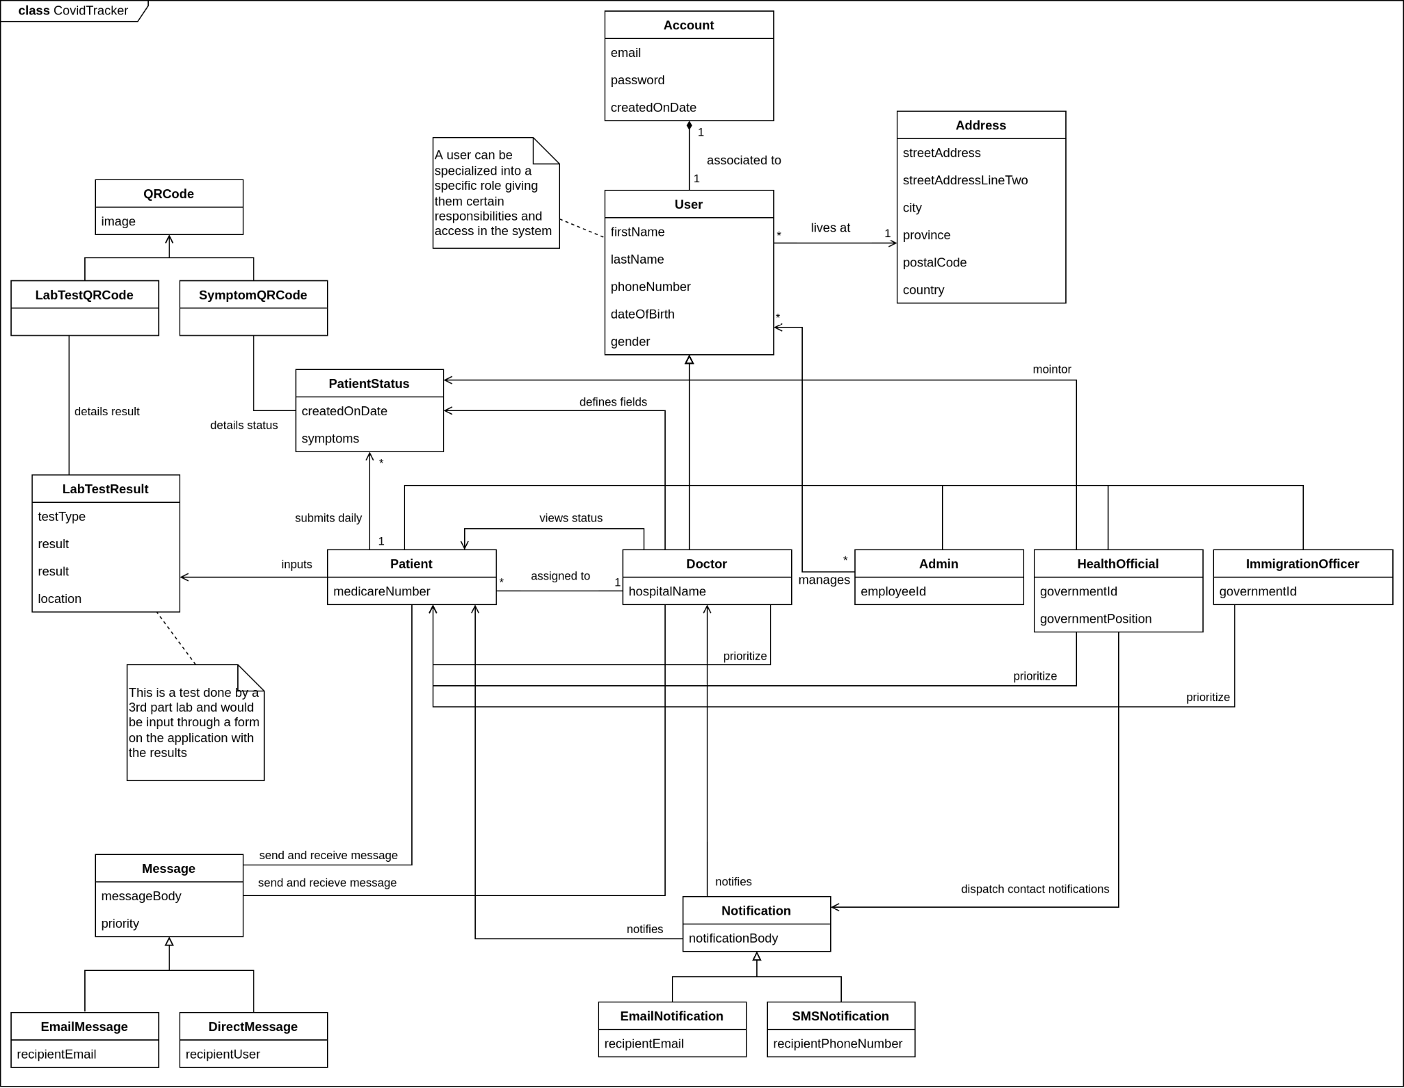

Figure 13: UML Domain Model Class Diagram of CovidTracker

A few key decisions were made during the creation of the Domain Model. The user entity is split into 2 separate entities: person and account. A user has a single account and then can have a specialized role through inheritance (i.e. Doctor, Admin, Patient etc.). This encapsulates the core attributes of a role in the user and keeps it modular from the account itself which gives us a lot of flexibility when designing the authentication and authorization system.

### 5.2.4 Process Viewpoint

The process viewpoint describes the lower level implementation details of the core system features. These diagrams depict the structure and dependencies of various classes and services when fulfilling the applications features and use cases. The stakeholders for this viewpoint are developers and testers.

#### 5.2.4.1 Status Management

#### 

**Define Status Report**

The following activity diagram describes the activity of a doctor defining the status report fields that a patient must fill up daily after testing positive for COVID-19. Further information can be found in section 7.3.6 Define Status Report.

#### 

Figure 14: Activity Diagram of Define Status Report

**View Status Report**

The following activity diagram describes the activity of a doctor viewing patient status reports, sharing the associated QR code when a second opinion is needed, and marking said status report as reviewed.

#### 

Figure 15: Activity Diagram of View Status Report

### 

**Submit Status Report**

The following sequence diagram describes the various system object interactions during the submit status report activity. Further information can be found in section 7.3.7 Status Report.

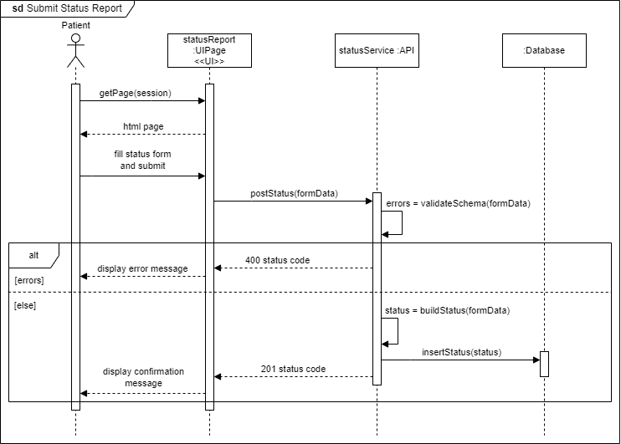

Figure 16: Sequence Diagram of Submit Status Report

#### 

#### 

#### 

#### 

#### 

#### 

#### 

#### 5.2.4.2 Patient Management

**Add Test Result**

The following activity diagram describes the activity of a doctor adding a test result to a patient’s records after testing positive for Covid-19.

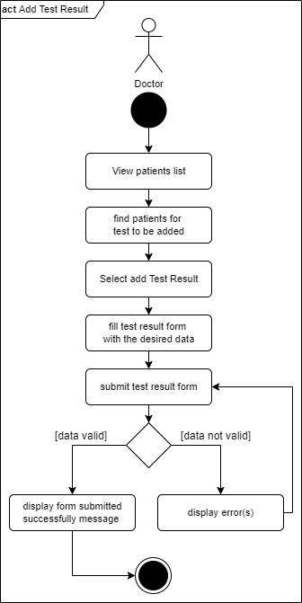

Figure 17: Activity Diagram of Add Test Result

**View Test Results**

The following sequence diagram describes the various system object interactions during the view test results activity. Further information can be found in section 7.3.14 Test Results.

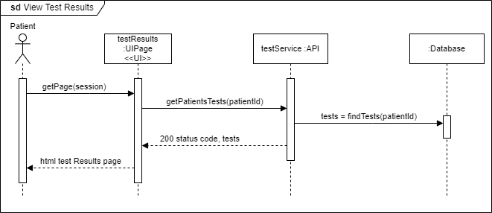

Figure 18: Sequence Diagram of View Test Results

**View Patient List**

The following sequence diagram describes the various system object interactions during the view patient list activity. Further information can be found in section 7.3.9 Patient List.

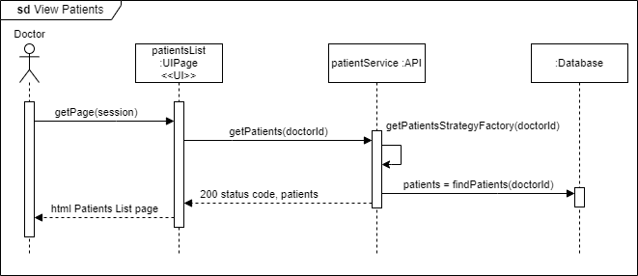

Figure 19: Sequence Diagram of View Patient List

**Prioritize Patient**

The following sequence diagram describes the various system object interactions during the prioritize patient activity. Further information can be found in section 7.3.9 Patient List.

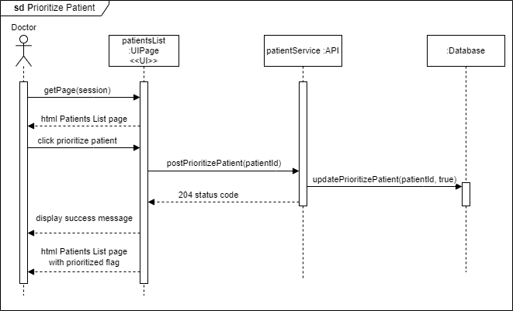

Figure 20: Sequence Diagram of Prioritize Patient

#### 

#### 5.2.4.3 Messaging System

**Send Message**

The following sequence diagram describes the various system object interactions during the send message activity. Further information can be found in section 7.3.16 Chat.

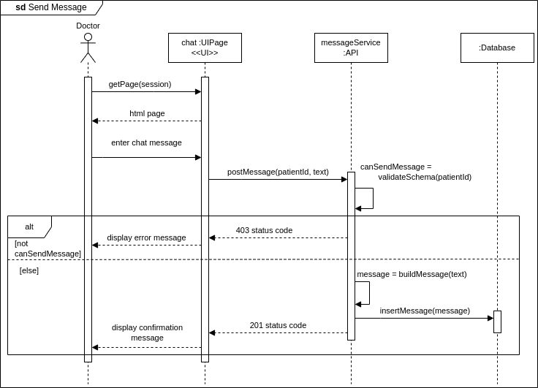

Figure 21: Sequence Diagram of Send Message

**Send Prioritized Message**

The following sequence diagram describes the various system object interactions during the send a prioritized message activity. Further information can be found in section 7.3.16 Chat.

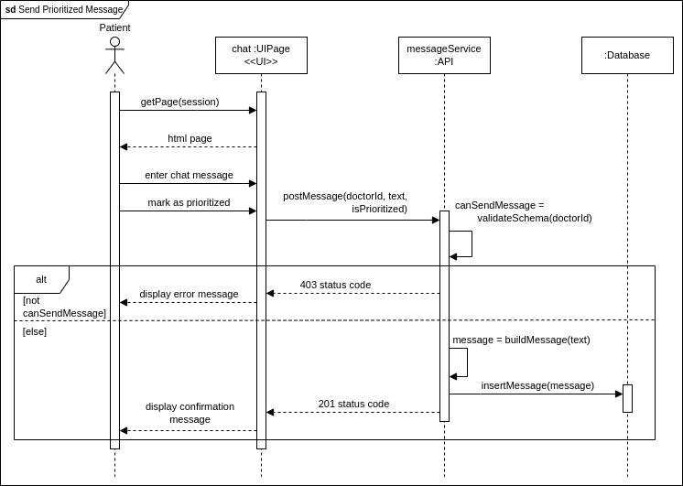

Figure 22: Sequence Diagram of Send Prioritized Message

**View Messages**

The following sequence diagram describes the various system object interactions during the view messages activity. Further information can be found in section 7.3.16 Chat.

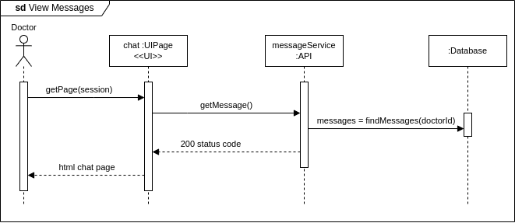

Figure 23: Sequence Diagram of View Messages

#### 

#### 

#### 

#### 

#### 

#### 

#### 

#### 

#### 

#### 5.2.4.4 Dashboards

**View Dashboard**

The following sequence diagram describes the various system object interactions during the view dashboard activity. Further information can be found in section 7.3.16 Chat.

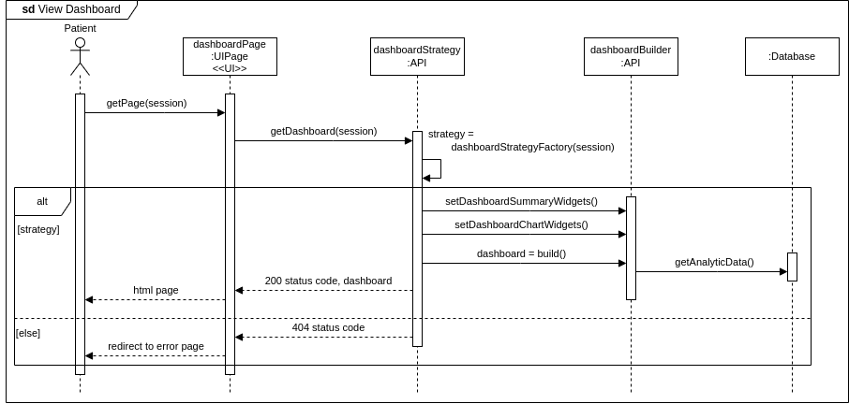

Figure 24: Sequence Diagram of View Dashboard

#### 

#### 

#### 

#### 

#### 

#### 5.2.4.5 Contact Tracing

**Contact Trace Patient**

The following activity diagram describes the activity of a health official contact tracing and notifying individuals to self-quarantine because they were in contact with a positive patient.

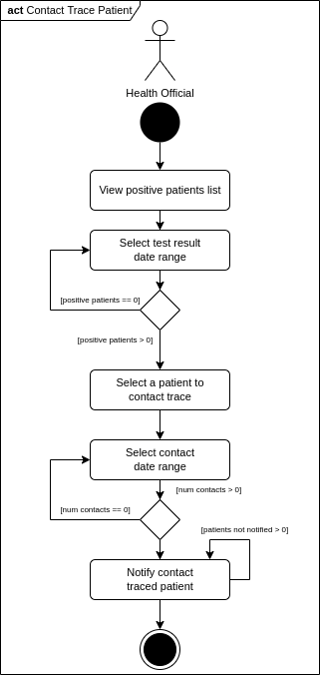

Figure 25: Activity Diagram of Contact Trace Patient

**Add Location Report**

The following sequence diagram describes the various system object interactions during the add location report activity. Further information can be found in section 7.3.19 Add Location.

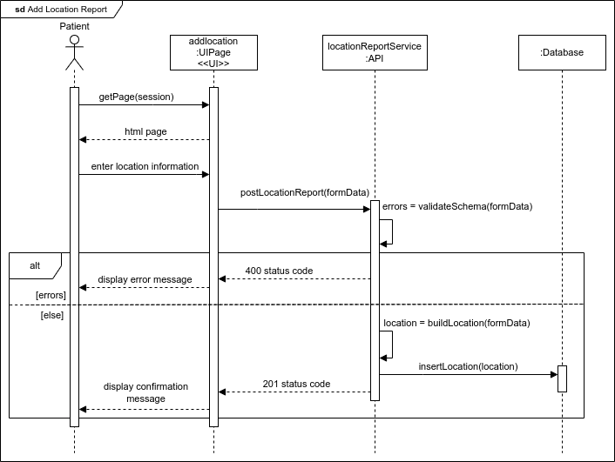

Figure 26: Sequence Diagram of Add Location Report

#### 

#### 

#### 

#### 

#### 5.2.4.6 Appointments

**Book Appointment**

The following sequence diagram describes the various system object interactions during the book appointment activity. Further information can be found in section 7.3.17 Book Appointment.

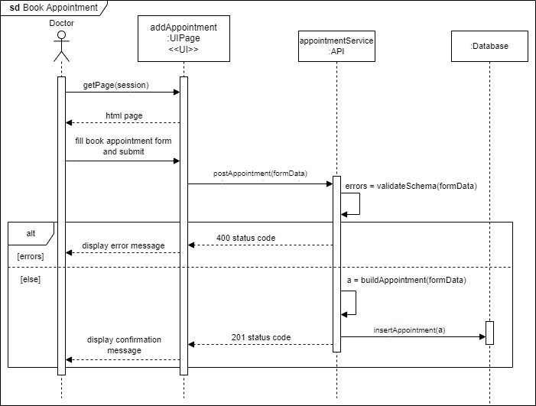

Figure 27: Sequence Diagram of Book Appointment

**View Appointments**

The following sequence diagram describes the various system object interactions during the view appointment activity. Further information can be found in section 7.3.18 Appointments.

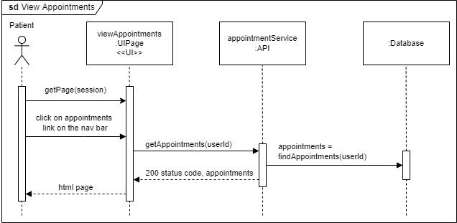

Figure 28: Sequence Diagram of View Appointments

### 5.2.5 Physical Viewpoint

The physical viewpoint describes the environment into which the system will be deployed, including the dependencies the system has on its runtime environment. The stakeholders for this viewpoint are developers and testers who focus on the infrastructure and deployment of the system.

#### 5.2.5.1 Deployment Diagram

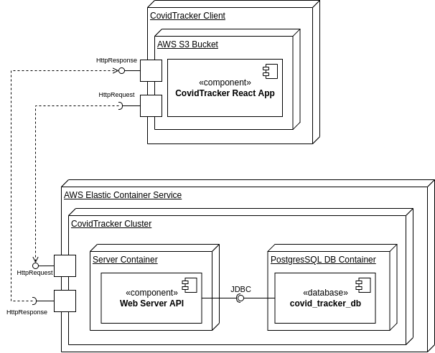

Figure 29: Deployment Diagram of CovidTracker

## 

## 5.3 Tech Stack

### 5.3.1 Presentation Tier

The client is encapsulated by the presentation tier and currently contains a single front end service, built using JavaScript and React, which is the primary way a client can interact with the system.

React was chosen because it is one of the largest and most tested front end frameworks on the open source market. Other competitors include Vue.JS and Angular. Angular is outdated and leans towards a thick client approach which is mostly considered an anti-pattern with front end web applications as they can become slow and hard to maintain overtime. While Vue.JS is a great framework, React ended up being chosen simply because more people on the team had experience with it.

The front end also uses SCSS which is a CSS preprocessing language that allows us to extend what can normally be done with CSS such as adding variables and mixins.

The client will be running in its own docker container which will allow it to be easily productionalized and deployed while also being compatible on all our developers' local machines.

### 5.3.2 Application Tier

The application tier consists of a single web server accepting HTTP requests from the front end client. This monolithic service is built using TypeScript and runs inside a docker container. TypeScript was chosen due to its clean syntax and advanced type system. As a result of TypeScript being transpiled in JavaScript, all JavaScript libraries work with TypeScript as well. This means we can also take advantage of the vast open source libraries built over the years by the web service oriented JavaScript community. Since we wanted to use a statically typed language to make it easier to model our domain in code and build clean type hierarchies, Python and JavaScript were out. Java was also considered however even with recent advancements aiming to improve the language it is still verbose and extremely opinionated in its packages with Java Spring being a perfect example. There was simply a desire to choose a language that was more flexible.

The web framework the service uses is Restify paired with the dependency injection package called Inversify. Restify was chosen because it is a simple framework that is not opinionated and allows us to only use and build what is needed. Thus abstracting away a lot of the boiler plate while still providing the ability to customize the service as needed. Other alternatives include express which has great 3rd party library support due to its popularity.

The web service uses an NPM package called pg which is a non-blocking client for PostgreSQL that provides the ability to write native SQL statements and abstract away the database connection pooling and type coercion. The main alternative for database interaction would be to use an object relational mapper (ORM), a popular one being TypeORM, that abstract away the entire concept of SQL statements and schema and leave a simple API for the application developer to work with. In our team's experience ORMs only make it easy to do the simple stuff which is easy to do anyways. When it comes to the complex parts you have to write the SQL by hand anyways so it's best to have full control from the start.

### 5.3.3 Data Tier

The data tier is currently using a single PostgreSQL database to store all the needed relational data. PostgreSQL was chosen as it is the most modern and maintained open source relational database. There is a large community that creates many libraries for all different types of languages and so many people on the team were already familiar with its standard SQL syntax. Other alternatives include MySQL and Oracle Database but these database systems lack some of the advanced features and polish PostgreSQL has. The PostgreSQL instance our application uses runs inside its own docker container to make setup quick and easy for the development team.

### 5.3.4 Deployment

The system is deployed in two parts using Amazon Web Services (AWS) cloud deployment services.

The first part consists of deploying the backend API and database. This is done through registering the respective docker container images in Elastic Container Registry (ECR). From there a new Elastic Container Service (ECS) task is started in a cluster for the application. The API and database are running in the same task on the same cluster.

The second part is for the client which is a single page application (SPA) built using React. This allows us to build the front end into static HTML, CSS, and JavaScript files along with the rest of our static assets. This content is pushed into a public static web hosting enabled bucket on AWS Simple Storage Service (S3). From there, clients can access the website through the publicly accessible S3 bucket URL.

The application can be reached at the following link:

* <http://covid-tracker-client-bucket.s3-website.us-east-2.amazonaws.com/>

Note to reader: To save costs the backend and database are scaled down to 0 instances in the cluster when not in use. If you are trying to access the website let Team 17 know on slack and we can spin up an instance.

The user account credentials needed to access the various features in CovidTracker are represented in the following table:

| **User Role** | **Email** | **Password** |
| --- | --- | --- |
| Patient | Rebecca_Feeney@hotmail.com | Test123! |
| Administrator | admin@test.com | Test123! |
| Doctor | doctor@test.com | Test123! |
| Health Official | health_official@test.com | Test123! |
| Immigration Officer | immigration_officer@test.com | Test123! |

Table 6: User Account Credentials for CovidTracker

## 5.4 External Libraries

### 5.4.1 Vuexy

Vuexy is a user interface templating library used for building user interface components and layouts in CovidTracker. Vuexy provides a fast and easy approach for building responsive web applications as it is built with a mobile first mindset. As such, this ensures that any element, component or feature built with the corresponding set of tools provided results in a responsive application from the onset. Without such a library, more painstaking time would be required to ensure that all user interface components function as expected regardless of platform. As such, developers can spend more time focusing on device compatibility and fine tuning the overall user experience.

Vuexy’s underlying architecture is built on various external React libraries and Bootstrap 5, thus ensuring vast compatibility and various ways to build elements. Developers are free to decide whether or not using a pre-built Vuexy component is a better option instead of either using a basic Bootstrap 5 component or building it from scratch.

Unfortunately, Vuexy does have some major disadvantages. The main one is the sheer complexity of the library. While one would assume it is simple in nature whereby you only need to search and find the relevant components, attempting to find, decipher and then import the associated code is rather complicated. There is an extreme amount of interconnectivity between the provided files that result in a less than ideal amount of time being spent understanding what is necessary for a single component to work. Secondly, due to the interconnectivity of files, it is a rather tedious process to delete any non relevant files given the complex references between all files and displayed errors if not removed properly. Lastly, while the documentation is rather informative and thorough, there is more to be desired in regards to further explanation of certain components and elements.

While other user interface templating libraries were researched - CoreUI, Fuse and Isomorphic -, Vuexy was decided as the go to for two reasons. The first one was due to the variety of pre-built elements and components provided. For example, with the inclusion of layouts, forms, authentication, localization, charts, graphs and interactive data table components, developers do not have to spend many hours building these complicated UI components once a level of understanding is achieved on how to use them. Secondly, Figma UI design files are included, a rarity for these types of libraries. The inclusion of these files are extremely helpful during UI mockup design as the designers do not have to recreate all the elements from the template from scratch. Thus, allowing designers to spend more time focusing on the overall user interface and experience. This also helps ensure both the UI mockups and developed interfaces are a 1 for 1 match.

# 

# 6.0 RISK ASSESSMENT AND MANAGEMENT PLAN

The risk assessment and management plan for CovidTracker is depicted and described in the following table. One risk R-15 was added and resolved in sprint 5.

| **Risk ID** | **Description** | **Resolved in Sprint** | **Strategy and Effectiveness** | **Probability** | **Impact** |
| --- | --- | --- | --- | --- | --- |
| **R-1** | Computers can crash causing us to lose our work | 1 | We decided to store our work in the cloud. This strategy has proven successful thus far. | Low | Severe |
| **R-2** | Database crashing |  |  | Low | Severe |
| **R-3** | Database leak and all the patient’s medical record is stolen |  |  | Low | Severe |
| **R-4** | Not having the same versions of software in our systems | 1 | We decided to use docker to ensure every member is on the same version while working on the project. | Low | Minor |
| **R-5** | Changes in the law preventing us from using GPS tracking |  |  | Medium | Severe |
| **R-6** | Code being pushed to the main without validation | 1 | A CI/CD pipeline is used in Github and at least one code approval is needed before any code code is merged in the main branch. This ensures the author of the code cannot just merge the code without approval. | Low | Moderate |
| **R-7** | Timeline estimates unrealistic | 1 | Playing poker was used. Every member took a vote on each task for a realistic timeline and we took the average length as the final length for a task. | Medium | Moderate |
| **R-8** | Project team availability | 1 | Every member dedicated a certain amount of time for this class from the beginning of the semester. | Low | Moderate |
| **R-9** | Weak user participation (if no one decides to use the website) |  |  | Medium | Moderate |
| **R-10** | A user having access to page/feature outside the scope of their role | 2 | The front end and back end of the application restrict users access to certain pages based on their role which is authenticated through the JWT. | Medium | Moderate |
| **R-11** | Users not properly reporting their locations | 3 | The strategy for this risk is acceptance. While this mitigation strategy is not very effective it is necessary to preserve the privacy of the application’s users. | Medium | Severe |
| **R-12** | User attempting a cross site scripting (XSS) software attack through the chat textbox. |  |  | Low | Sever |
| **R-13** | Dashboard information isn’t displaying correct | 4 | Implement unit and integration tests to make sure dashboard info correctly reflects the analytics. | Low | Minor |
| **R-14** | Patient is double notified during a contact trace | 4 | The strategy for this risk is acceptance because notifying a patient twice to self quarantine if they are in contact with a positive patient twice is not a major issue. | Low | Minor |
| **R-15** | Appointment is booked for an invalid date | 5 | Added front end guards and siabled dates outside valid ranges | Low | Minor |

Table 7: Risk Analysis Table

# 7.0 USER INTERFACE DESIGN

All personas, supported devices, UI and user flow mockups, and interactive prototypes are depicted and described in the following sections.

## 7.1 Personas

CovidTracker is accessible by the following five user personas: Patients (see Figure 30), Doctors (see Figure 31), Health Officials (see Figure 32), Immigration Officers (see Figure 33) and Administrators (see Figure 34). Each persona is considered to be representative of a certain archetype within the general demographic.

|  |
| --- |
| Figure 30: Patient Persona |

|  |
| --- |
| Figure 31: Doctor Persona |

|  |
| --- |
| Figure 32: Health Official Persona |

|  |
| --- |
| Figure 33: Immigration Officer Persona |

|  |
| --- |
| Figure 34: Administrator Persona |

## 7.2 Supported Devices

CovidTracker currently supports desktop and mobile platforms. More specifically, regardless of desktop device, all desktop based web browsers are supported. Likewise, regardless of mobile and tablet devices, all associated web browsers are supported. Figures have been provided below describing the various physical and virtual interface elements present on some of the supported devices.

|  |
| --- |
| Figure 35: Safari Web Browser Interface Elements |

|  |
| --- |
| Figure 36: Google Chrome Web Browser Interface Elements |

|  |
| --- |
| Figure 37: Apple iPhone 8 Buttons and Safari Web Browser Interface Elements |

|  |
| --- |
| Figure 38: Apple iPhone 11 Buttons and Safari Web Browser Interface Elements    Figure 39: Apple iPad Pro Buttons and Safari Web Browser Interface Elements |

## 7.3 UI Mockups and Prototypes

All UI mockups and associated interactive prototypes are created in Figma. The Figma is organized with the following pages: Components, Personas, Supported Devices, Research, Drafts and UI. The Components page contains all reusable UI elements - logo, form elements, buttons, etc. - which designers might need to use when designing the various mockups. The Personas page contains all the personas information, as discussed in section 7.1 Personas. The Supported Devices page contains information about the various supported devices the application currently supports, as discussed in section 7.2 Supported Devices. The Research page is where various website links, ideas and snippets that one might have come across reside for possible future reference. The Drafts page contains UI mockups or elements that were either discarded or partially worked on. The UI page contains the finalized UI mockups and their associated interactive prototype.

A set of user interface (UI) mockups and interactive prototypes are created for each corresponding user story. The mockups are broken down into groups based on the platform they represent - desktop, tablet and mobile - resulting in a platform specific accessible and ease of use user experience. Each set of mockups are organized in the following manner: the first row describes the user flow steps for the associated user story and each subsequent row below represents various states a particular interface in any given column can have. User flow steps proceed from left to right (start to finish) while each child mockup in a given column can depict one of the following states: active, filled or error. Subsequently, once all the mockups are completed, an interactive prototype is created.

### 7.3.1 Sign Up

COV-42 - As a User, I want to be able to sign up, so that I can access the apps features

An active user account is required to interact with all features in CovidTracker. As such, if the user does not have an account, they must first sign up to create an account. The sign up page is reached by a clear visible link at the bottom of the sign in page. There are two separate steps that must be completed during the sign up process: a user must fill in their personal information and secondly account information. Context awareness is provided to the user by way of a wizard at the top of the form highlighting the associated icon and text corresponding to the step the user is currently in during the sign up process. Such an element also helps users have a clear visible guideline regarding how many steps are required to be completed. The UI does not adjust based on persona. A selection of UI mockups for desktop, tablet, and mobile can be seen in Figures 40 and 41. All UI mockups, user flow and associated interactive prototypes for desktop, tablet and mobile platforms are accessible at the following links:

* [UI and User Flow Mockup - Sign Up / Desktop & Tablet](https://drive.google.com/file/d/1A7hJo-o5oS6mhmVmXt3k4YArJYgHFemo/view?usp=sharing)
* [UI and User Flow Mockup - Sign Up / Mobile](https://drive.google.com/file/d/1xjxnhr8e_YFsnyKksgtgLBl6HEjVPNoZ/view?usp=sharing)
* [▶ Prototype - Sign Up / Desktop & Tablet](https://www.figma.com/proto/It4nC0bENajBMuQdTviwQG/covidtrack?node-id=291%3A4813&starting-point-node-id=291%3A4813&show-proto-sidebar=1)
* [▶ Prototype - Sign Up / Mobile](https://www.figma.com/proto/It4nC0bENajBMuQdTviwQG/covidtrack?node-id=291%3A4700&starting-point-node-id=291%3A4700&show-proto-sidebar=1)

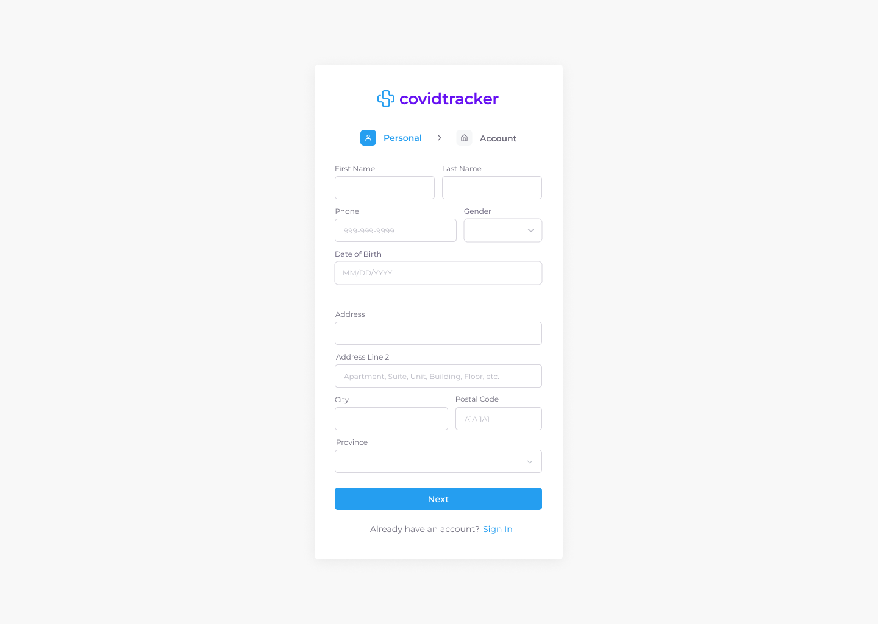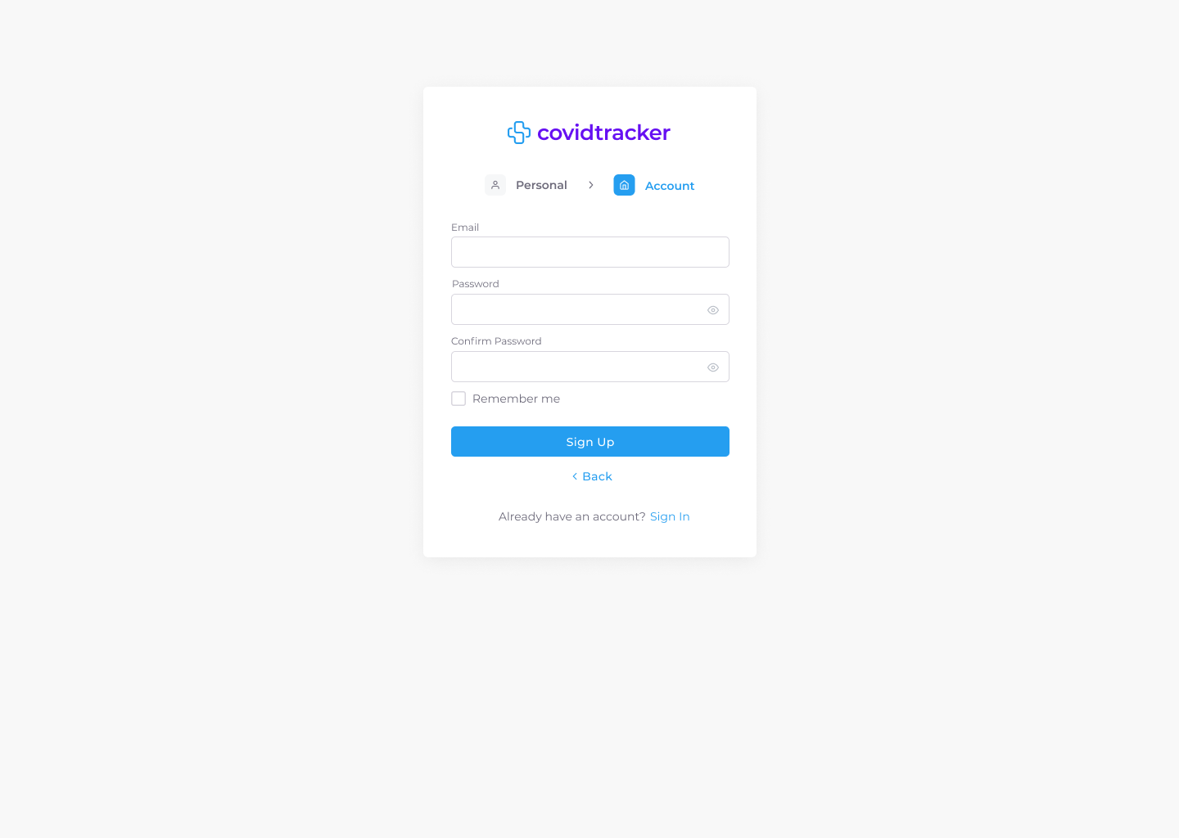

Figure 40: Sign Up Desktop & Tablet UI Mockup

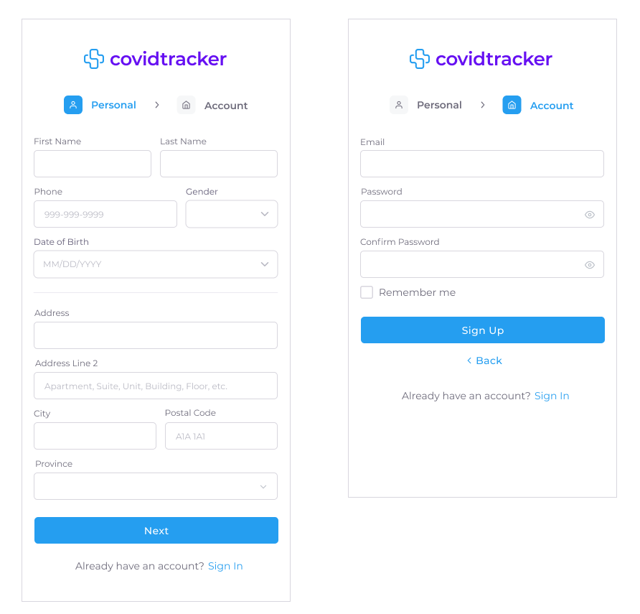

Figure 41: Sign Up Mobile UI Mockup

### 7.3.2 Sign In

COV-48 - As a User, I want to be able to sign in, so that I can access my account

A non logged in user is automatically redirected to the sign in page when trying to access the CovidTracker website. The UI does not adjust based on persona. A selection of UI mockups for desktop, tablet, and mobile can be seen in Figures 42 and 43. All UI mockups, user flow and associated interactive prototypes for desktop, tablet and mobile platforms are accessible at the following links:

* [UI and User Flow Mockup - Sign In / Desktop & Tablet](https://drive.google.com/file/d/1ygeYPusKKwFrbDOo8KGS_eEk7PQi0tLp/view?usp=sharing)
* [UI and User Flow Mockup - Sign In / Mobile](https://drive.google.com/file/d/1mE2_2KfZcaT-ROMQlXTF2Zmf-LsV_rQG/view?usp=sharing)
* [▶ Prototype - Sign In / Desktop & Tablet](https://www.figma.com/proto/It4nC0bENajBMuQdTviwQG/covidtrack?node-id=27%3A75&starting-point-node-id=27%3A75&show-proto-sidebar=1)
* [▶ Prototype - Sign In / Mobile](https://www.figma.com/proto/It4nC0bENajBMuQdTviwQG/covidtrack?node-id=45%3A5546&starting-point-node-id=45%3A5546&show-proto-sidebar=1)

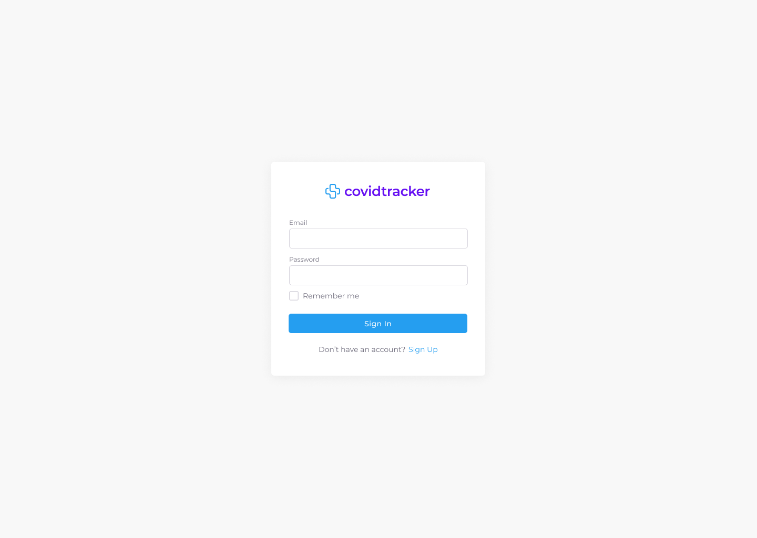

Figure 42: Sign In Desktop & Tablet UI Mockup

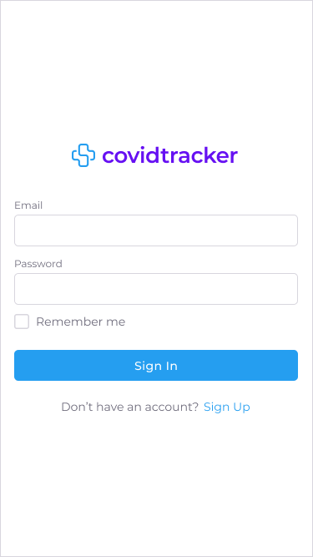

Figure 43: Sign In Mobile UI Mockup

### 7.3.3 Sign Out

COV-52 - As a User, I want to be able to sign out, so that I can delete my session

A user is only able to sign out of their account if they are currently signed in. The UI does not adjust based on persona. A selection of UI mockups for desktop, tablet, and mobile can be seen in Figures 44 and 45. All UI mockups, user flows and associated interactive prototypes for desktop, tablet and mobile platforms are accessible at the following links:

* [UI and User Flow Mockup - Sign Out / Desktop & Tablet](https://drive.google.com/file/d/1aBEessNnjKTMYejaxLRgl3ICZSnfnvnA/view?usp=sharing)
* [UI and User Flow Mockup - Sign Out / Mobile](https://drive.google.com/file/d/1Xu3q0fpfmBsl3HSH66UVZhbvRqKUUnMx/view?usp=sharing)
* [▶ Prototype - Sign Out / Desktop & Tablet](https://www.figma.com/proto/It4nC0bENajBMuQdTviwQG/covidtrack?node-id=1202%3A79057&starting-point-node-id=1202%3A79057&show-proto-sidebar=1)
* [▶ Prototype - Sign Out / Mobile](https://www.figma.com/proto/It4nC0bENajBMuQdTviwQG/covidtrack?node-id=1205%3A85071&starting-point-node-id=1205%3A85071&show-proto-sidebar=1)

# 

Figure 44: Sign Out Desktop & Tablet UI Mockup

# 

Figure 45: Sign Out Mobile UI Mockup

# 

### 7.3.4 Add a Role

COV-85 - As an Administrator, I want to assign a role to a user, so that I can manage access rights

An administrator is able to assign a role to a user using their user id. A user can be assigned one of the following roles: Patient, Doctor, Health Official, Immigration Officer, or Administrator. Once assigned a role, a user has access to certain functionalities deemed appropriate for said role in CovidTracker. A user cannot be assigned more than one role at any time. The UI is only accessible by the Administrator persona and does not adjust based on persona. A selection of UI mockups for desktop, tablet, and mobile can be seen in Figures 46 and 47. All UI mockups, user flows and associated interactive prototypes for desktop, tablet and mobile platforms are accessible at the following links:

* [UI and User Flow Mockup - Add a Role / Desktop & Tablet](https://drive.google.com/file/d/19VaCJ3nwXdgIidbU_Gvoi1ctKEauspSN/view?usp=sharing)
* [UI and User Flow Mockup - Add a Role / Mobile](https://drive.google.com/file/d/1HO8KHPbFeF_HEQ1wbKVBdv5AMIKWbCI9/view?usp=sharing)
* [▶ Prototype - Add a Role / Desktop & Tablet](https://www.figma.com/proto/It4nC0bENajBMuQdTviwQG/covidtrack?node-id=1201%3A68618&starting-point-node-id=1201%3A68618&show-proto-sidebar=1)
* [▶ Prototype - Add a Role / Mobile](https://www.figma.com/proto/It4nC0bENajBMuQdTviwQG/covidtrack?node-id=1205%3A86233&starting-point-node-id=1205%3A86233&show-proto-sidebar=1)

# 

Figure 46: Add a Role Desktop & Tablet UI Mockup

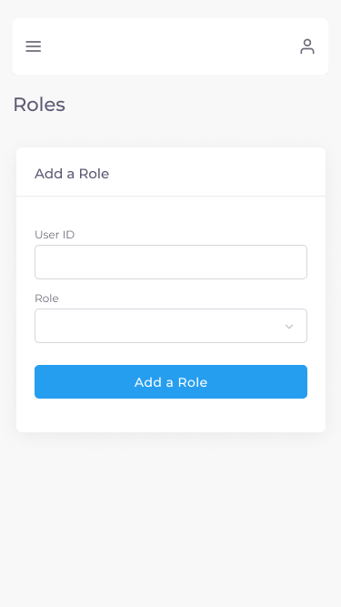

Figure 47: Add a Role Mobile UI Mockup

### 

### 7.3.5 Assign Patient to Doctor

COV-26 - As an Administrator, I want to assign a Patient to a Doctor, so that I can manage the Patients

An administrator is able to assign a patient to a doctor using both the patient and doctor ids, respectively. A patient can only be assigned to a single doctor at a given time. The UI is only accessible by the Administrator persona and does not adjust based on persona. A selection of UI mockups for desktop, tablet, and mobile can be seen in Figures 48 and 49. All UI mockups, user flows and associated interactive prototypes for desktop, tablet and mobile platforms are accessible at the following links:

* [UI and User Flow Mockup - Assign Patient to Doctor / Desktop & Tablet](https://drive.google.com/file/d/1NAvHexdz56kGeUAQxLfXXratwlGR3sry/view?usp=sharing)
* [UI and User Flow Mockup - Assign Patient to Doctor / Mobile](https://drive.google.com/file/d/1wAsZIyw-OSBQofkp1rPREHYb2KSQAXpf/view?usp=sharing)
* [▶ Prototype - Assign Patient to Doctor / Desktop & Tablet](https://www.figma.com/proto/It4nC0bENajBMuQdTviwQG/covidtrack?node-id=1205%3A87664&starting-point-node-id=1205%3A87664&show-proto-sidebar=1)
* [▶ Prototype - Assign Patient to Doctor / Mobile](https://www.figma.com/proto/It4nC0bENajBMuQdTviwQG/covidtrack?node-id=1205%3A88785&starting-point-node-id=1205%3A88785&show-proto-sidebar=1)

# 

Figure 48: Assign Patient to Doctor Desktop & Tablet UI Mockup

# 

Figure 49: Assign Patient to Doctor Mobile UI Mockup

### 7.3.6 Define Status Report

COV-95 - As a Doctor, I want to define the status report fields for my Patients, so I can properly track them

A doctor is able to assign a unique status report to each assigned patient. The “Define Status Report” form allows a doctor to choose specific status report fields which must be filled up by the assigned patient of said report. The fields are classified as either general or symptoms (primary and secondary). General fields are pre-selected for the doctor as they are mandatory whereas the symptom fields are up to the doctors discretion. A status report is unique for each assigned patient. In other words, certain fields might not need to be filled up by certain patients compared to others. This page can be accessed from the Patient List by selecting the “Defined Status Report” option found in the more options dropdown for a given patient as described in section 7.3.9 Patient List. The UI is only accessible by the Doctor persona and does not adjust based on persona. A selection of UI mockups for desktop, tablet, and mobile can be seen in Figures 50 and 51. All UI mockups, user flows and associated interactive prototypes for desktop, tablet and mobile platforms are accessible at the following links:

* [UI and User Flow Mockup - Define Status Report / Desktop & Tablet](https://drive.google.com/file/d/11RSUAuT3hHIJ7w5I1zx1DqNJQUGXDh0Z/view?usp=sharing)
* [UI and User Flow Mockup - Define Status Report / Mobile](https://drive.google.com/file/d/1QS9170hdxjBEOb7Cosl_yJrgtJH32rOL/view?usp=sharing)
* [▶ Prototype - Define Status Report / Desktop & Tablet](https://www.figma.com/proto/It4nC0bENajBMuQdTviwQG/covidtrack?node-id=1056%3A56141&starting-point-node-id=1056%3A56141&show-proto-sidebar=1)
* [▶ Prototype - Define Status Report / Mobile](https://www.figma.com/proto/It4nC0bENajBMuQdTviwQG/covidtrack?node-id=1070%3A92311&starting-point-node-id=1070%3A92311&show-proto-sidebar=1)

# 

Figure 50: Define Status Report Desktop & Tablet UI Mockup

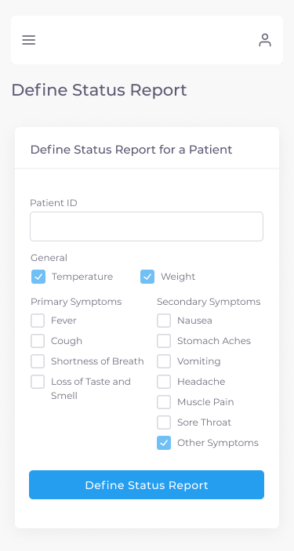

Figure 51: Define Status Report Mobile UI Mockup

### 7.3.7 Status Report

COV-25 - As a Patient, I want to submit my status, so that I can keep my Doctor updated

Once a patient is assigned a status report by their doctor due to a positive test result, they must fill up their report daily until no longer required to. The status report form fields displayed are adjusted per patient based on the chosen options defined by the doctor as described in section 7.3.6 Define Status Report. Therefore, the status report that a patient must fill out will only display the fields the doctor selects. For example, if a doctor deems secondary symptoms as unnecessary to be filled up by a patient then said patient will not see that option in their daily status report. The UI is only accessible by the Patient persona. A selection of UI mockups for desktop, tablet, and mobile can be seen in Figures 52 and 53. All UI mockups, user flows and associated interactive prototypes for desktop, tablet and mobile platforms are accessible at the following links:

* [UI and User Flow Mockup - Status Report / Desktop & Tablet](https://drive.google.com/file/d/1q8UO5on9x-C9kGuCKlQg_UeHwSPfFPar/view?usp=sharing)
* [UI and User Flow Mockup - Status Report / Mobile](https://drive.google.com/file/d/1IkLpd7cw86ph18ymO9JXFEdrr2ew7zmF/view?usp=sharing)
* [▶ Prototype - Status Report / Desktop & Tablet](https://www.figma.com/proto/It4nC0bENajBMuQdTviwQG/covidtrack?node-id=1205%3A197511&starting-point-node-id=1205%3A197511&show-proto-sidebar=1)
* [▶ Prototype - Status Report / Mobile](https://www.figma.com/proto/It4nC0bENajBMuQdTviwQG/covidtrack?node-id=1205%3A197512&starting-point-node-id=1205%3A197512&show-proto-sidebar=1)

# 

Figure 52: Status Report Desktop & Tablet UI Mockup

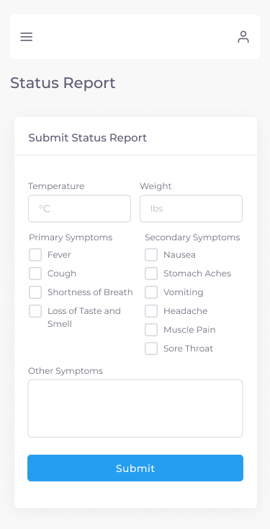

Figure 53: Status Report Mobile UI Mockup

### 7.3.8 Number of Patients Assigned to a Doctor

COV-27 - As an Administrator, I want to view the number of Patients assigned to a Doctor, so that no Doctor has too many Patients

An administrator is able to view a table containing all doctors and the number of patients assigned to them. There are also two information cards above the table describing the total number of patients assigned to all doctors and the number of assigned patients per doctor. The UI is only accessible by the Administrator persona and does not adjust based on persona. A selection of UI mockups for desktop, tablet, and mobile can be seen in Figures 54 and 55. All UI mockups, user flows and associated interactive prototypes for desktop, tablet and mobile platforms are accessible at the following links:

* [UI and User Flow Mockup - Number of Patients Assigned to a Doctor / Desktop & Tablet](https://drive.google.com/file/d/1XZ63EloHWc2iQERy_7lWpHtBFXfqWDlf/view?usp=sharing)
* [UI and User Flow Mockup - Number of Patients Assigned to a Doctor / Mobile](https://drive.google.com/file/d/1P6l8ivJqv2GyG9fJQGFDAHx4MNDYT_w6/view?usp=sharing)
* [▶ Prototype - Number of Patients Assigned to a Doctor / Desktop & Tablet](https://www.figma.com/proto/It4nC0bENajBMuQdTviwQG/covidtrack?node-id=1205%3A199818&starting-point-node-id=1205%3A199818&show-proto-sidebar=1)
* [▶ Prototype - Number of Patients Assigned to a Doctor / Desktop & Tablet](https://www.figma.com/proto/It4nC0bENajBMuQdTviwQG/covidtrack?node-id=1205%3A201563&starting-point-node-id=1205%3A201563&show-proto-sidebar=1)

# 

Figure 54: Number of Patients Assigned to a Doctor Desktop & Tablet UI Mockup

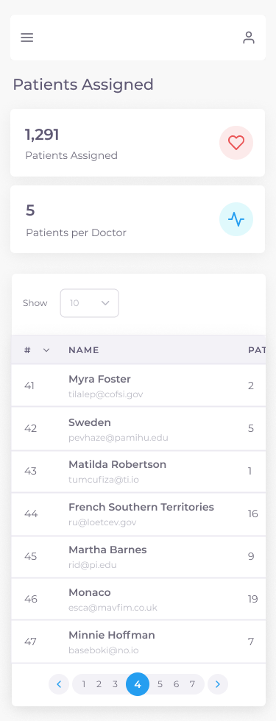

Figure 55: Number of Patients Assigned to a Doctor Mobile UI Mockup

### 7.3.9 Patient List

COV-114 - As a Doctor, I want to flag certain patients, so that their updates are prioritized over others

COV-157 - As a Doctor, I want to view a list of my Patients, so that I can easily navigate to their specific detailed views

COV-222 - As a Doctor, I want to define status report fields from the patient list page

COV-223 - As an Immigration Officer, I want to view the patients list, so I can be aware of test results and prioritize them

A doctor is able to view a table containing all patients they are assigned to by an administrator. A doctor can prioritize a patient by clicking the “flag” icon under the “Actions” column allowing said patient’s status reports to be prioritized over other patients. A doctor can also click the “more options” (three dots) icon and choose one of the following actions: add a test result for a patient, view a patient’s test results, view a patient's status reports, book an appointment, and define a status report. This page is also accessible to a health official and immigration officer. A health official can have the same abilities as a doctor would, such as prioritization, adding a test result, and viewing all test results and status reports but cannot, however, book an appointment with a patient. An immigration officer can only see patient test results. The only adjustment between all personas is the health official and immigration officer will see a list of all patients in the system and a doctor only sees their assigned patients. Therefore, the UI is only accessible by the Doctor, Health Official, and Immigration Officer personas. A selection of UI mockups for desktop, tablet, and mobile can be seen in Figures 56 and 57 for the Doctor and Health official personas and Figures 58 and 59 for the Immigration Officer persona. All UI mockups, user flows and associated interactive prototypes for desktop, tablet and mobile platforms are accessible at the following links:

* [UI and User Flow Mockup - Patient List (Doctor/Health Official) / Desktop & Tablet](https://drive.google.com/file/d/1dD7Tn4ahGrNr4PQqGTdXSQiibLG9ufH0/view?usp=sharing)
* [UI and User Flow Mockup - Patient List (Doctor/Health Official) / Mobile](https://drive.google.com/file/d/1H6sJpM4yKAWNznWe2AvWGJHOT-TWewFl/view?usp=sharing)
* [▶ Prototype - Patient List (Doctor/Health Official) / Desktop & Tablet](https://www.figma.com/proto/It4nC0bENajBMuQdTviwQG/covidtrack?node-id=1213%3A80697&starting-point-node-id=1213%3A80697&show-proto-sidebar=1)
* [▶ Prototype - Patient List (Doctor/Health Official) / Mobile](https://www.figma.com/proto/It4nC0bENajBMuQdTviwQG/covidtrack?node-id=1213%3A80698&starting-point-node-id=1213%3A80698&show-proto-sidebar=1)

# 

Figure 56: Patient List (Doctor & Health Official) Desktop & Tablet UI Mockup

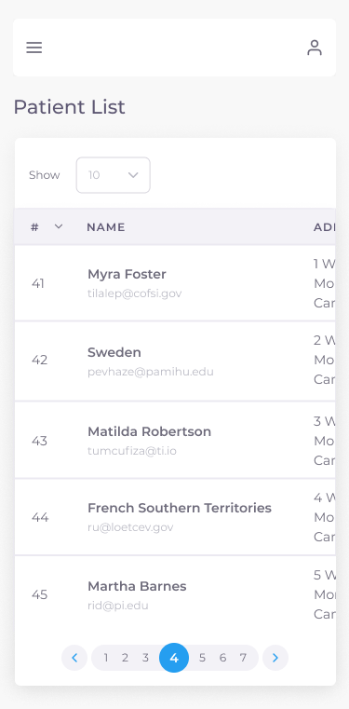

Figure 57: Patient List (Doctor & Health Official) Mobile UI Mockup

* [UI and User Flow Mockup - Patient List (Immigration Officer) / Desktop & Tablet](https://drive.google.com/file/d/1SX-hxcDXQoxR9jMR86t5aXlOe4Er4jkI/view?usp=sharing)
* [UI and User Flow Mockup - Patient List (Immigration Officer) / Mobile](https://drive.google.com/file/d/1h5ssMmtvBkIzvkB3JSGnCdSSUYCAQxGY/view?usp=sharing)
* [▶ Prototype - Patient List (Immigration Officer) / Desktop & Tablet](https://www.figma.com/proto/It4nC0bENajBMuQdTviwQG/covidtrack?node-id=1213%3A95957&starting-point-node-id=1213%3A95957&show-proto-sidebar=1)
* [▶ Prototype - Patient List (Immigration Officer) / Mobile](https://www.figma.com/proto/It4nC0bENajBMuQdTviwQG/covidtrack?node-id=1213%3A95958&starting-point-node-id=1213%3A95958&show-proto-sidebar=1)

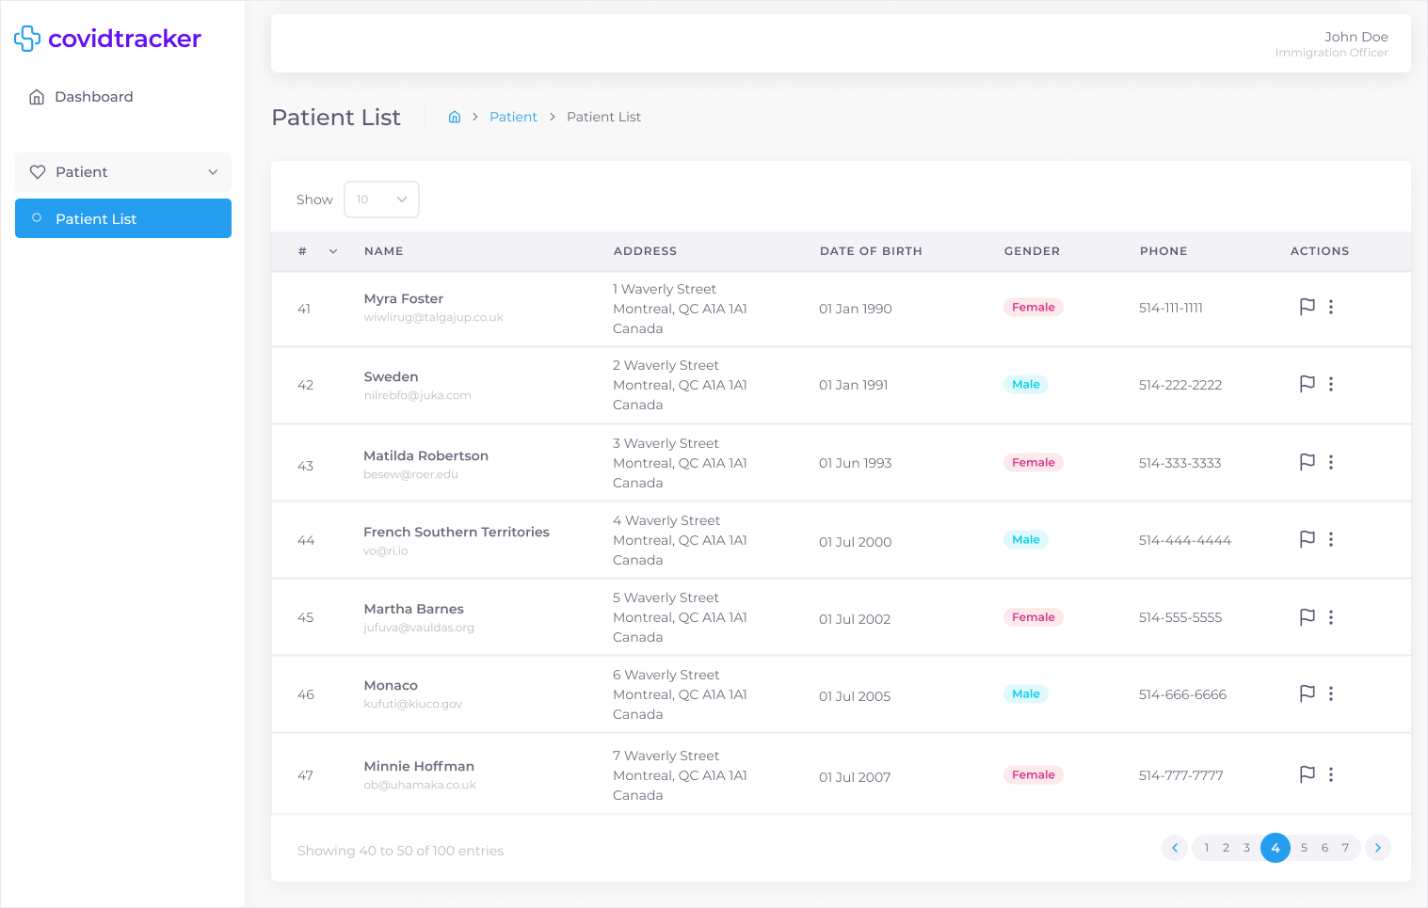

Figure 58: Patient List (Immigration Officer) Desktop & Tablet UI Mockup



Figure 59: Patient List (Immigration Officer) Mobile UI Mockup

### 7.3.10 Status Reports

COV-111 - As a Patient, I want to view all my line item statuses, so that I can monitor my progress over time

A patient is able to view a table containing all the status reports submitted to their doctor. By clicking the “see details” (eye) icon under the “Actions” column, a patient would be able to see a full description of the status report as described in section 7.3.13 Status Report Details. A doctor and health official can also view a similar page upon selecting the “Status Reports” option found in the more options dropdown for a given patient within the Patient List page as described in section 7.3.9 Patient List. Therefore, the UI is only accessible by the Patient, Doctor and Health Official personas. The only UI element that adjusts based on the persona is the breadcrumb text. A selection of UI mockups for desktop, tablet, and mobile can be seen in Figures 60 and 61 for the Patient persona and Figures 62 and 63 for the Doctor and Health Official personas. All UI mockups, user flows and associated interactive prototypes for desktop, tablet and mobile platforms are accessible at the following links:

* [UI and User Flow Mockup - Status Reports (Patient) / Desktop & Tablet](https://drive.google.com/file/d/1kOgjE4WiAuBIBYHo-6Xd3QhtwmVi7JC-/view?usp=sharing)
* [UI and User Flow Mockup - Status Reports (Patient) / Mobile](https://drive.google.com/file/d/1g3LkBDbHhzLlDVTE7sEPxapRV1oQ_Opf/view?usp=sharing)
* [▶ Prototype - Status Reports (Patient) / Desktop & Tablet](https://www.figma.com/proto/It4nC0bENajBMuQdTviwQG/covidtrack?node-id=1213%3A98403&starting-point-node-id=1213%3A98403&show-proto-sidebar=1)
* [▶ Prototype - Status Reports (Patient) / Mobile](https://www.figma.com/proto/It4nC0bENajBMuQdTviwQG/covidtrack?node-id=1213%3A98404&starting-point-node-id=1213%3A98404&show-proto-sidebar=1)

# 

Figure 60: Status Reports (Patient) Desktop & Tablet UI Mockup

# 

Figure 61: Status Reports (Patient) Mobile UI Mockup

* [UI and User Flow Mockup - Status Reports (Doctor/Health Official) / Desktop & Tablet](https://drive.google.com/file/d/1tQI01xftjNEZ_I9kDJx007oJNtZminOd/view?usp=sharing)
* [UI and User Flow Mockup - Status Reports (Doctor/Health Official) / Mobile](https://drive.google.com/file/d/1mQIaLG5FCVdTvDmvayRLkCwhbWrcT5Sg/view?usp=sharing)
* [▶ Prototype - Status Reports (Doctor/Health Official) / Desktop & Tablet](https://www.figma.com/proto/It4nC0bENajBMuQdTviwQG/covidtrack?node-id=623%3A79407&starting-point-node-id=623%3A79407&show-proto-sidebar=1)
* [▶ Prototype - Status Reports (Doctor/Health Official) / Mobile](https://www.figma.com/proto/It4nC0bENajBMuQdTviwQG/covidtrack?node-id=855%3A56697&starting-point-node-id=855%3A56697&show-proto-sidebar=1)

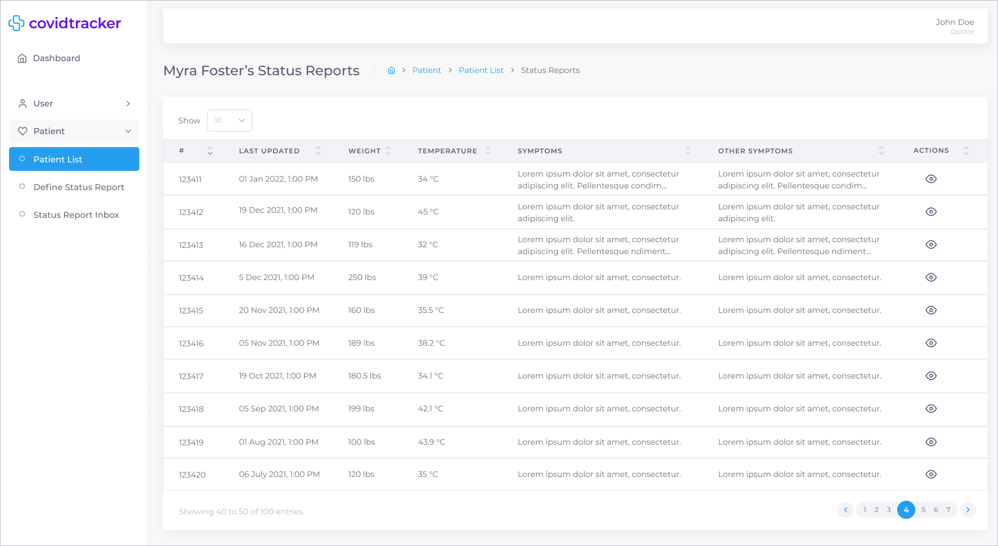

Figure 62: Status Reports (Doctor/Health Official) Desktop & Tablet UI Mockup

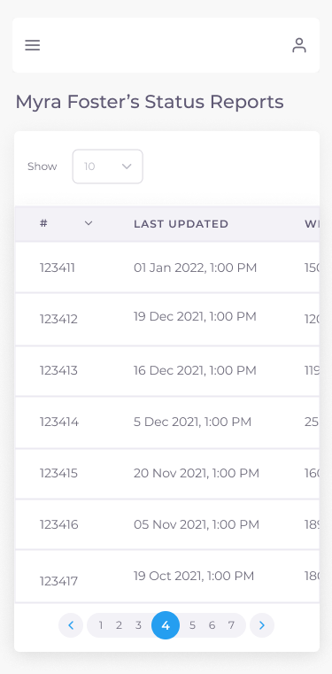

Figure 63: Status Reports (Doctor/Health Official) Mobile UI Mockup

### 7.3.11 Add Test Result

COV-107 - As a Health Official, I want to input my COVID test results, so that I can report if a Patient tested positive or negative

A health official and doctor are able to add a test result for a given patient. The following information must be provided: test result (positive or negative), type of test (antigen or PCR), date of test, and location of test. This page can be accessed from the Patient List by selecting the “Add Test Result” option found in the more options dropdown for a given patient as described in section 7.3.9 Patient List. The UI is only accessible by the Doctor and Health Official personas and does not adjust based on persona. A selection of UI mockups for desktop, tablet, and mobile can be seen in Figures 64 and 65. All UI mockups, user flows and associated interactive prototypes for desktop, tablet and mobile platforms are accessible at the following links:

* [UI and User Flow Mockup - Add Test Result / Desktop & Tablet](https://drive.google.com/file/d/1pGnZhI-Gn85cv2e2jZEpBgiQthvVtOXx/view?usp=sharing)
* [UI and User Flow Mockup - Add Test Result / Mobile](https://drive.google.com/file/d/1Vm0dsbXAS_X-qjPc4Cfr78zifBCjsMfM/view?usp=sharing)
* [▶ Prototype - Add Test Result / Desktop & Tablet](https://www.figma.com/proto/It4nC0bENajBMuQdTviwQG/covidtrack?node-id=623%3A80246&starting-point-node-id=623%3A80246&show-proto-sidebar=1)
* [▶ Prototype - Add Test Result / Mobile](https://www.figma.com/proto/It4nC0bENajBMuQdTviwQG/covidtrack?node-id=1070%3A86734&starting-point-node-id=1070%3A86734&show-proto-sidebar=1)

# 

Figure 64: Add Test Result Desktop & Tablet UI Mockup

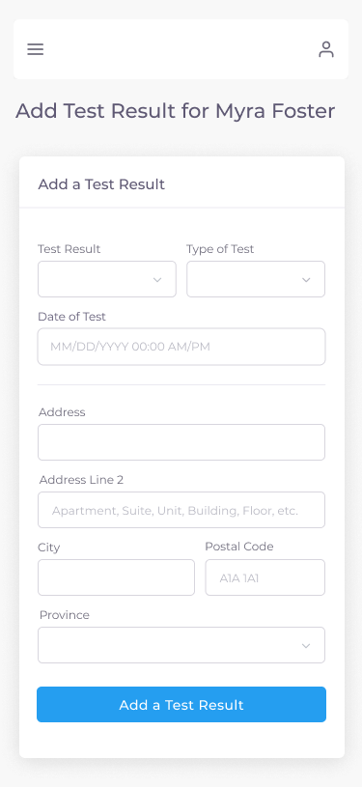

Figure 65: Add Test Result Mobile UI Mockup

### 7.3.12 Status Report Inbox

COV-113 - As a Doctor, I want to view a line item list of my patients with their most recent line item status update, so that I can keep track of any updates

COV-115 - As a Doctor, I want to mark a Patient's status update as "Reviewed", so that I can see which statuses I've already seen

A doctor is able to view a table containing all status reports submitted by all their assigned patients. A doctor can subsequently, press the checkbox to mark a status report as viewed or uncheck it to mark it as not viewed. A doctor can also click the “see details” (eye) icon under the “Actions” column to view a full description of the status report as described in section 7.3.13 Status Report Details. The UI is only accessible by the Doctor persona and does not adjust based on persona. A selection of UI mockups for desktop, tablet, and mobile can be seen in Figures 66 and 67. All UI mockups, user flows and associated interactive prototypes for desktop, tablet and mobile platforms are accessible at the following links:

* [UI and User Flow Mockup - Status Report Inbox / Desktop & Tablet](https://drive.google.com/file/d/1AQJcS2OHYpSMqdH2iP8Y7wxGYr8gdX8U/view?usp=sharing)
* [UI and User Flow Mockup - Status Report Inbox / Mobile](https://drive.google.com/file/d/1TVBQ5LJjF2GzyIq3nR9iNv2wDmxHwEsn/view?usp=sharing)
* [▶ Prototype - Status Report Inbox / Desktop & Tablet](https://www.figma.com/proto/It4nC0bENajBMuQdTviwQG/covidtrack?node-id=1213%3A101707&starting-point-node-id=1213%3A101707&show-proto-sidebar=1)
* [▶ Prototype - Status Report Inbox / Mobile](https://www.figma.com/proto/It4nC0bENajBMuQdTviwQG/covidtrack?node-id=1213%3A101708&starting-point-node-id=1213%3A101708&show-proto-sidebar=1)

# 

Figure 66: Status Report Inbox Desktop & Tablet UI Mockup

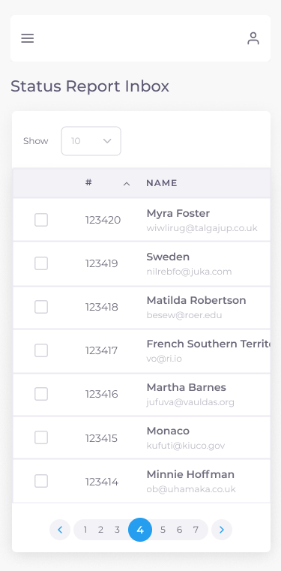

Figure 67: Status Report Inbox Mobile UI Mockup

# 

### 7.3.13 Status Report Details

COV-112 - As a Patient, I want to view the details of a single status report of a Patient, so that I can view their progress at a point in time

COV-121 - As a Patient, I want to be able to generate a QR code for a status report, so that I can share it with others

A patient is able to view a full detailed description of a given status report and its associated QR code that can be used to easily share such information with either their doctor or a health official. Likewise, upon scanning such QR code, a doctor or health official will be redirected to a similar page. The UI is only accessible by the Patient, Doctor and Health Official personas. The only UI element that adjusts based on the persona is the breadcrumb text. A selection of UI mockups for desktop, tablet, and mobile can be seen in Figures 68 and 69 for the Patient person and Figures 70 and 71 for the Doctor and Health Official personas. All UI mockups, user flows and associated interactive prototypes for desktop, tablet and mobile platforms are accessible at the following links:

* [UI and User Flow Mockup - Status Report Details (Patient) / Desktop & Tablet](https://drive.google.com/file/d/1lnwco3AVU5s9GIGp3YD20ny21cCcLnTj/view?usp=sharing)
* [UI and User Flow Mockup - Status Report Details (Patient) / Mobile](https://drive.google.com/file/d/1W-jyrA7f7miD3VzRb9o83cTuUSSCQ85P/view?usp=sharing)
* [▶ Prototype - Status Report Details (Patient) / Desktop & Tablet](https://www.figma.com/proto/It4nC0bENajBMuQdTviwQG/covidtrack?node-id=623%3A98320&starting-point-node-id=623%3A98320&show-proto-sidebar=1)
* [▶ Prototype - Status Report Details (Patient) / Mobile](https://www.figma.com/proto/It4nC0bENajBMuQdTviwQG/covidtrack?node-id=1213%3A105196&starting-point-node-id=1213%3A105196&show-proto-sidebar=1)

# 

Figure 68: Status Report Details (Patient) Desktop & Tablet UI Mockup

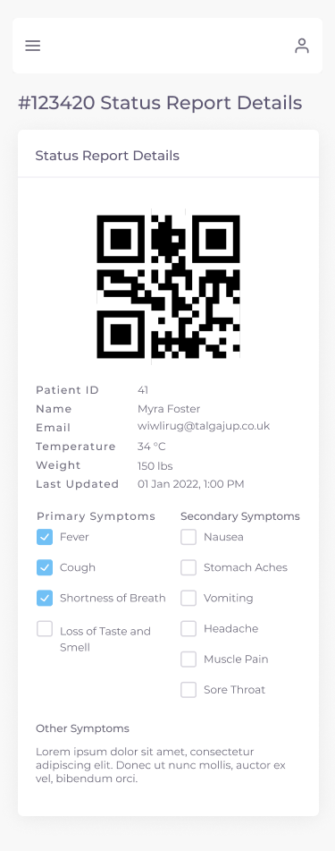

Figure 69: Status Report Details (Patient) Mobile UI Mockup

* [UI and User Flow Mockup - Status Report Details (Doctor/Health Official) / Desktop & Tablet](https://drive.google.com/file/d/16Cb6qahaYfCOAC1yI2ph4M6nGJH4yG6K/view?usp=sharing)
* [UI and User Flow Mockup - Status Report Details (Doctor/Health Official) / Mobile](https://drive.google.com/file/d/1V4bSYbB6sR9P4nddA5F_6c3Ecd-lj2ET/view?usp=sharing)
* [▶ Prototype - Status Report Details (Doctor/Health Official) / Desktop & Tablet](https://www.figma.com/proto/It4nC0bENajBMuQdTviwQG/covidtrack?node-id=623%3A98972&starting-point-node-id=623%3A98972&show-proto-sidebar=1)
* [▶ Prototype - Status Report Details (Doctor/Health Official) / Mobile](https://www.figma.com/proto/It4nC0bENajBMuQdTviwQG/covidtrack?node-id=1213%3A106083&starting-point-node-id=1213%3A106083&show-proto-sidebar=1)

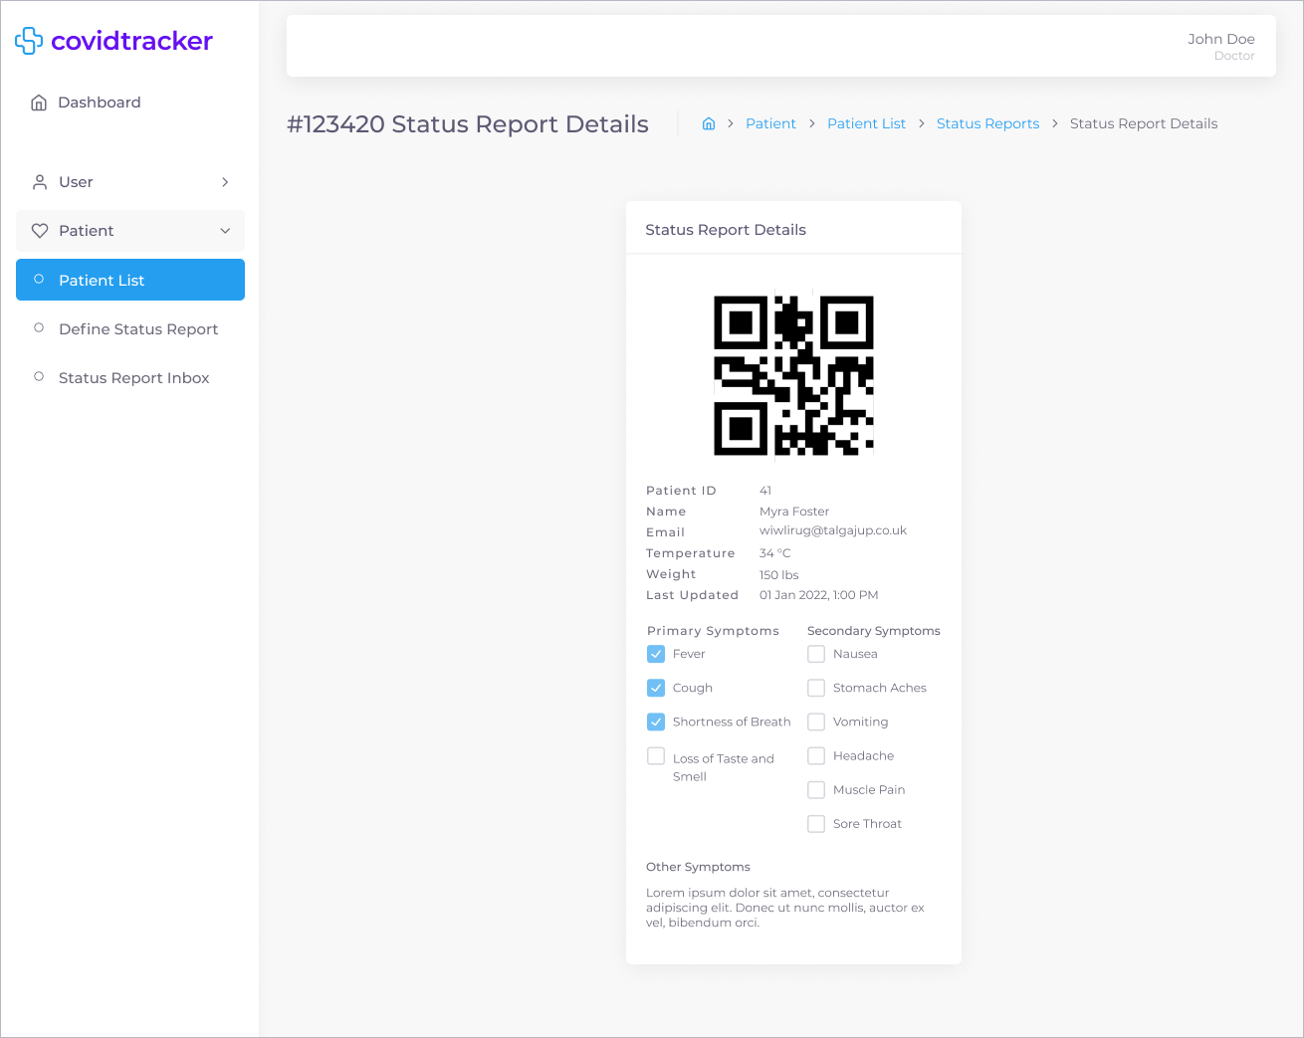

Figure 70: Status Report Details (Doctor/Health Official) Desktop & Tablet UI Mockup

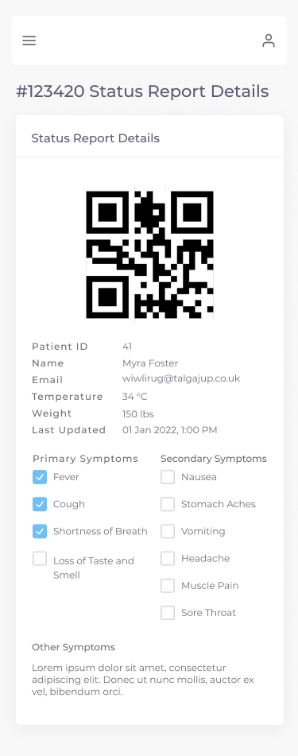

Figure 71: Status Report Details (Doctor/Health Official) Mobile UI Mockup

### 7.3.14 Test Results

COV-123 - As a Patient, I want to view all my line item COVID test results, so that I'm aware of my diagnosis

COV-223 - As an Immigration Officer, I want to view the patients list, so I can be aware of test results and prioritize them

A patient is able to view a table containing all their test results. By clicking the “see details” (eye) icon under the “Actions” column, a patient would be able to see a full description of the test result as described in section 7.3.15 Test Result Details. A doctor, health official, and immigration can also view a similar page upon selecting the “Test Results” option found in the more options dropdown for a given patient within the Patient List page as described in section 7.3.9 Patient List. Therefore, the UI is only accessible by the Patient, Doctor, Health Official, and Immigration Officer personas. The only UI element that adjusts based on the persona is the breadcrumb text. A selection of UI mockups for desktop, tablet, and mobile can be seen in Figures 72 and 73 for the Patient person, Figures 74 and 75 for the Doctor and Health Official personas, and Figures 76 and 77 for the Immigration Officer persona. All UI mockups, user flows and associated interactive prototypes for desktop, tablet and mobile platforms are accessible at the following links:

* [UI and User Flow Mockup - Test Results (Patient) / Desktop & Tablet](https://drive.google.com/file/d/1ubW6PzD7DbYWGu4_9f1BHecVNt08c0Dq/view?usp=sharing)
* [UI and User Flow Mockup - Test Results (Patient) / Mobile](https://drive.google.com/file/d/1-fpslD1SpAaKYa9XVkKMzEC0QQOozz_E/view?usp=sharing)
* [▶ Prototype - Test Results (Patient) / Desktop & Tablet](https://www.figma.com/proto/It4nC0bENajBMuQdTviwQG/covidtrack?node-id=1213%3A106463&starting-point-node-id=1213%3A106463&show-proto-sidebar=1)
* [▶ Prototype - Test Results (Patient) / Mobile](https://www.figma.com/proto/It4nC0bENajBMuQdTviwQG/covidtrack?node-id=1213%3A106464&starting-point-node-id=1213%3A106464&show-proto-sidebar=1)

# 

# 

Figure 72: Test Results (Patient) Desktop & Tablet UI Mockup

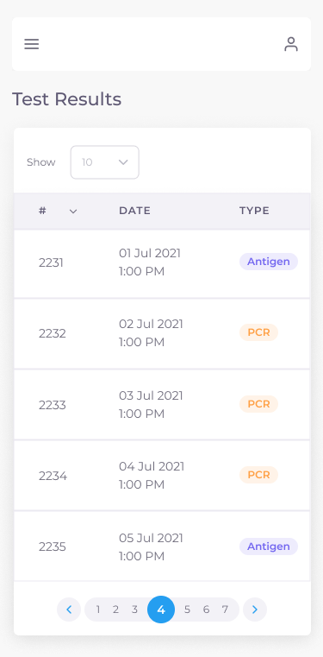

Figure 73: Test Results (Patient) Mobile UI Mockup

* [UI and User Flow Mockup - Test Results (Doctor/Health Official) / Desktop & Tablet](https://drive.google.com/file/d/1XSHROoncrA9nXzfJUogjOqms5vqFqK9W/view?usp=sharing)
* [UI and User Flow Mockup - Test Results (Doctor/Health Official) / Mobile](https://drive.google.com/file/d/1tvhYLrF3bJoYIjBnFNABFqRVjDf78MIv/view?usp=sharing)
* [▶ Prototype - Test Results (Doctor/Health Official) / Desktop & Tablet](https://www.figma.com/proto/It4nC0bENajBMuQdTviwQG/covidtrack?node-id=691%3A36284&starting-point-node-id=691%3A36284&show-proto-sidebar=1)
* [▶ Prototype - Test Results (Doctor/Health Official) / Mobile](https://www.figma.com/proto/It4nC0bENajBMuQdTviwQG/covidtrack?node-id=1070%3A85669&starting-point-node-id=1070%3A85669&show-proto-sidebar=1)

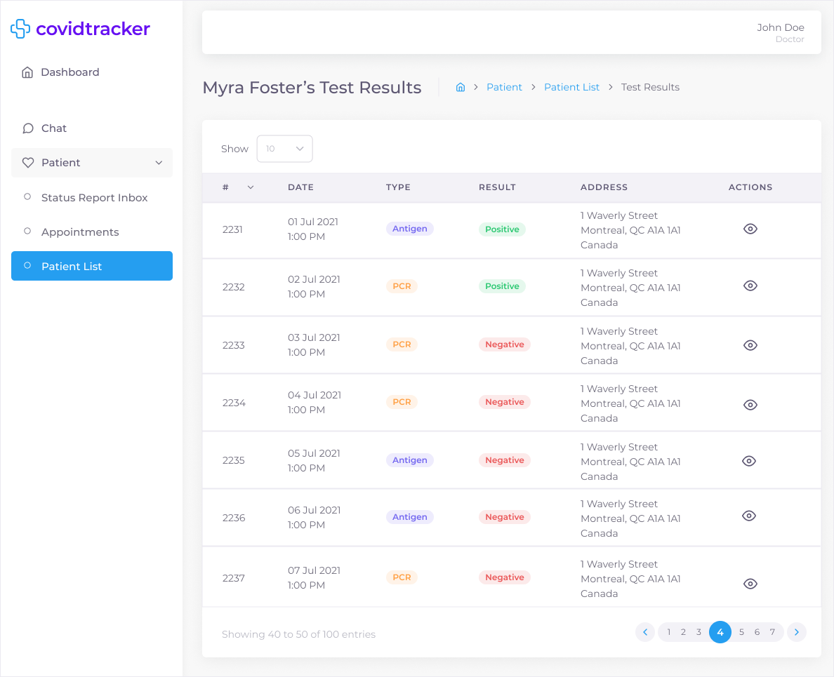

Figure 74: Test Results (Doctor/Health Official) Desktop & Tablet UI Mockup

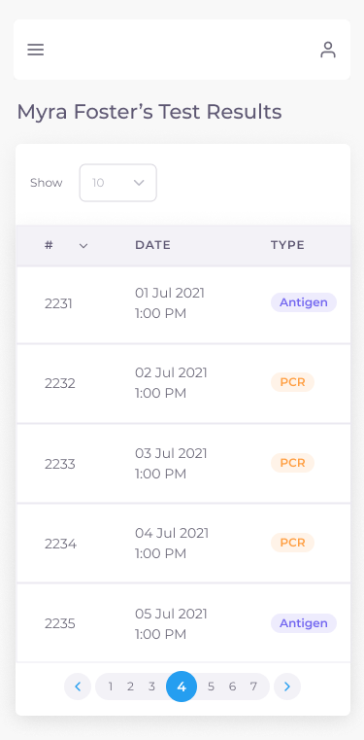

Figure 75: Test Results (Doctor/Health Official) Desktop & Tablet UI Mockup

* [UI and User Flow Mockup - Test Results (Immigration Officer) / Desktop & Tablet](https://drive.google.com/file/d/1_ZmK242QjamlM02Q5VNqV0k0Gk1E0WF5/view?usp=sharing)
* [UI and User Flow Mockup - Test Results (Immigration Officer) / Mobile](https://drive.google.com/file/d/16nJyGClY9OSszqAci9v3hTooLUKAp0O9/view?usp=sharing)
* [▶ Prototype - Test Results (Immigration Officer) / Desktop & Tablet](https://www.figma.com/proto/It4nC0bENajBMuQdTviwQG/covidtrack?node-id=1062%3A61884&starting-point-node-id=1062%3A61884&show-proto-sidebar=1)
* [▶ Prototype - Test Results (Immigration Officer) / Mobile](https://www.figma.com/proto/It4nC0bENajBMuQdTviwQG/covidtrack?node-id=1056%3A70076&starting-point-node-id=1056%3A70076&show-proto-sidebar=1)

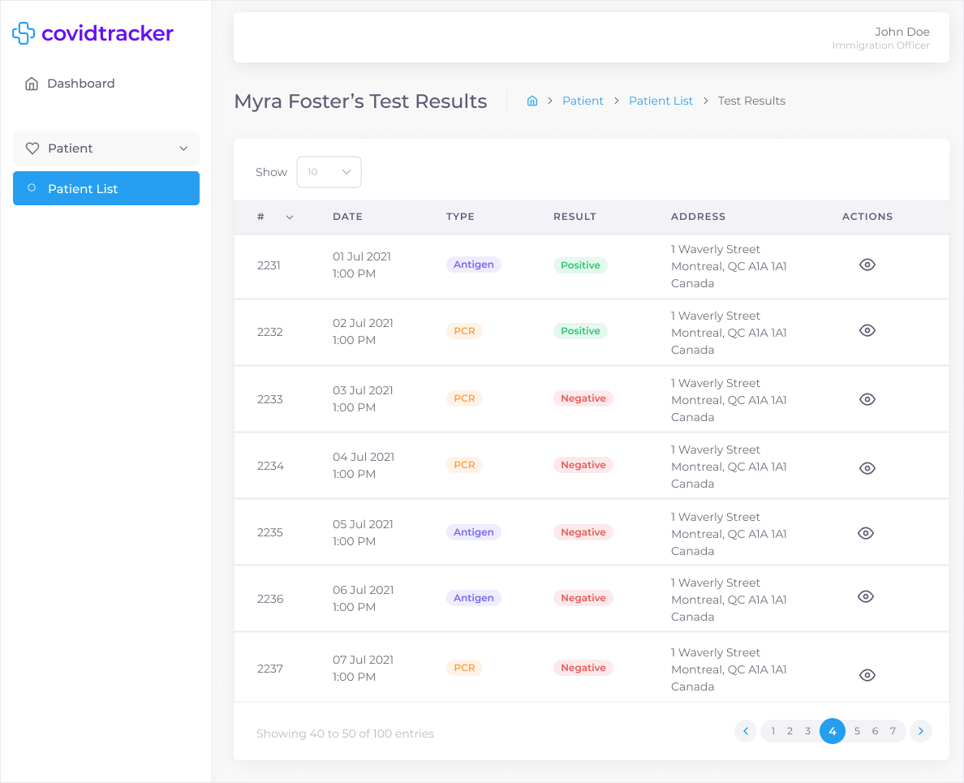

Figure 76: Test Results (Immigration Officer) Desktop & Tablet UI Mockup



Figure 77: Test Results (Immigration Officer) Mobile UI Mockup

### 7.3.15 Test Result Details

COV-122 - As a Patient, I want to be able to generate a QR code for a lab test result, so that I can share it with others

COV-124 - As a Patient, I want to view the details of a single COVID test result, so that I'm aware of my diagnosis

COV-223 - As an Immigration Officer, I want to view the patients list, so I can be aware of test results and prioritize them

A patient is able to view a full detailed description of a given test result and its associated QR code (additional feature) that can be used to easily share such information with either their doctor or a health official. Likewise, upon scanning such QR code, a doctor or health official will be redirected to a similar page. The UI is only accessible by the Patient, Doctor, Health Official and Immigration Officer personas. The only UI element that adjusts based on the persona is the breadcrumb text. A selection of UI mockups for desktop, tablet, and mobile can be seen in Figures 78 and 79 for the Patient person, Figures 80 and 81 for the Doctor and Health Official personas, and Figures 82 and 83 for Immigration Officer personas. All UI mockups, user flows and associated interactive prototypes for desktop, tablet and mobile platforms are accessible at the following links:

* [UI and User Flow Mockup - Test Result Details (Patient) / Desktop & Tablet](https://drive.google.com/file/d/12g1EZdyyZNq13dxR61-A7T4xBWiJvsrM/view?usp=sharing)
* [UI and User Flow Mockup - Test Result Details (Patient) / Mobile](https://drive.google.com/file/d/1b5BJJfo1UN4NwdREAQMnG0RswHP03gtg/view?usp=sharing)
* [▶ Prototype - Test Result Details (Patient) / Desktop & Tablet](https://www.figma.com/proto/It4nC0bENajBMuQdTviwQG/covidtrack?node-id=637%3A34909&starting-point-node-id=637%3A34909&show-proto-sidebar=1)
* [▶ Prototype - Test Result Details (Patient) / Mobile](https://www.figma.com/proto/It4nC0bENajBMuQdTviwQG/covidtrack?node-id=1213%3A108753&starting-point-node-id=1213%3A108753&show-proto-sidebar=1)

# 

Figure 78: Test Result Details (Patient) Desktop & Tablet UI Mockup

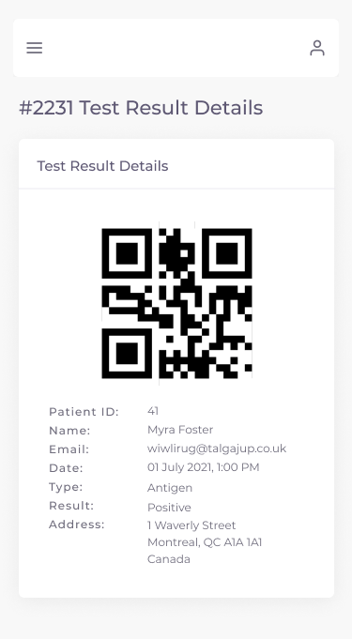

Figure 79: Test Result Details (Patient) Mobile UI Mockup

* [UI and User Flow Mockup - Test Result Details (Doctor/Health Official) / Desktop & Tablet](https://drive.google.com/file/d/1Vq1SxVYMQX4s9rPnJ4h_T84DJ_AKbM6U/view?usp=sharing)
* [UI and User Flow Mockup - Test Result Details (Doctor/Health Official) / Mobile](https://drive.google.com/file/d/1kvoHF3JFDuKQmFAkfWWfNeO0Nh6ryeN5/view?usp=sharing)
* [▶ Prototype - Test Result Details (Doctor/Health Official) / Desktop & Tablet](https://www.figma.com/proto/It4nC0bENajBMuQdTviwQG/covidtrack?node-id=623%3A89009&starting-point-node-id=623%3A89009&show-proto-sidebar=1)
* [▶ Prototype - Test Result Details (Doctor/Health Official) / Mobile](https://www.figma.com/proto/It4nC0bENajBMuQdTviwQG/covidtrack?node-id=1213%3A109300&starting-point-node-id=1213%3A109300&show-proto-sidebar=1)

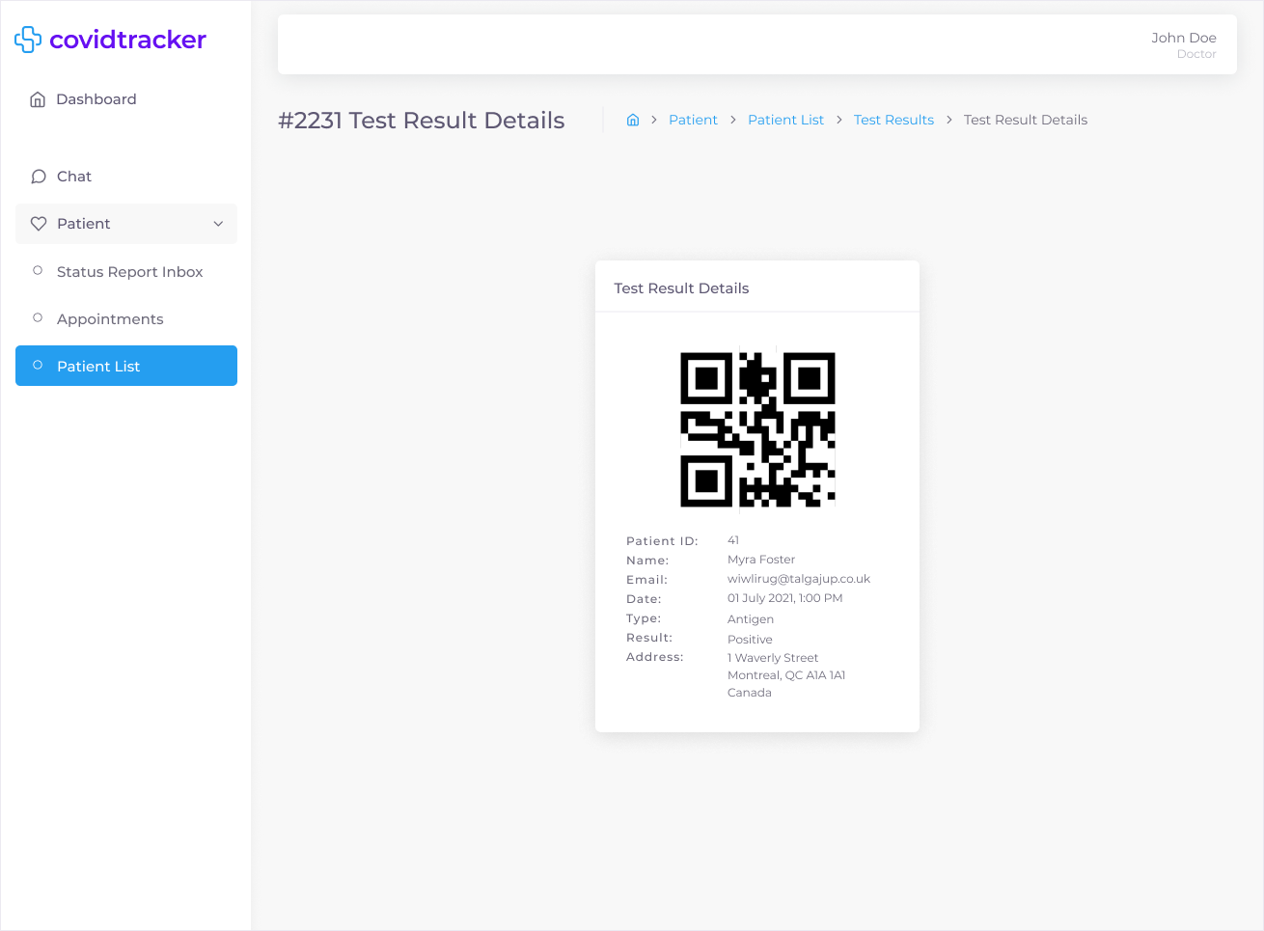

Figure 80: Test Result Details (Doctor/Health Official) Desktop & Tablet UI Mockup

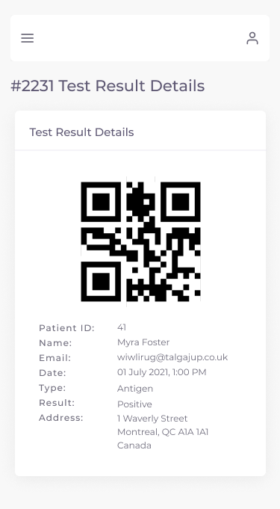

Figure 81: Test Result Details (Doctor/Health Official) Mobile UI Mockup

* [UI and User Flow Mockup - Test Result Details (Immigration Officer) / Desktop & Tablet](https://drive.google.com/file/d/1B6GEVx5IViz7sn0VuzXvaWwPZ0ShnBN8/view?usp=sharing)
* [UI and User Flow Mockup - Test Result Details (Immigration Officer) / Mobile](https://drive.google.com/file/d/1XJJ_osVRoRZJNqimHp1rwWPVS0-jdUDW/view?usp=sharing)
* [▶ Prototype - Test Result Details (Immigration Officer) / Desktop & Tablet](https://www.figma.com/proto/It4nC0bENajBMuQdTviwQG/covidtrack?node-id=1064%3A75009&starting-point-node-id=1064%3A75009&show-proto-sidebar=1)
* [▶ Prototype - Test Result Details (Immigration Officer) / Mobile](https://www.figma.com/proto/It4nC0bENajBMuQdTviwQG/covidtrack?node-id=1213%3A109743&starting-point-node-id=1213%3A109743&show-proto-sidebar=1)

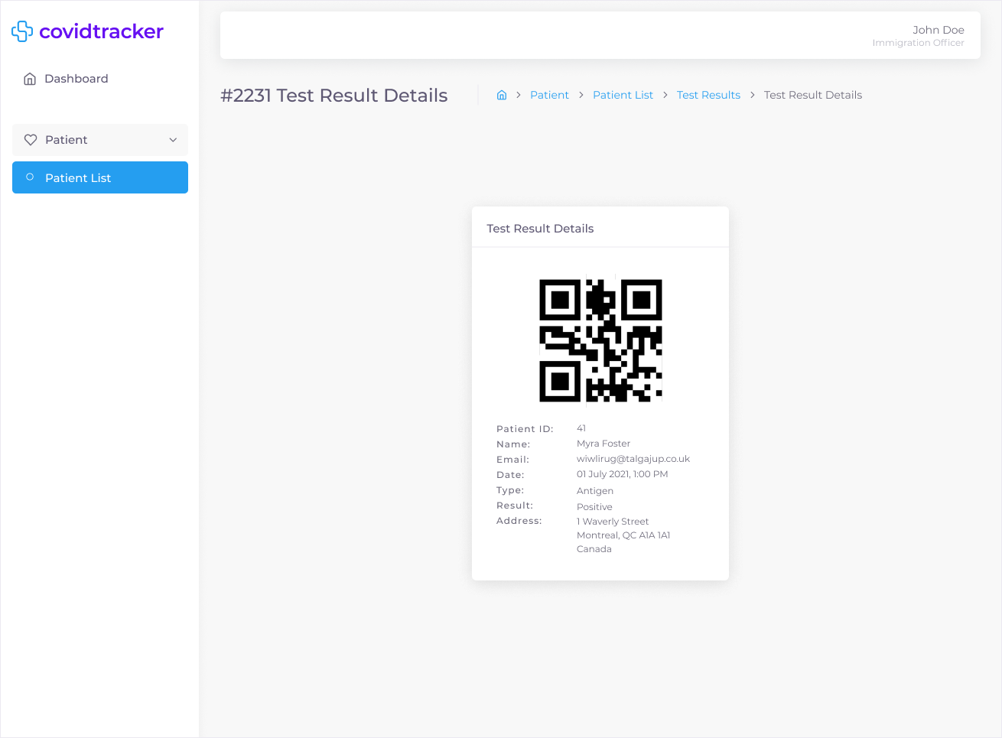

Figure 82: Test Result Details (Immigration Officer) Desktop & Tablet UI Mockup

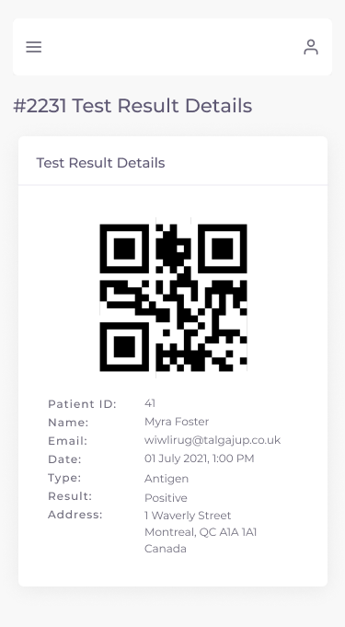

Figure 83: Test Result Details (Immigration Officer) Mobile UI Mockup

### 7.3.16 Chat

COV-119 - As a Patient, I want to direct message my Doctor, so that I can ask them questions

COV-120 - As a Patient, I want to mark my message with a priority level, so that my Doctor will view it quicker

A doctor and patient are able to communicate with each other through instant messaging. The UI is split in two sections: contacts (left) and chat (right). The contacts section is a list view of all the contacts assigned to either a doctor or patient. A doctor can communicate with any of their patients while a patient can only communicate with their assigned doctor. The number of unread messages from each contact is displayed as either a red (urgent message) or blue (regular message) bubble under the last message timestamp. A search bar is provided to easily and quickly find a contact. The chat section contains all exchanged messages between the two parties. A patient is able to flag a message as urgent by clicking the flag icon located in the message textbox. Urgent messages are then represented as a red background within the chat window and act as signals to doctors for immediate action. A doctor cannot flag a message as urgent. The UI is only accessible by the Patient and Doctor personas. The only UI element that adjusts based on the persona is the presence of the urgent message flag icon within the message textbox for the patient. A selection of UI mockups for desktop, tablet, and mobile can be seen in Figures 84 and 85 for the Doctor person and Figures 86 and 87 for the Patient personas. All UI mockups, user flows and associated interactive prototypes for desktop, tablet and mobile platforms are accessible at the following links:

* [UI and User Flow Mockup - Chat (Doctor) / Desktop & Tablet](https://drive.google.com/file/d/1b1Ggy7-GsSI6QFRFIeDvblidCtTTJZsD/view?usp=sharing)
* [UI and User Flow Mockup - Chat (Doctor) / Mobile](https://drive.google.com/file/d/1-DaC5WvuJhHO46N9rVE-0zWGxg27oWTW/view?usp=sharing)
* [▶ Prototype - Chat (Doctor) / Desktop & Tablet](https://www.figma.com/proto/It4nC0bENajBMuQdTviwQG/covidtrack?node-id=1205%3A220087&starting-point-node-id=1205%3A220087&show-proto-sidebar=1)
* [▶ Prototype - Chat (Doctor) / Mobile](https://www.figma.com/proto/It4nC0bENajBMuQdTviwQG/covidtrack?node-id=1205%3A220088&starting-point-node-id=1205%3A220088&show-proto-sidebar=1)

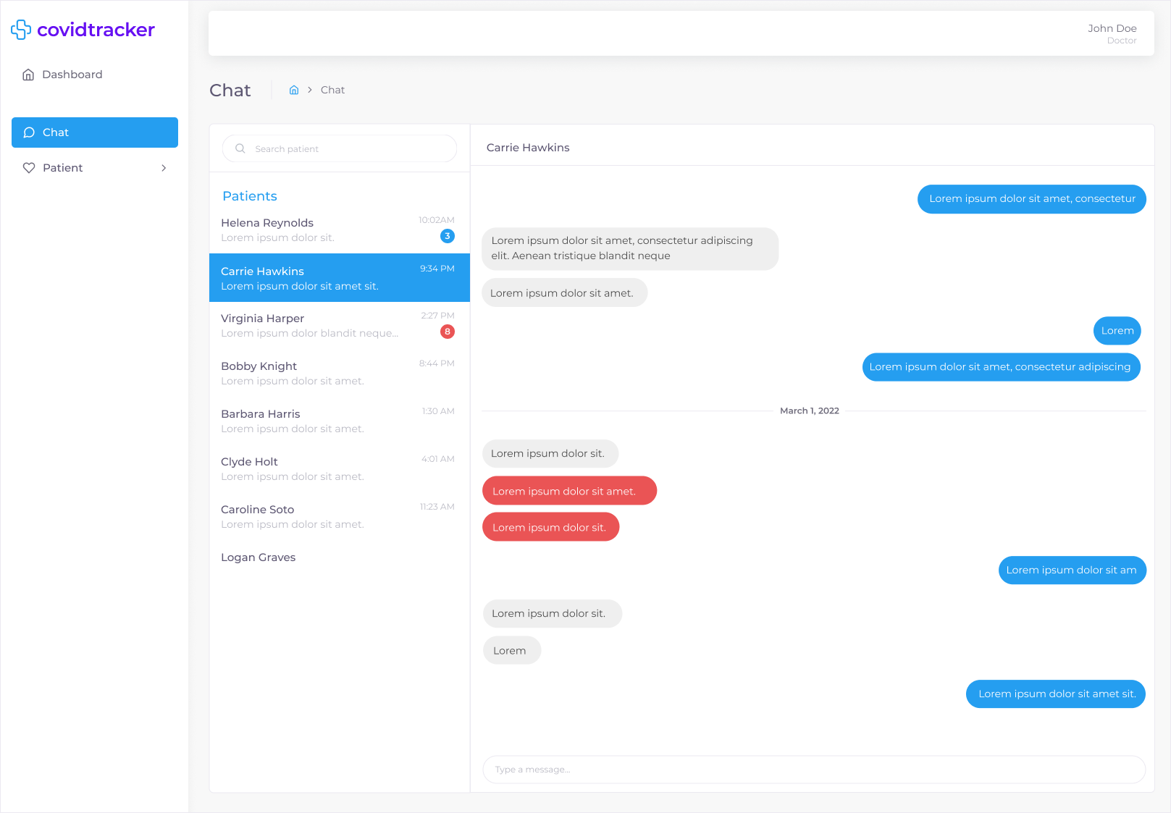Figure 84: Chat (Doctor) Desktop & Tablet UI Mockup

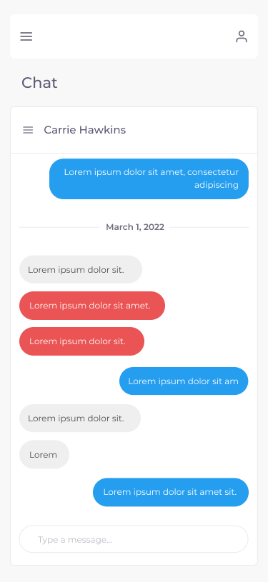

Figure 85: Chat (Doctor) Mobile UI Mockup

* [UI and User Flow Mockup - Chat (Patient) / Desktop & Tablet](https://drive.google.com/file/d/1J87LIGb_zW8Je7cykhqruYBgYuM2yQv2/view?usp=sharing)
* [UI and User Flow Mockup - Chat (Patient) / Mobile](https://drive.google.com/file/d/1UTDRKhoXRe2IYdTr8GkDevJ7oxlLDaZe/view?usp=sharing)
* [▶ Prototype - Chat (Patient) / Desktop & Tablet](https://www.figma.com/proto/It4nC0bENajBMuQdTviwQG/covidtrack?node-id=1205%3A241223&starting-point-node-id=1205%3A241223&show-proto-sidebar=1)
* [▶ Prototype - Chat (Patient) / Mobile](https://www.figma.com/proto/It4nC0bENajBMuQdTviwQG/covidtrack?node-id=1205%3A241224&starting-point-node-id=1205%3A241224&show-proto-sidebar=1)

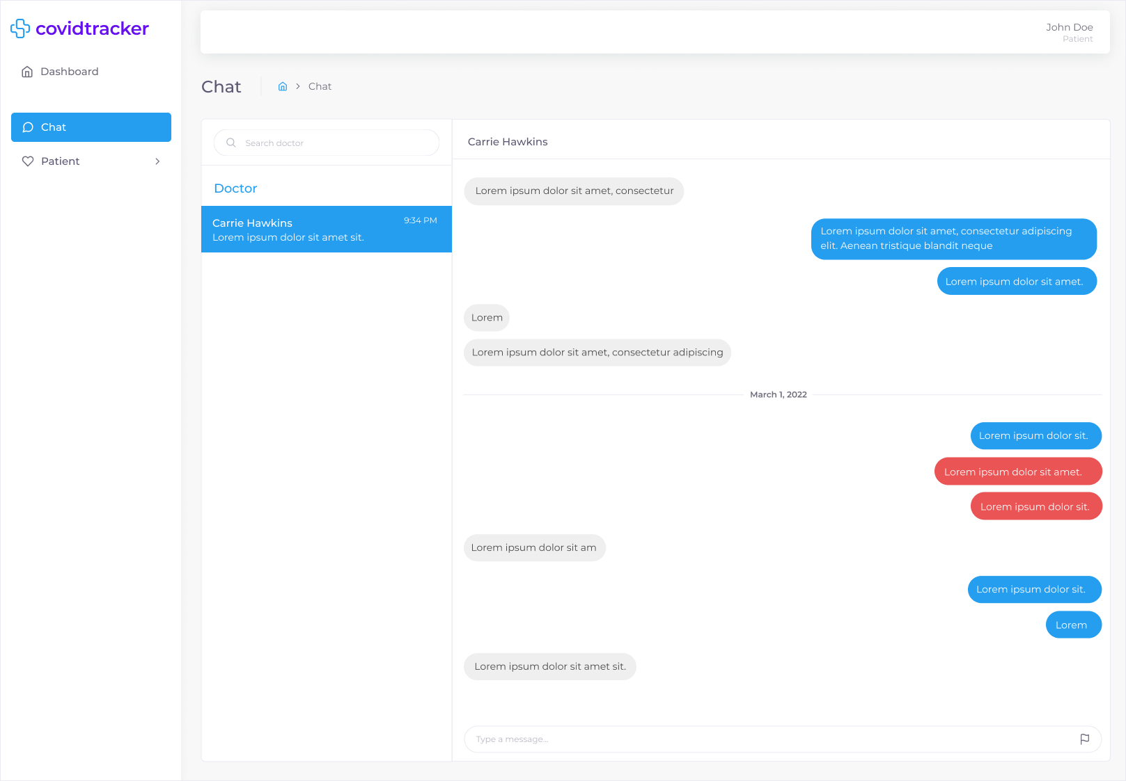

Figure 86: Chat (Patient) Desktop & Tablet UI Mockup

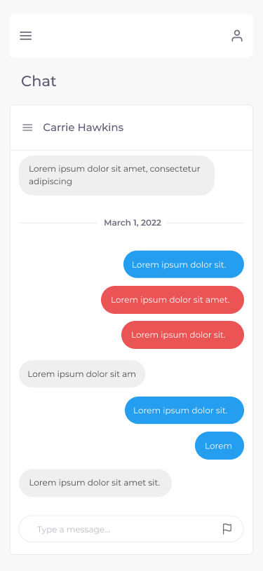

Figure 87: Chat (Patient) Mobile UI Mockup

### 7.3.17 Book Appointment

COV-116 - As a Doctor, I want to book an appointment with a Patient, so that we can discuss their symptoms

A doctor is able to book an appointment with a given patient. The following information must be provided: date of appointment, time of appointment (start time and end time), and location of appointment. This page can be accessed from the Patient List by selecting the “Book Appointment” option found in the more options dropdown for a given patient as described in section 7.3.9 Patient List. The UI is only accessible by the Doctor persona and does not adjust based on persona. A selection of UI mockups for desktop, tablet, and mobile can be seen in Figures 87 and 88. All UI mockups, user flows and associated interactive prototypes for desktop, tablet and mobile platforms are accessible at the following links:

* [UI and User Flow Mockup - Book Appointment / Desktop & Tablet](https://drive.google.com/file/d/1-A2Nr2djclDODikvTnxJiANxGNP5NXUk/view?usp=sharing)
* [UI and User Flow Mockup - Book Appointment / Mobile](https://drive.google.com/file/d/1N6BkOqNBDtqLZ7pZaRjMbWWa4bhzVdsV/view?usp=sharing)
* [▶ Prototype - Book Appointment / Desktop & Tablet](https://www.figma.com/proto/It4nC0bENajBMuQdTviwQG/covidtrack?node-id=842%3A39611&starting-point-node-id=842%3A39611&show-proto-sidebar=1)
* [▶ Prototype - Book Appointment / Mobile](https://www.figma.com/proto/It4nC0bENajBMuQdTviwQG/covidtrack?node-id=855%3A58638&starting-point-node-id=855%3A58638&show-proto-sidebar=1)

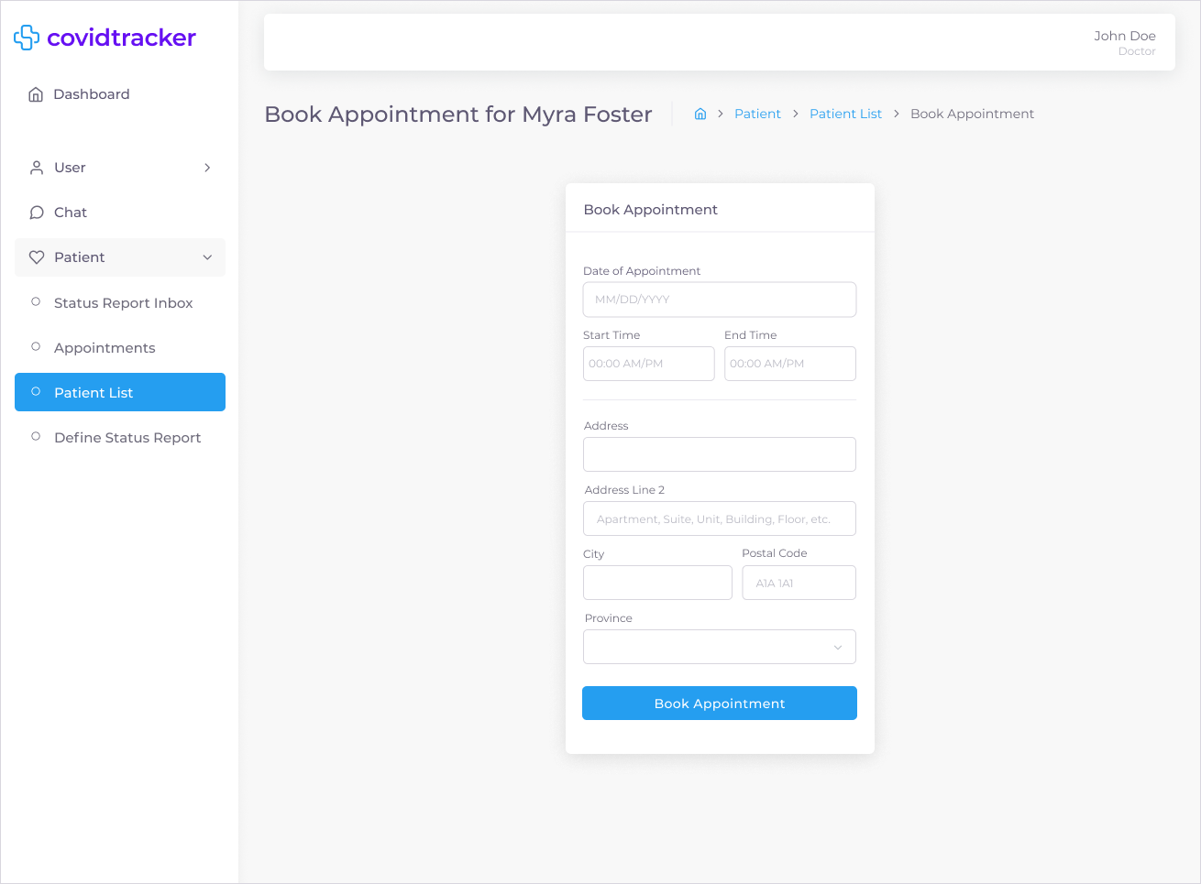

Figure 87: Book Appointment Desktop & Tablet UI Mockup

### 

### 

### 

### 

### 

### 

### 

Figure 88: Book Appointment Desktop & Tablet UI Mockup

### 

### 

### 

### 

### 

### 

### 

### 

### 

### 7.3.18 Appointments

COV-169 - As a Doctor, I want to view my appointments, so that I can schedule myself

A doctor is able to view a table containing all their patient appointments. There are also two information cards above the table describing the total number of appointments and number of appointments for the current day. This page is also accessible to a patient displaying a list of all appointments with their doctor. There are two UI adjustments present on the page between the doctor and patient. The first UI adjustment is the doctor will see information cards above the table while a patient will not. The second UI adjustment is that for a doctor each appointment will contain the patient name and email while for the patient the appointment table will contain the doctor name and email. Therefore, the UI is only accessible by the Doctor, and Patient personas. A selection of UI mockups for desktop, tablet, and mobile can be seen in Figures 89 and 90 for the Doctor person and Figures 91 and 92 for the Patient personas. All UI mockups, user flows and associated interactive prototypes for desktop, tablet and mobile platforms are accessible at the following links:

* [UI and User Flow Mockup - Appointments (Doctor) / Desktop & Tablet](https://drive.google.com/file/d/1ZxaQfTBolcZ5ynHjJNngb9i92Kg8sMP9/view?usp=sharing)
* [UI and User Flow Mockup - Appointments (Doctor) / Mobile](https://drive.google.com/file/d/1YSeacT-q_qtEb8figzGaWWnonXBqnV16/view?usp=sharing)
* [▶ Prototype - Appointment (Doctor) / Desktop & Tablet](https://www.figma.com/proto/It4nC0bENajBMuQdTviwQG/covidtrack?node-id=1213%3A113139&starting-point-node-id=1213%3A113139&show-proto-sidebar=1)
* [▶ Prototype - Appointments (Doctor) / Desktop & Tablet](https://www.figma.com/proto/It4nC0bENajBMuQdTviwQG/covidtrack?node-id=1213%3A113140&starting-point-node-id=1213%3A113140&show-proto-sidebar=1)

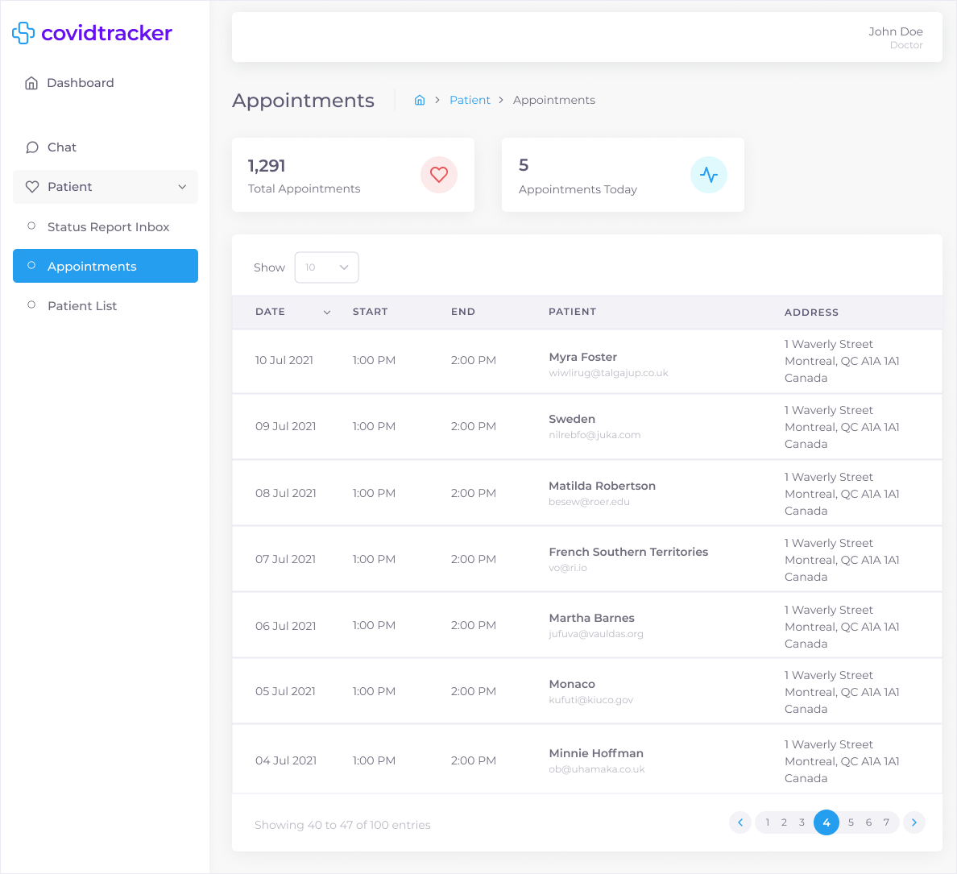

Figure 89: Appointments (Doctor) Desktop & Tablet UI Mockup

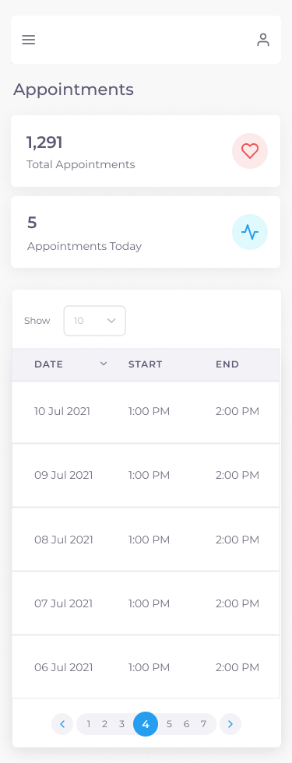

Figure 90: Appointments (Doctor) Mobile UI Mockup

* [UI and User Flow Mockup - Appointments (Patient) / Desktop & Tablet](https://drive.google.com/file/d/1SG3GZ9TzoQWUSbt-HlEDJpKhR1yhVQ3F/view?usp=sharing)
* [UI and User Flow Mockup - Appointments (Patient) / Mobile](https://drive.google.com/file/d/168Ry95elrZZw7upq9mFOKovG4VlYi0_v/view?usp=sharing)
* [▶ Prototype - Appointment (Patient) / Desktop & Tablet](https://www.figma.com/proto/It4nC0bENajBMuQdTviwQG/covidtrack?node-id=1213%3A111065&starting-point-node-id=1213%3A111065&show-proto-sidebar=1)
* [▶ Prototype - Appointments (Patient) / Desktop & Tablet](https://www.figma.com/proto/It4nC0bENajBMuQdTviwQG/covidtrack?node-id=1213%3A111066&starting-point-node-id=1213%3A111066&show-proto-sidebar=1)

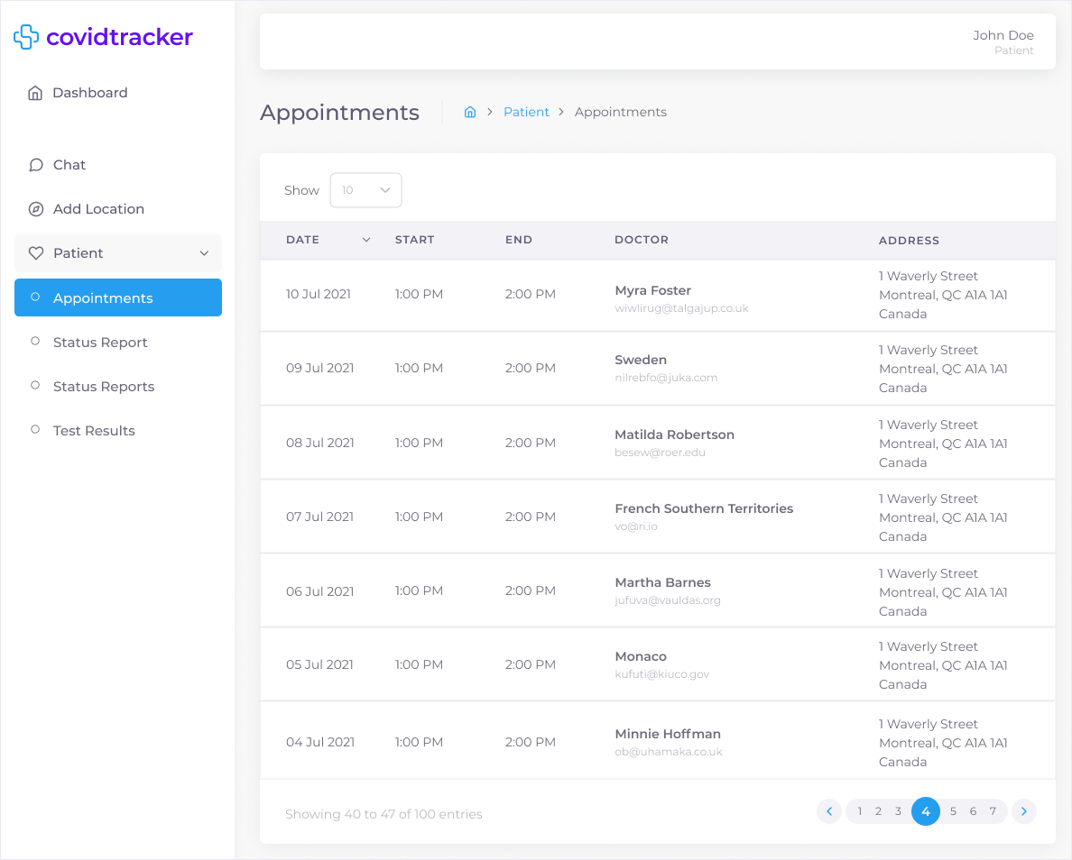

Figure 91: Appointments (Patient) Desktop & Tablet UI Mockup

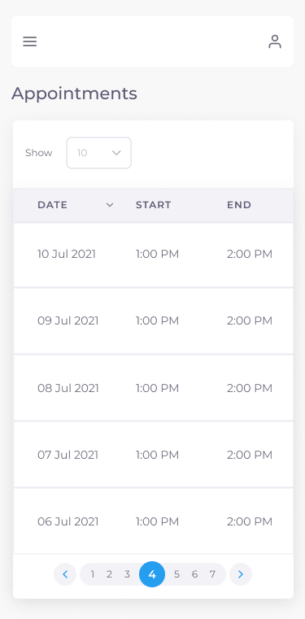

Figure 92: Appointments (Patient) Mobile UI Mockup

### 

### 

### 

### 

### 

### 

### 

### 

### 7.3.19 Add Location

COV-172 - As a Patient, I want to add the locations of where I have been during the day, so that I can be contact traced if I come in contact with someone that has tested positive with COVID-19

A patient and user (not an administrator, doctor, health official or immigration officer) are able to add the locations of where they can be during any given day in order to be contacted by a health official if they have come in contact with someone that has tested positive to COVID-19. The following information must be provided: date, and location. A form was decided as the best course of action for handling contact tracing within the system as compared to GPS or bluetooth for a variety of reasons. The first reason is that, since CovidTracker is a web app, it would be infeasible to ask a user to constantly keep their mobile phone open and on the website whenever in public. Secondly, with the rise of online tracking, people are more aware and concerned about being tracked by websites and apps they use than ever before. This is most evident with the rise in popularity of disabling tracking capabilities in mobile phones. In fact, according to statista, [as of September 2021, the opt-in rate of iOS users worldwide choosing to allow app tracking after iOS 14.5 update is 21%](https://www.statista.com/statistics/1234634/app-tracking-transparency-opt-in-rate-worldwide/). Meaning, 79% of iOS users worldwide are choosing to not be tracked by the apps they use. Lastly, implementing GPS or bluetooth functionality is extremely difficult and as such would take months of planning, development and testing to get it right from a functionality and privacy perspective. Therefore, given these reasons it was decided that having users fill up a form each time they leave their homes would be the best course of action for implementing contact tracing. While there is no way of ensuring all users will fill up the form each time they are in public, an assumption is being made that they will. The UI is only accessible by the Patient persona and users and does not adjust based on persona. A selection of UI mockups for desktop, tablet, and mobile can be seen in Figures 93 and 94 for the Patient person and users. All UI mockups, user flows and associated interactive prototypes for desktop, tablet and mobile platforms are accessible at the following links:

* [UI and User Flow Mockup - Add Location / Desktop & Tablet](https://drive.google.com/file/d/1kRn7co3Ozu0h-4yscWlemR1_GEoVyuKS/view?usp=sharing)
* [UI and User Flow Mockup - Add Location / Mobile](https://drive.google.com/file/d/1oWHjebG4gUDUbd2tpq4K4XbnAgjhqPGm/view?usp=sharing)
* [▶ Prototype - Add Location / Desktop & Tablet](https://www.figma.com/proto/It4nC0bENajBMuQdTviwQG/covidtrack?node-id=1205%3A242270&starting-point-node-id=1205%3A242270&show-proto-sidebar=1)
* [▶ Prototype - Add Location / Mobile](https://www.figma.com/proto/It4nC0bENajBMuQdTviwQG/covidtrack?node-id=1205%3A242271&starting-point-node-id=1205%3A242271&show-proto-sidebar=1)

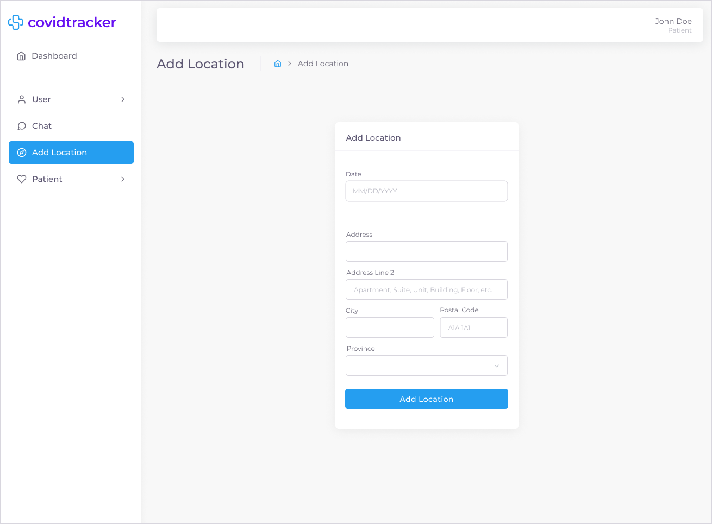

Figure 93: Add Location Desktop & Tablet UI Mockup

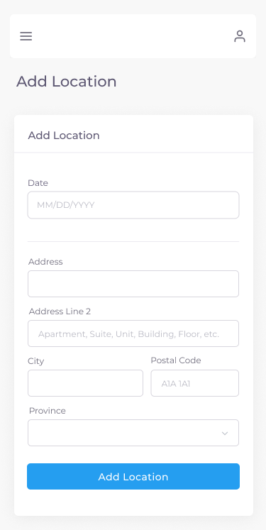

Figure 94: Add Location Desktop & Tablet UI Mockup

### 7.3.20 Contact Tracing

COV-171 - As a Health Official, I want to view a list of all patients who have tested positive in the last [x] days, so that I can contract trace them

A health official is able to view a table containing all patients that have tested positive for COVID-19. A health official is able to filter the result date (date patient tested positive) either by a range or single dates. A health official can also see all the individuals the patient has been in contact with over a period of time in order to begin the contact tracing process by clicking the “contacts” (multiple users) icon under the “Contacts” column. The UI is only accessible by the Health Official persona and does not adjust based on persona. A selection of UI mockups for desktop, tablet, and mobile can be seen in Figures 95 and 96 for the Patient person and users. All UI mockups, user flows and associated interactive prototypes for desktop, tablet and mobile platforms are accessible at the following links:

* [UI and User Flow Mockup - Contact Tracing / Desktop & Tablet](https://drive.google.com/file/d/1sFtVZ7vGhQPVOu46sVUEXKyTqaTQ5wFk/view?usp=sharing)
* [UI and User Flow Mockup - Contact Tracing / Mobile](https://drive.google.com/file/d/1mVJk3tpD6tW2yxE5Ld6z2yIyzlkcmx4f/view?usp=sharing)
* [▶ Prototype - Contact Tracing / Desktop & Tablet](https://www.figma.com/proto/It4nC0bENajBMuQdTviwQG/covidtrack?node-id=1213%3A76800&starting-point-node-id=1213%3A76800&show-proto-sidebar=1)
* [▶ Prototype - Contact Tracing / Mobile](https://www.figma.com/proto/It4nC0bENajBMuQdTviwQG/covidtrack?node-id=1213%3A76801&starting-point-node-id=1213%3A76801&show-proto-sidebar=1)

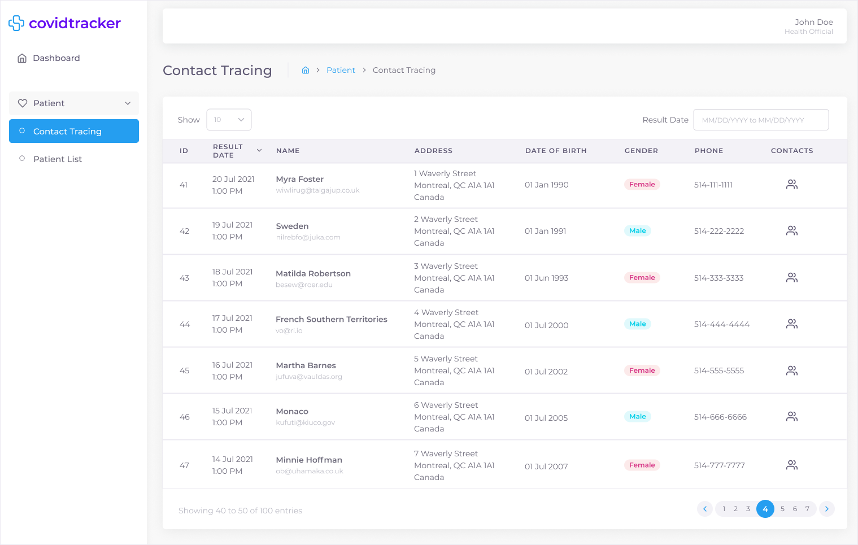

Figure 95: Contact Tracing Desktop & Tablet UI Mockup

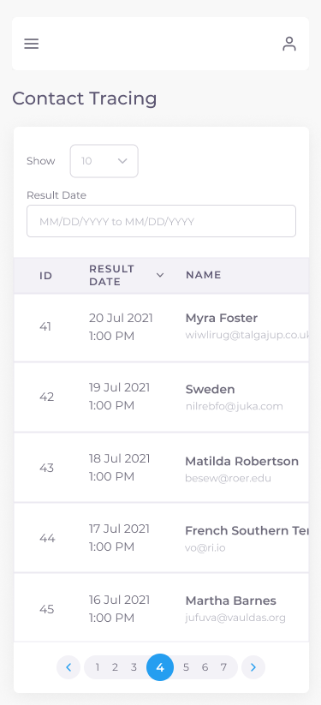

Figure 96: Contact Tracing Mobile UI Mockup

### 7.3.21 Contact Tracing Contacts

COV-126 - As a Health Official, I want to contact trace who a Patient has been in contact with in the last [x] days, so that I can manage who is at risk

A health official is able to view a table containing all individuals that have been in contact with a specific person that has tested positive for COVID-19. This page can be accessed from the Contact Tracing page by selecting the “contacts” (multiple users) icon found under the “Contacts” as described in section 7.3.20 Contact Tracing. Similar to the Contact Tracing page, a health official is able to filter the contact date either by a range of single dates. A health official is subsequently able to notify those individuals that have been in contact with the positive patient by clicking the “send” icon under the “Notify” column. Once the notification is successfully sent, a toast confirmation is displayed on the screen. The UI is only accessible by the Health Official persona and does not adjust based on persona. A selection of UI mockups for desktop, tablet, and mobile can be seen in Figures 97 and 98 for the Patient person and users. All UI mockups, user flows and associated interactive prototypes for desktop, tablet and mobile platforms are accessible at the following links:

* [UI and User Flow Mockup - Contact Tracing Contacts / Desktop & Tablet](https://drive.google.com/file/d/1bkrAtg1xKPnHkX47BXlkjJ7vgfQIsnhT/view?usp=sharing)
* [UI and User Flow Mockup - Contact Tracing Contacts / Mobile](https://drive.google.com/file/d/1LUSZNuFHgJWkDYqKD-W_BPS-IybURBkH/view?usp=sharing)
* [▶ Prototype - Contact Tracing Contacts / Desktop & Tablet](https://www.figma.com/proto/It4nC0bENajBMuQdTviwQG/covidtrack?node-id=902%3A63594&starting-point-node-id=902%3A63594&show-proto-sidebar=1)
* [▶ Prototype - Contact Tracing Contacts / Mobile](https://www.figma.com/proto/It4nC0bENajBMuQdTviwQG/covidtrack?node-id=902%3A63382&starting-point-node-id=902%3A63382&show-proto-sidebar=1)

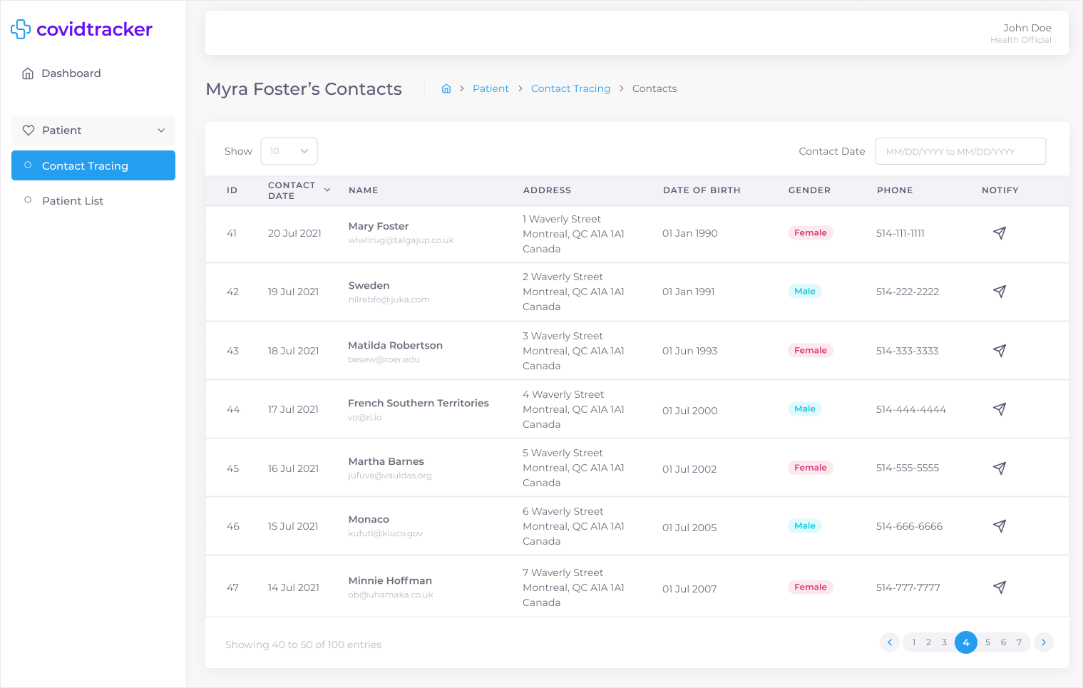

Figure 97: Contact Tracing Desktop & Tablet UI Mockup

# 

Figure 98: Contact Tracing Mobile UI Mockup

### 7.3.22 Dashboard

COV-125 - As a User, I want to a dashboard personalized for my role, so I can have an overview of the system

The dashboard allows users (i.e., without an assigned role), administrators, doctors, health officials, patients, and immigration officers to view an overview of various COVID-19 information, daily tasks, and personalized information. As such the UI adjusts based on each persona. All personas are able to view at a glance COVID-19 related information such as total cases, active cases, new cases for the day, total and new cases over time and cases by age. Information specific to the administrator persona is a patient summary (total patients in the system, and patients per doctor). Information specific to the doctor persona is a patient summary (total patients assigned, and newly assigned patients for the day), daily tasks (scheduled appointments, and unread status reports), and a primary & secondary symptoms chart of all symptoms submitted by patients through their daily status reports. Likewise, the health official persona has similar information such as a patient summary and a primary & secondary symptoms chart of all patients in the system. The immigration officer persona has a patient summary of all patients in the system. Information specific to the patient persona is a daily task summary (scheduled appointments, and number of status reports to submit). A selection of UI mockups for desktop, tablet, and mobile can be seen in Figures 99 and 100 for a User (i.e., without an assigned role), Figures 101 and 102 for an Administrator persona, Figures 103 and 104 for a Doctor persona, Figures 105 and 106 for a Health Official persona, Figures 107 and 108 for a Patient persona, and Figures 109 and 110 for an Immigration Officer persona. All UI mockups, user flows and associated interactive prototypes for desktop, tablet and mobile platforms are accessible at the following links:

* [UI and User Flow Mockup - Dashboard (User) / Desktop & Tablet](https://drive.google.com/file/d/1gz9Q73llAFWxUzgFqVB5ljK0iWO-7UlC/view?usp=sharing)
* [UI and User Flow Mockup - Dashboard (User) / Mobile](https://drive.google.com/file/d/1KVCldS0ecmpiPZ9vZSshtF7m4TRo94WT/view?usp=sharing)
* [▶ Prototype - Dashboard (User) / Desktop & Tablet](https://www.figma.com/proto/It4nC0bENajBMuQdTviwQG/covidtrack?node-id=1201%3A66068&starting-point-node-id=1201%3A66068&show-proto-sidebar=1)
* [▶ Prototype - Dashboard (User) / Mobile](https://www.figma.com/proto/It4nC0bENajBMuQdTviwQG/covidtrack?node-id=1201%3A66178&starting-point-node-id=1201%3A66178&show-proto-sidebar=1)

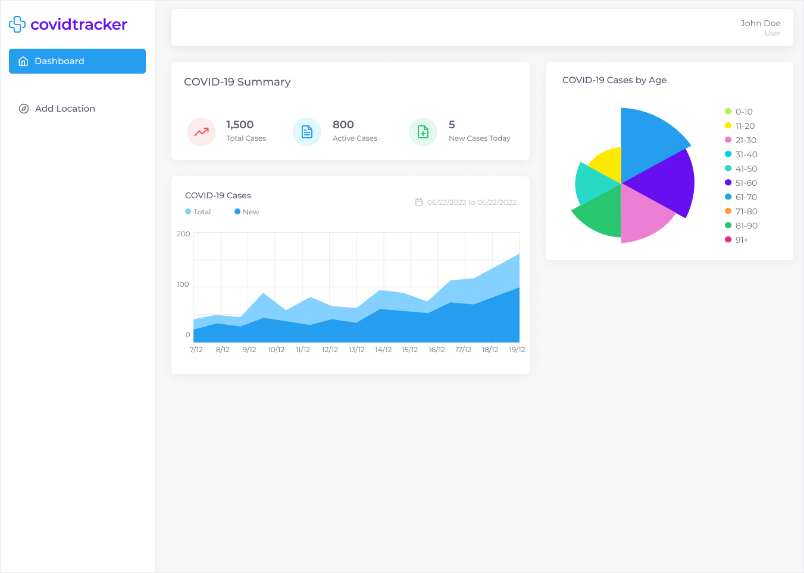

Figure 99: Dashboard (User) Desktop & Tablet UI Mockup

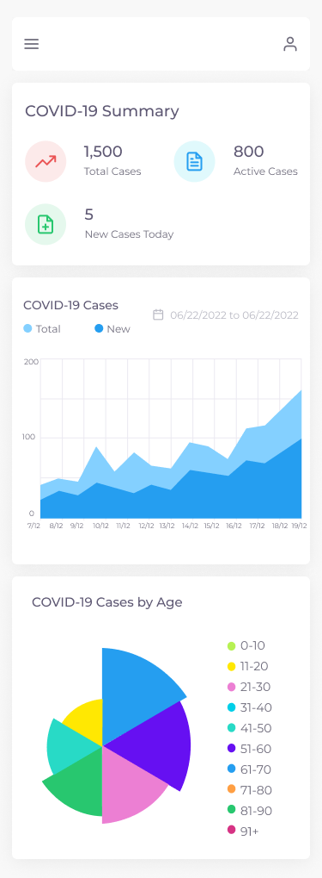

Figure 100: Dashboard (User) Mobile UI Mockup

* [UI and User Flow Mockup - Dashboard (Administrator) / Desktop & Tablet](https://drive.google.com/file/d/1VRMAjyeUrV0ZhM3Za0cIap5MKvQmE_X7/view?usp=sharing)
* [UI and User Flow Mockup - Dashboard (Administrator) / Mobile](https://drive.google.com/file/d/1S6OmPGdejfwqfzlGrfp3iEiSAG3f7hR6/view?usp=sharing)
* [▶ Prototype - Dashboard (Administrator) / Desktop & Tablet](https://www.figma.com/proto/It4nC0bENajBMuQdTviwQG/covidtrack?node-id=1201%3A65503&starting-point-node-id=1201%3A65503&show-proto-sidebar=1)
* [▶ Prototype - Dashboard (Administrator) / Mobile](https://www.figma.com/proto/It4nC0bENajBMuQdTviwQG/covidtrack?node-id=1201%3A65650&starting-point-node-id=1201%3A65650&show-proto-sidebar=1)

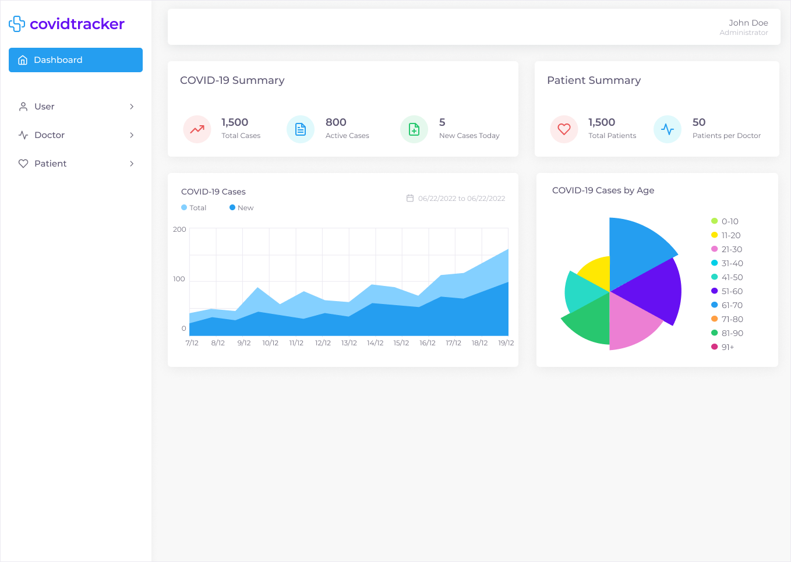

Figure 101: Dashboard (Administrator) Desktop & Tablet UI Mockup

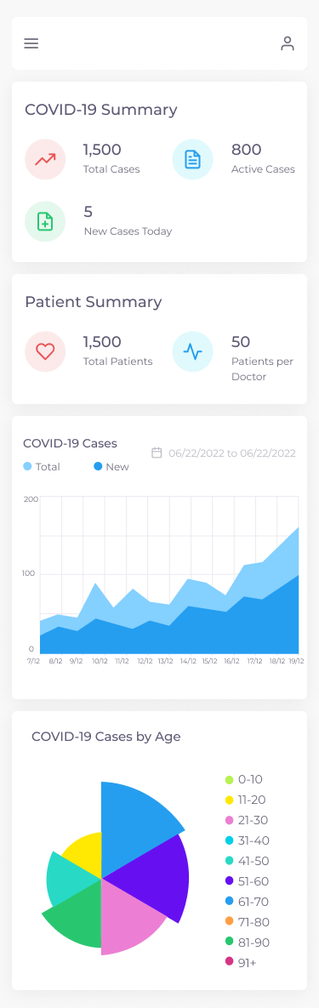

Figure 102: Dashboard (Administrator) Mobile UI Mockup

* [UI and User Flow Mockup - Dashboard (Doctor) / Desktop & Tablet](https://drive.google.com/file/d/1D26vQRdz_GC11x7Lgj8moZty8sIYqOM0/view?usp=sharing)
* [UI and User Flow Mockup - Dashboard (Doctor) / Mobile](https://drive.google.com/file/d/1ERwGyZoswxVfNzWPBHH89fN25tICpjCQ/view?usp=sharing)
* [▶ Prototype - Dashboard (Doctor) / Desktop & Tablet](https://www.figma.com/proto/It4nC0bENajBMuQdTviwQG/covidtrack?node-id=1201%3A65651&starting-point-node-id=1201%3A65651&show-proto-sidebar=1)
* [▶ Prototype - Dashboard (Doctor) / Mobile](https://www.figma.com/proto/It4nC0bENajBMuQdTviwQG/covidtrack?node-id=1201%3A65802&starting-point-node-id=1201%3A65802&show-proto-sidebar=1)

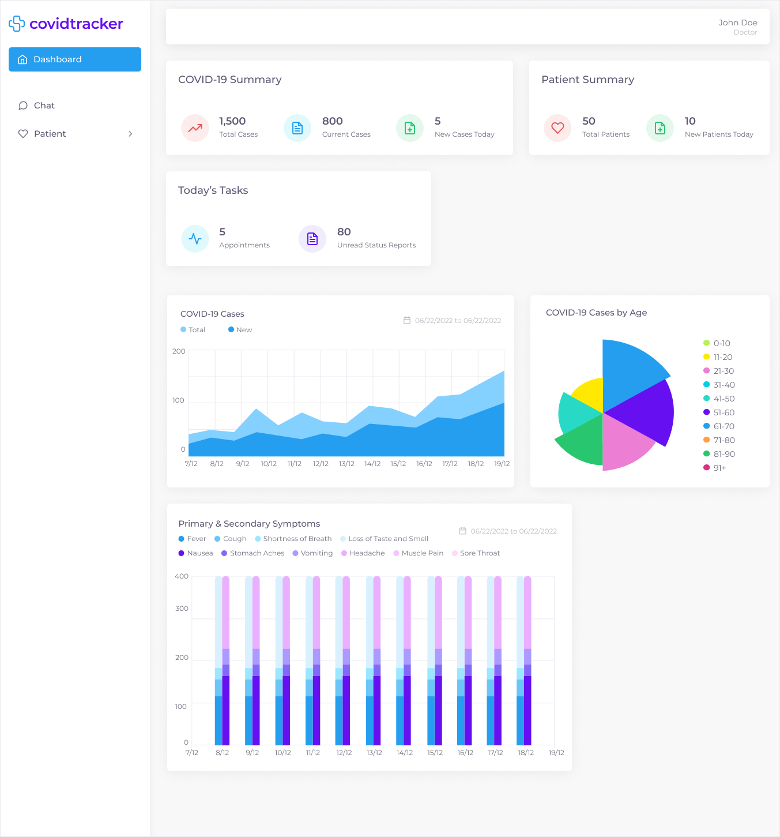

Figure 103: Dashboard (Doctor) Desktop & Tablet UI Mockup

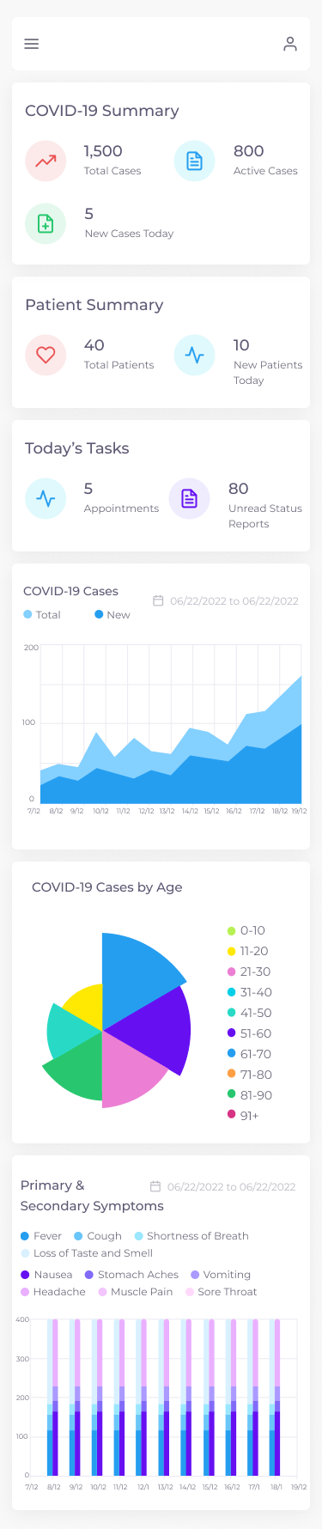

Figure 104: Dashboard (Doctor) Mobile UI Mockup

* [UI and User Flow Mockup - Dashboard (Health Official) / Desktop & Tablet](https://drive.google.com/file/d/1Ui4iDZz2TSsfyH8BTFDx9VZ5fZ1qiUmh/view?usp=sharing)
* [UI and User Flow Mockup - Dashboard (Health Official) / Mobile](https://drive.google.com/file/d/1hlW6WH4pacg9oHXpKX-G0lbGJNrvBrWi/view?usp=sharing)
* [▶ Prototype - Dashboard (Health Official) / Desktop & Tablet](https://www.figma.com/proto/It4nC0bENajBMuQdTviwQG/covidtrack?node-id=1201%3A65948&starting-point-node-id=1201%3A65948&show-proto-sidebar=1)
* [▶ Prototype - Dashboard (Health Official) / Mobile](https://www.figma.com/proto/It4nC0bENajBMuQdTviwQG/covidtrack?node-id=1201%3A66067&starting-point-node-id=1201%3A66067&show-proto-sidebar=1)

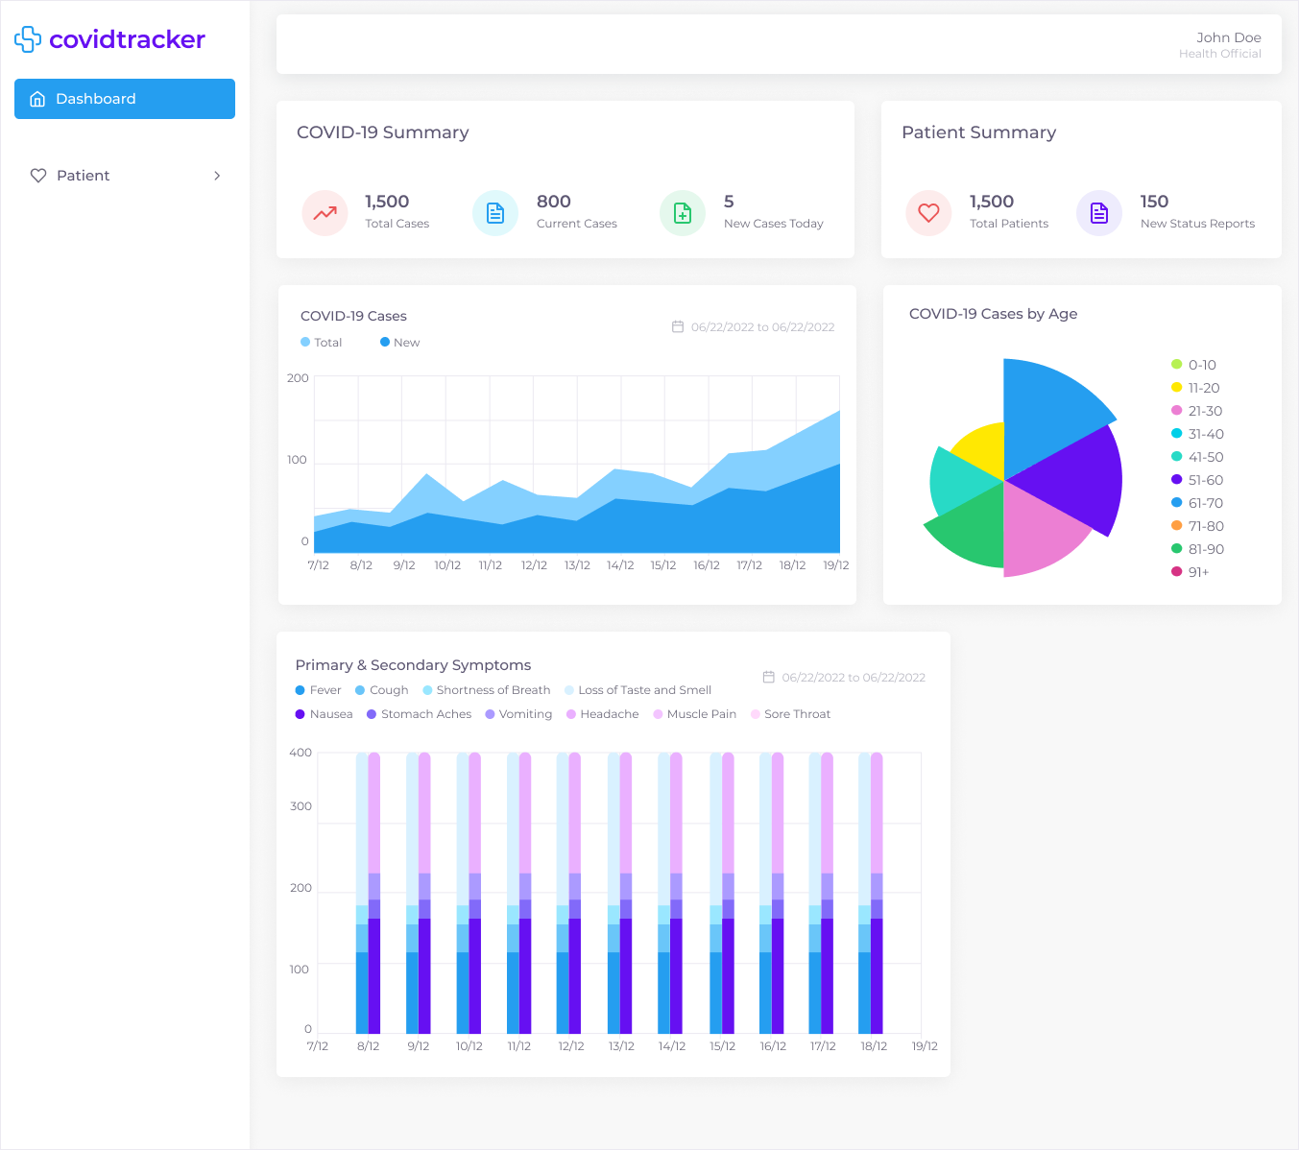

Figure 105: Dashboard (Health Official) Desktop & Tablet UI Mockup

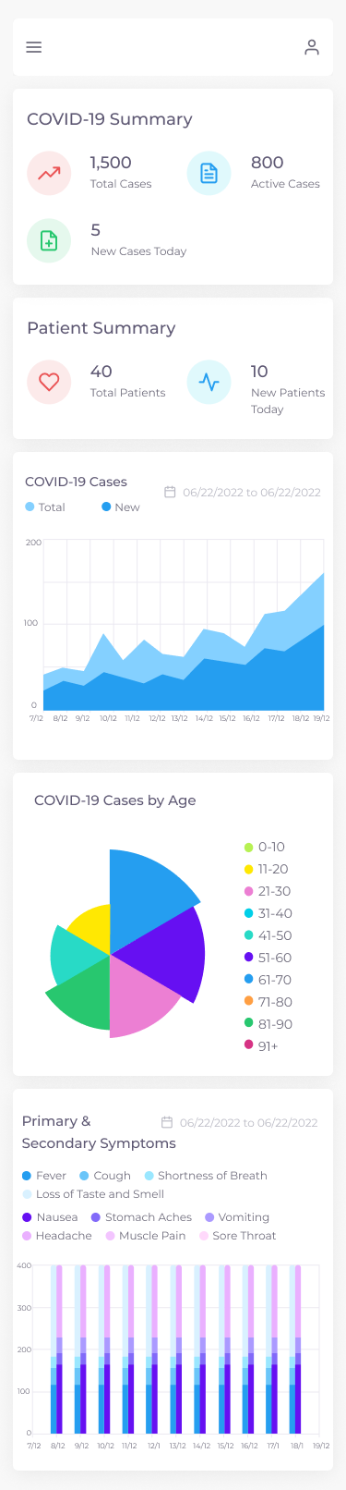

Figure 106: Dashboard (Health Official) Mobile UI Mockup

* [UI and User Flow Mockup - Dashboard (Patient) / Desktop & Tablet](https://drive.google.com/file/d/1yTAEnNkCNFlbNwdWOXgOK5g3jujPFeTy/view?usp=sharing)
* [UI and User Flow Mockup - Dashboard (Patient) / Mobile](https://drive.google.com/file/d/1gJKXiieTRRUs0Z8vSFb9rtqJqIFlpbH4/view?usp=sharing)
* [▶ Prototype - Dashboard (Patient) / Desktop & Tablet](https://www.figma.com/proto/It4nC0bENajBMuQdTviwQG/covidtrack?node-id=1201%3A65803&starting-point-node-id=1201%3A65803&show-proto-sidebar=1)
* [▶ Prototype - Dashboard (Patient) / Mobile](https://www.figma.com/proto/It4nC0bENajBMuQdTviwQG/covidtrack?node-id=1201%3A65947&starting-point-node-id=1201%3A65947&show-proto-sidebar=1)

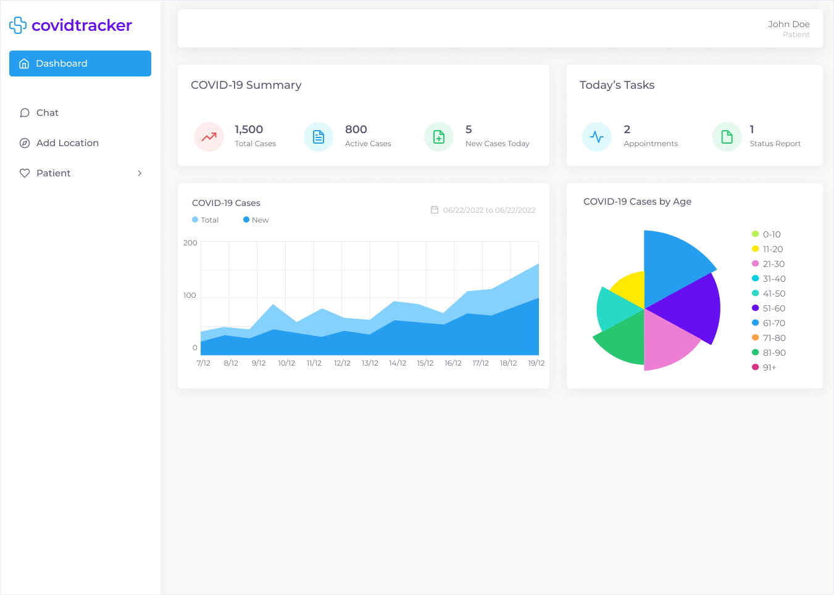

Figure 107: Dashboard (Patient) Desktop & Tablet UI Mockup

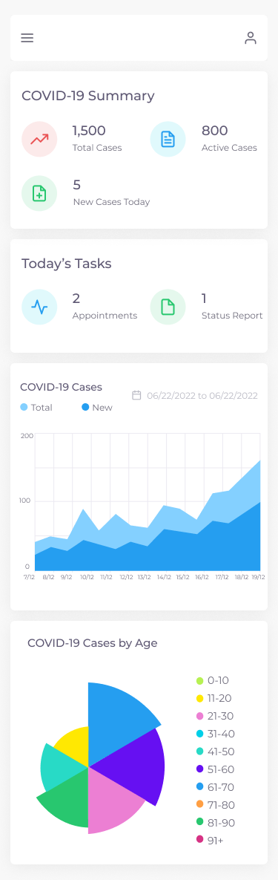

Figure 108: Dashboard (Patient) Mobile UI Mockup

* [UI and User Flow Mockup - Dashboard (Immigration Officer) / Desktop & Tablet](https://drive.google.com/file/d/1YYMMSHLn9fyaIzzJy59E91Ynsspggqvo/view?usp=sharing)
* [UI and User Flow Mockup - Dashboard (Immigration Officer) / Mobile](https://drive.google.com/file/d/1zuFDcK0st-BfaQw7ThNe8kG1YuS62qPx/view?usp=sharing)
* [▶ Prototype - Dashboard (Immigration Officer) / Desktop & Tablet](https://www.figma.com/proto/It4nC0bENajBMuQdTviwQG/covidtrack?node-id=1201%3A66179&starting-point-node-id=1201%3A66179&show-proto-sidebar=1)
* [▶ Prototype - Dashboard (Immigration Officer) / Mobile](https://www.figma.com/proto/It4nC0bENajBMuQdTviwQG/covidtrack?node-id=1201%3A66289&starting-point-node-id=1201%3A66289&show-proto-sidebar=1)

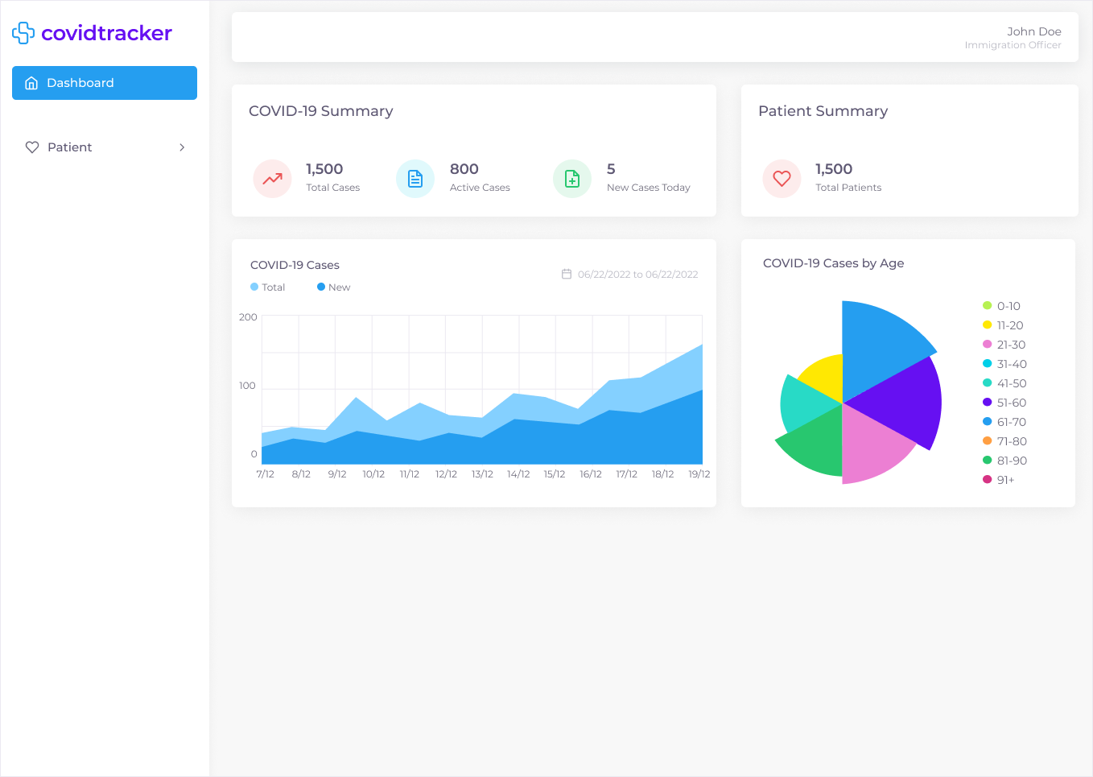

Figure 109: Dashboard (Immigration Officer) Desktop & Tablet UI Mockup

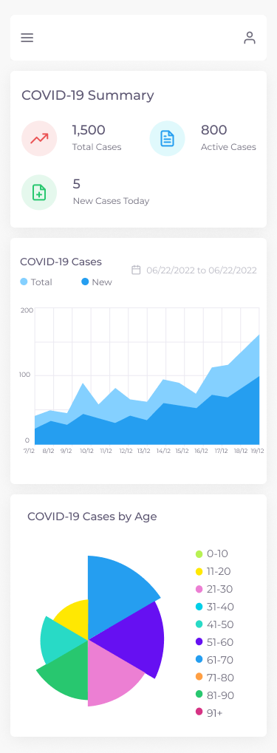

Figure 110: Dashboard (Immigration Officer) Mobile UI Mockup

# 8.0 TESTING PLAN AND REPORT

## 8.1 Unit Tests

### 8.1.1 Client

Unit tests for the client are automated tests that are run through the CI/CD pipeline on every pull request and commit on the main branch. These tests can be run using the command `npm run test`. We will also be using snapshot testing which will render our front end javascript into HTML and save it in a file. We can then compare it later to make sure no unintended changes were made to the rendered HTML.

All unit tests, including snapshot tests, for the front end will be using the Jest testing framework. We chose this framework because it has the best support for snapshot testing which is the primary way we will be unit testing front end components.

### 8.1.2 Server

Unit tests for the server are automated tests that are run through the CI/CD pipeline on every pull request and commit on the main branch. These tests can be run using the command `npm run test:unit`.

All unit tests for the server will be using the mocha testing framework and the sinon library to generate spies, mocks, fakes, and stubs. We chose mocha because it has the best support for TypeScript testing suites and integrates well with chai - our assertion library - and sinon which allows us to creates spies, mocks, fakes, and stubs extremely easy so there is little to no boilerplate required when writing unit tests.

A generated unit test report of the system is depicted in the following figure.

## 

## 8.2 Integration Tests

### 8.2.1 Client

Integration tests for the client are automated tests that are run through the CI/CD pipeline on every pull request and commit on the main branch. These tests can be run using the command `npm run test`. All integration tests for the front end will be using the Jest testing framework. We chose Jest for the same reasons mentioned in the above section.

These tests use a mock API that returns mock server responses to test the integration between all the client side code and the server API.

### 8.2.2 Server

Integration tests for the server are automated tests that are run through the CI/CD pipeline on every pull request and commit on the main branch. These tests can be run using the command `npm run test:integration`.

All integration tests for the server will be using the mocha testing framework and supertest in order to create a callable instance of our web server. We chose to use supertest because it provides the easiest integration with our web framework library.

These tests use a database to test the integration between all the server side code and the database implementation.

## 8.3 Acceptance Tests

Acceptance tests will be documented and run manually to show an entire flow of the application. These tests will use the client to interface with the server which will persist the data in the database. All these tests will be based on the user stories to ensure that all user flows work as specified by the requirements.

These tests can be automated using a tool like Selenium in order to mock a real user interacting with the full system. The acceptance tests are also written in Gherkin Syntax which is a behavioral driven development syntax that allows us to define our tests in terms of user state and behavior.

Below are the current acceptance tests for the system.

| **AT-1** | **COV-42 - As a User, I was to be able to sign up, so that I can access the apps features** | | |
| --- | --- | --- | --- |
| **Preconditions** | New user without an account is accessing the website | | |
| **Acceptance Criteria** | | **Expected Result** | **Input Data** |
| GIVEN I am on the sign up page | | Sign up page should be displayed |  |
| AND I input all required fields with valid data on the Personal page | | No form errors should be displayed | - First name  - Last name  - Phone  - Gender  - Date of birth  - Address  - City  - Postal Code  - Province |
| AND I click the Next button | | The Account page of the Sign Up form should be shown |  |
| AND I input all required fields with valid data on the Account page | | No form errors should be displayed | - Email  - Password  - Confirm Password |
| WHEN I click the Sign Up button | |  |
| THEN my account should be created | |  |  |
| AND I should be logged in | |  |  |
| AND I should be redirected to the main screen. | |  |  |
| **Result** | **PASS** | | |

Table 8: Acceptance Test for COV-42

| **AT-2** | **COV-48 - As a User, I want to be able to sign in, so that I can access my account** | | |
| --- | --- | --- | --- |
| **Preconditions** | New user with an account is accessing the website | | |
| **Acceptance Criteria** | | **Expected Result** | **Input Data** |
| GIVEN that I am on the sign in page | | Sign in page should be displayed |  |
| AND that I input my valid email | | No form errors should be displayed | email: doctor@test.com |
| AND that I input my valid password | | password:  Test123! |
| WHEN I click the Sign In button | |  |
| THEN I should be logged into the site | |  |  |
| AND my session should persist | |  |  |
| AND I should be redirected to the main screen | |  |  |
| **Result** | **PASS** | | |

Table 9: Acceptance Test for COV-48

| **AT-3** | **COV-52 -As a User, I want to be able to sign out so, that I can delete my session** | | |
| --- | --- | --- | --- |
| **Preconditions** | User is logged in on the site | | |
| **Acceptance Criteria** | | **Expected Result** | **Input Data** |
| GIVEN that I am on a page with a navbar | | Navbar should be displayed |  |
| AND that I am signed in | | User info should be displayed on the top right of the webpage |  |
| WHEN I click the Sign Out button | |  |  |
| THEN I should be logged out of the site | |  |  |
| AND my session should be deleted | |  |  |
| AND I should be redirected to the sign in page | |  |  |
| **Result** | **PASS** | | |

Table 10: Acceptance Test for COV-52

| **AT-4** | **COV-85 - As an Administrator, I want to assign a role to a User, so that I can manage access rights** | | |
| --- | --- | --- | --- |
| **Preconditions** | User is logged in on the site as an admin | | |
| **Acceptance Criteria** | | **Expected Result** | **Input Data** |
| GIVEN that I am on the assign role page | | Assign role page should be displayed |  |
| AND that I am signed in as an admin | | User info should be displayed on the top right of the webpage |  |
| AND I inputted a valid user id that has no current role | | No form errors should be displayed | userId: 1 |
| AND I selected a role from the dropdown | | role: PATIENT |
| WHEN I click the “Add a Role” button | |  |
| THEN the role should be assigned to the user | |  |  |
| AND I should receive a confirmation of my action | | Should see a green confirmation message at the top right of the screen |  |
| **Result** | **PASS** | | |

Table 11: Acceptance Test for COV-85

| **AT-5** | **COV-26 - As an Administrator, I want to assign a Patient to a Doctor, so that I can manage the Patients** | | |
| --- | --- | --- | --- |
| **Preconditions** | User is logged in on the site as an admin | | |
| **Acceptance Criteria** | | **Expected Result** | **Input Data** |
| GIVEN that I am on the assign doctor page | | Assign doctor page should be displayed |  |
| AND that I am signed in as an admin | | User info should be displayed on the top right of the webpage |  |
| AND I input a valid patient id that has no doctor assigned | | No form errors should be displayed | patientId: 2 |
| AND I input a valid doctorId | | doctorId: 5 |
| WHEN I click the “Assign a Patient” button | |  |
| THEN the patient should be assigned to the doctor | |  |  |
| AND I should receive a confirmation of my action | | Should see a green confirmation message at the top right of the screen |  |
| **Result** | **PASS** | | |

Table 12: Acceptance Test for COV-26

| **AT-6** | **COV-95 - As a Doctor, I want to define the status report fields for my Patients, so I can properly track them** | | |
| --- | --- | --- | --- |
| **Preconditions** | User is logged in on the site as a doctor | | |
| **Acceptance Criteria** | | **Expected Result** | **Input Data** |
| GIVEN that I am on the define status report fields page | | Assign doctor page should be displayed |  |
| AND that I am signed in as a doctor | | User info should be displayed on the top right of the webpage |  |
| AND I inputted a valid patient id that is assigned to the doctor | | No form errors should be displayed | patient: 3 |
| AND I selected the fields to assign | | - Fever  - Cough  - Nausea |
| WHEN I click the “Define Status Report” button | |  |
| THEN the patient should be assigned the status report fields | |  |  |
| AND I should receive a confirmation of my action. | | Should see a green confirmation message at the top right of the screen |  |
| **Result** | **PASS** | | |

Table 13: Acceptance Test for COV-95

| **AT-7** | **COV-25 - As a Patient, I want to submit my status, so that I can keep my Doctor updated** | | |
| --- | --- | --- | --- |
| **Preconditions** | User is logged in on the site as a patient | | |
| **Acceptance Criteria** | | **Expected Result** | **Input Data** |
| GIVEN that I am on the submit status page | | Submit status page should be displayed |  |
| AND that I am signed in as a patient | | User info should be displayed on the top right of the webpage |  |
| AND I inputted the required fields | | No form errors should be displayed | - temperature  - weight  - other symptoms |
| WHEN I click the “Submit” button | |  |
| THEN the my status report should be submitted | |  |  |
| AND I should receive a confirmation of my action. | |  |  |
| **Result** | **PASS** | | |

Table 14: Acceptance Test for COV-25

| **AT-8** | **COV-27 - As an Administrator, I want to view the number of Patients assigned to a Doctor, so that no Doctor has too many Patients** | | |
| --- | --- | --- | --- |
| **Preconditions** | User is logged in on the site as an admin | | |
| **Acceptance Criteria** | | **Expected Result** | **Input Data** |
| GIVEN that I am on the view patients count page | | Submit status page should be displayed |  |
| AND that I am signed in as an admin | | User info should be displayed on the top right of the webpage |  |
| THEN I should be able to view the patient count per doctor | |  |  |
| AND the total number of assigned patients | |  |  |
| AND the average number of patients per doctor. | |  |  |
| **Result** | **PASS** | | |

Table 15: Acceptance Test for COV-27

| **AT-9** | **COV-107 - As a Health Official, I want to input COVID test results, so that I can report if a Patient tested positive or negative** | | |
| --- | --- | --- | --- |
| **Preconditions** | User is logged in on the site as a health official | | |
| **Acceptance Criteria** | | **Expected Result** | **Input Data** |
| GIVEN that I am on the submit test result page | | Submit test result page should be displayed |  |
| AND that I am signed in as a health official | | User info should be displayed on the top right of the webpage |  |
| WHEN I input the test result of a patient | | No form errors should be displayed | Test result: POSITIVE  Type of Test: PCR |
| AND the location of the test | | - Address  - City  - Postal Code  - Province |
| AND the date of the test | | Date of Test: select a date |
| THEN the result should be persisted in the database for that patient | |  |  |
| AND I should get a confirmation of my action | |  |  |
| **Result** | **PASS** | | |

Table 16: Acceptance Test for COV-107

| **AT-10** | **COV-112 - As a Patient, I want to view the details of a single status report of a Patient, so that I can view their progress at a point in time** | | |
| --- | --- | --- | --- |
| **Preconditions** | User is logged in on the site as a patient | | |
| **Acceptance Criteria** | | **Expected Result** | **Input Data** |
| GIVEN that I am on the status report details page | | Status report details page should be displayed |  |
| AND that I am signed in as a patient | | User info should be displayed on the top right of the webpage |  |
| AND the status report is mine | | Page should be accessible to user |  |
| THEN I should be able to view the details of the status report. | |  |  |
| **Result** | **PASS** | | |

Table 17: Acceptance Test for COV-112

| **AT-11** | **COV-124 - As a Patient, I want to view the details of a single COVID test result, so that I'm aware of my diagnosis** | | |
| --- | --- | --- | --- |
| **Preconditions** | User is logged in on the site as a patient | | |
| **Acceptance Criteria** | | **Expected Result** | **Input Data** |
| GIVEN that I am on the test result details page | | Test result details page should be displayed |  |
| AND that I am signed in as a patient | | User info should be displayed on the top right of the webpage |  |
| AND the test result is mine | | Page should be accessible to user |  |
| THEN I should be able to view the details of the test result | |  |  |
| **Result** | **PASS** | | |

Table 18: Acceptance Test for COV-124

| **AT-12** | **COV-123 - As a Patient, I want to view all my line item COVID test results, so that I'm aware of my diagnosis** | | |
| --- | --- | --- | --- |
| **Preconditions** | User is logged in on the site as a patient | | |
| **Acceptance Criteria** | | **Expected Result** | **Input Data** |
| GIVEN that I am on the test results page | | Test results page should be displayed |  |
| AND that I am signed in as a patient | | User info should be displayed on the top right of the webpage |  |
| THEN I should be able to view the line item details of my latest results | |  |  |
| AND click into any of them to view more details about a given test results | | User should be redirected to the details page for that test result |  |
| **Result** | **PASS** | | |

Table 19: Acceptance Test for COV-123

| **AT-13** | **COV-111 - As a Patient, I want to view all my line item statuses, so that I can monitor my progress over time** | | |
| --- | --- | --- | --- |
| **Preconditions** | User is logged in on the site as a patient | | |
| **Acceptance Criteria** | | **Expected Result** | **Input Data** |
| GIVEN that I am on the status reports page | | Status reports page should be displayed |  |
| AND that I am signed in as a patient | | User info should be displayed on the top right of the webpage |  |
| THEN I should be able to view the line item details of my status reports | |  |  |
| AND click into any of them to view more details about a given status report | | User should be redirected to the details page for that status report |  |
| **Result** | **PASS** | | |

Table 20: Acceptance Test for COV-111

| **AT-14** | **COV-157 - As a Doctor, I want to view a list of my Patients, so that I can easily navigate to their specific detailed views** | | |
| --- | --- | --- | --- |
| **Preconditions** | User is logged in on the site as a doctor | | |
| **Acceptance Criteria** | | **Expected Result** | **Input Data** |
| GIVEN that I am on the patient list page | | Patient list page should be displayed |  |
| AND that I am signed in as a doctor | | User info should be displayed on the top right of the webpage |  |
| THEN I should be able to view a table of my patients | |  |  |
| AND actions associated to each patient | | The actions button should be clickable displaying the possible actions   * Add Test Result * Test Results * Status Reports |  |
| **Result** | **PASS** | | |

Table 21: Acceptance Test for COV-157

| **AT-15** | **COV-113 - As a Doctor, I want to view a line item list of my patients with their most recent line item status update, so that I can keep track of any updates** | | |
| --- | --- | --- | --- |
| **Preconditions** | User is logged in on the site as a doctor | | |
| **Acceptance Criteria** | | **Expected Result** | **Input Data** |
| GIVEN that I am on the status report inbox page | | Status report inbox page should be displayed |  |
| AND that I am signed in as a doctor | | User info should be displayed on the top right of the webpage |  |
| THEN I should be able to view the line item status reports of all my patients sorted in descending order by date | |  |  |
| **Result** | **PASS** | | |

Table 22: Acceptance Test for COV-113

| **AT-16** | **COV-115 - As a Doctor, I want to mark a Patient's status update as "Reviewed", so that I can see which statuses I've already seen** | | |
| --- | --- | --- | --- |
| **Preconditions** | User is logged in on the site as a doctor and there is at least status not marked as reviewed and there is at least 1 status marked as reviewed | | |
| **Acceptance Criteria** | | **Expected Result** | **Input Data** |
| GIVEN that I am on the status report inbox page | | Status report inbox page should be displayed |  |
| AND that I am signed in as a doctor | | User info should be displayed on the top right of the webpage |  |
| THEN I should be able to mark a status report as reviewed | |  | Mark flag with boolean value isReviewed: false |
| AND I should be able to mark a reviewed status report as unreviewed | |  | Mark flag with boolean value isReviewed: true |
| **Result** | **PASS** | | |

Table 23: Acceptance Test for COV-115

| **AT-17** | **COV-114 - As a Doctor, I want to flag certain patients, so that their updates are prioritized over others** | | |
| --- | --- | --- | --- |
| **Preconditions** | User is logged in on the site as a Doctor | | |
| **Acceptance Criteria** | | **Expected Result** | **Input Data** |
| GIVEN that I am on the patient list page | | The patient list should be displayed |  |
| AND that I am signed in as a doctor | | User info should be displayed at the top of the page |  |
| THEN I should be able to mark a patient as prioritized | | flag should turn red on line item | Mark flag with boolean value isFlaged: true |
| AND I should be able to mark a prioritized patient as unprioritized | | flag should go from red to white on line item | Mark flag with boolean value isFlaged: false |
| **Result** | **PASS** | | |

Table 24: Acceptance Test for COV-114

| **AT-18** | **COV-121 - As a Patient, I want to be able to generate a QR code for a status report, so that I can share it with others** | | |
| --- | --- | --- | --- |
| **Preconditions** | User is logged in on the site as a Patient | | |
| **Acceptance Criteria** | | **Expected Result** | **Input Data** |
| GIVEN that I am on the status report details page | | The status report page should be displayed |  |
| AND that I am signed in as a patient | | User info should be displayed at the top of the page |  |
| AND the test result is mine | |  |  |
| THEN I should be able to view and scan a qr code that can be shared with others which links to the status report page | | should see a qr code on the screen that scans for my test result |  |
| **Result** | **PASS** | | |

Table 25: Acceptance Test for COV-121

| **AT-19** | **COV-122 - As a Patient, I want to be able to generate a QR code for a lab test result, so that I can share it with others** | | |
| --- | --- | --- | --- |
| **Preconditions** | User is logged in on the site as a Patient | | |
| **Acceptance Criteria** | | **Expected Result** | **Input Data** |
| GIVEN that I am on the test result details page | | The status report page should be displayed |  |
| AND that I am signed in as a patient | | User info should be displayed at the top of the page |  |
| AND the test result is mine | |  |  |
| THEN I should be able to view and scan a qr code that can be shared with others which links to the test result page | | should see a qr code on the screen that scans for my test result |  |
| **Result** | **PASS** | | |

Table 26: Acceptance Test for COV-122

| **AT-20** | **COV-108 - As a Patient, I want to update my status for the day after already submitting, so that my Doctor stays up to date** | | |
| --- | --- | --- | --- |
| **Preconditions** | User is logged in on the site as a Patient | | |
| **Acceptance Criteria** | | **Expected Result** | **Input Data** |
| GIVEN that I am on the submit status report page | | The status report page should be displayed |  |
| AND that I am signed in as a patient | | User info should be displayed at the top of the page |  |
| AND I have already submitted a status report in the same calendar day | |  |  |
| WHEN I fill out the form with updated status info | |  | - Fever  - Cough  - Nausea |
| AND click submit | | no form error should be displayed |  |
| THEN my new status should be persisted in the database | |  |  |
| AND the status report should be viewable by my doctor | | Should see a green confirmation message at the top right of the screen |  |
| **Result** | **PASS** | | |

Table 27: Acceptance Test for COV-108

| **AT-21** | **COV-171 - As a Health Official, I want to view a list of all patients who have tested positive in the last [x] days, so that I can contract trace them** | | |
| --- | --- | --- | --- |
| **Preconditions** | User is logged in on the site as a Health Official | | |
| **Acceptance Criteria** | | **Expected Result** | **Input Data** |
| GIVEN that I am on the contact trace page | | The contact trace page should be displayed |  |
| AND that I am signed in as a Health Official | | User info should be displayed at the top of the page |  |
| WHEN I select a date range from the calendar input | | The date range should be displayed in the input | - From (February 1st)  - To (March 1st) |
| THEN the patients who tested positive in that date range should appear | | The positive users should be displayed |  |
| **Result** | **PASS** | | |

Table 28: Acceptance Test for COV-171

| **AT-22** | **COV-119 - As a Patient, I want to direct message my Doctor, so that I can ask them questions** | | |
| --- | --- | --- | --- |
| **Preconditions** | User is logged in on the site as a Patient | | |
| **Acceptance Criteria** | | **Expected Result** | **Input Data** |
| GIVEN that I am on the chat page | | The chat page should be displayed |  |
| AND that I am signed in as a patient | | User info should be displayed at the top of the page |  |
| AND I have been assigned a doctor | | The patients doctor should be displayed as a contact on the left hand panel |  |
| WHEN I input a message | |  | - “Test message text” |
| AND click the send button | | no form error should be displayed |  |
| THEN my message should be sent to my doctor | |  |  |
| AND the message should be visible in my chat page | | Should see the message in the chat with the doctor |  |
| **Result** | **PASS** | | |

Table 29: Acceptance Test for COV-119

| **AT-23** | **COV-116 - As a Doctor, I want to book an appointment with a Patient, so that we can discuss their symptoms** | | |
| --- | --- | --- | --- |
| **Preconditions** | User is logged in on the site as a Doctor | | |
| **Acceptance Criteria** | | **Expected Result** | **Input Data** |
| GIVEN that I am on the create appointment page | | The create appointment page should be displayed |  |
| AND that I am signed in as a Doctor | | User info should be displayed at the top of the page |  |
| WHEN I fill out the form with the appointment info | |  | - Start time (March 1st 1PM)  - End time (March 1st 2PM)  - Address  - City  - Postal Code  - Province |
| AND click submit | | no form error should be displayed |  |
| THEN the appointment should be persisted in the database | | Should see a green confirmation message at the top right of the screen |  |
| AND the patient should receive a notification for the appointment | | The notification will be by text and email to make sure the patient sees the information |  |
| **Result** | **PASS** | | |

Table 30: Acceptance Test for COV-116

| **AT-24** | **COV-172 - As a Patient, I want to add the locations of where I have been during the day, so that I can be contact traced if I come in contact with someone that has tested positive with COVID-19** | | |
| --- | --- | --- | --- |
| **Preconditions** | User is logged in on the site as a Patient | | |
| **Acceptance Criteria** | | **Expected Result** | **Input Data** |
| GIVEN that I am on the location report report page | | The location report page should be displayed |  |
| AND that I am signed in as a patient | | User info should be displayed at the top of the page |  |
| WHEN I fill out the form with a location and select the date | |  | - Date (March 1st)  - Address  - City  - Postal Code  - Province |
| AND click submit | | no form error should be displayed |  |
| THEN my location report should be persisted in the database | |  |  |
| AND I should see a confirmation of my action | | Should see a green confirmation message at the top right of the screen |  |
| **Result** | **PASS** | | |

Table 31: Acceptance Test for COV-172

| **AT-25** | **COV-169 - As a Doctor, I want to view my appointments, so that I can schedule myself** | | |
| --- | --- | --- | --- |
| **Preconditions** | User is logged in on the site as a Doctor | | |
| **Acceptance Criteria** | | **Expected Result** | **Input Data** |
| GIVEN that I am on the view appointments page | | The view appointments page should be displayed |  |
| AND that I am signed in as a Doctor | | User info should be displayed at the top of the page |  |
| AND I have at least 1 appointment booked with a patient | |  |  |
| THEN I should see a list of my appointments with the details | | The list should be sorted by date in descending order so the newest appointments are at the top |  |
| **Result** | **PASS** | | |

Table 32: Acceptance Test for COV-169

| **AT-26** | **COV-126 - As a Health Official, I want to contact trace who a Patient has been in contact with in the last [x] days, so that I can manage who is at risk** | | |
| --- | --- | --- | --- |
| **Preconditions** | User is logged in on the site as a Health Official | | |
| **Acceptance Criteria** | | **Expected Result** | **Input Data** |
| GIVEN that I am on the contact trace page | | The contact trace page should be displayed |  |
| AND that I am signed in as a Health Official | | User info should be displayed at the top of the page |  |
| AND I select a date range from the calendar input | | The date range should be displayed in the input | - From (February 1st)  - To (March 1st) |
| WHEN I click on a patients contact trace button | |  |  |
| THEN I should see a list of patients they have been in contact with | |  |  |
| AND I should be able to adjust the date range for the results | | The list should auto update as the date range is updated so the list is dynamic with the selection | - From (February 1st)  - To (March 1st) |
| **Result** | **PASS** | | |

Table 33: Acceptance Test for COV-126

| **AT-27** | **COV-120 - As a Patient, I want to mark my message with a priority level, so that my Doctor will view it quicker** | | |
| --- | --- | --- | --- |
| **Preconditions** | User is logged in on the site as a Patient | | |
| **Acceptance Criteria** | | **Expected Result** | **Input Data** |
| GIVEN that I am on the chat page | | The chat page should be displayed |  |
| AND that I am signed in as a patient | | User info should be displayed at the top of the page |  |
| AND I have been assigned a doctor | | The patients doctor should be displayed as a contact on the left hand panel |  |
| WHEN I input a message | |  | - “Test message text” |
| AND mark the message as priority | | Priority flag should turn red when checked | - Check priority flag |
| AND click the send button | | no form error should be displayed |  |
| THEN my message should be sent to my doctor | | The message text should display as red |  |
| AND the message should be visible in my chat page | | Should see the message in the chat with the doctor |  |
| **Result** | **PASS** | | |

Table 34: Acceptance Test for COV-120

| **AT-28** | **COV-222 - As a Doctor, I want to define status report fields from the patient list page** | | |
| --- | --- | --- | --- |
| **Preconditions** | User is logged in on the site as a Doctor | | |
| **Acceptance Criteria** | | **Expected Result** | **Input Data** |
| GIVEN that I am on the patient list page | | The patient list page should be displayed |  |
| AND that I am signed in as a Doctor | | User info should be displayed at the top of the page |  |
| WHEN I click on the action items | |  |  |
| AND select define status fields | | The browser will redirect to the define status report fields page for that patients |  |
| THEN I should be able to define the status report fields for that patient without inputting the patientId | | Should be able to define the status report fields for that patient directly without inputting the patientId as normal |  |
| **Result** | **PASS** | | |

Table 35: Acceptance Test for COV-222

| **AT-29** | **COV-223 - As an Immigration Officer, I want to view the patients list, so I can be aware of test results and prioritize them** | | |
| --- | --- | --- | --- |
| **Preconditions** | User is logged in on the site as an Immigration Officer | | |
| **Acceptance Criteria** | | **Expected Result** | **Input Data** |
| GIVEN that I am on the patient list page | | The patient list page should be displayed |  |
| AND that I am signed in as a Immigration Officer | | User info should be displayed at the top of the page |  |
| THEN I should see limited patient information | |  |  |
| AND limited action items for each patient | | The Immigration Officer should only see a list of the patients test results |  |
| **Result** | **PASS** | | |

Table 36: Acceptance Test for COV-223

| **AT-30** | **COV-125 - As a User, I want to a dashboard personalized for my role, so I can have an overview of the system** | | |
| --- | --- | --- | --- |
| **Preconditions** | User is logged in on the site as a User | | |
| **Acceptance Criteria** | | **Expected Result** | **Input Data** |
| GIVEN that I am on the dashboard page | | The dashboard page should be displayed |  |
| AND that I am signed in as a User | | User info should be displayed at the top of the page |  |
| THEN personalized dashboard should be displayed | | Dashboard should only contain information the user is allowed to see |  |
| AND the summary widgets should be displayed | | Should see at least 2 personalized summary widgets |  |
| AND the chart widgets should be displayed | | Should see at least 2 chart widgets |  |
| **Result** | **PASS** | | |

Table 37: Acceptance Test for COV-125

## 8.4 System Tests

System tests will be documented and run manually to show an entire flow of the application. These tests will use the client to interface with the server which will persist the data in the database. All these tests will be based on the user stories to ensure that all user flows work as specified by the requirements

These tests can be automated using a tool like Selenium in order to mock a real user interacting with the full system.

Below are the current system tests for the system.

| **ST-1** | **COV-42 - As a User, I was to be able to sign up, so that I can access the apps features** | |
| --- | --- | --- |
| **Steps to reproduce** | **Expected output for each step** | **Input Data** |
| 1. Navigate to the sign up page (relative url “/sign_up”) 2. Fill all required fields with valid inputs 3. Click the Sign Up Button | 1. You should see the sign up page 2. The form should not give any input errors 3. The form should not give any input errors, your account should be created, you should be signed in, and you should be redirected to the main screen | 2.  First name  Last name  Phone  Gender  Date of birth  Address  City  Postal Code  Province  3.  Email  Password  Confirm Password |
| **Result** | **PASS** | |

Table 38: System Test for COV-42

| **ST-2** | **COV-48 - As a User I want to be able to sign in, so that I can access my account** | |
| --- | --- | --- |
| **Steps to reproduce** | **Expected output for each step** | **Input Data** |
| 1. Navigate to the sign in page (relative url “/sign_in”) 2. Input your email and password 3. Click the Sign In Button | 1. You should see the sign in page 2. The form should not give any input errors 3. The form should not give any input errors, you should be signed in, and you should be redirected to the main screen | 2.  email: [doctor@test.com](mailto:doctor@test.com)  password: Test123! |
| **Result** | **PASS** | |

Table 39: System Test for COV-48

| **ST-3** | **COV-52 - As a User I want to be able to sign out, so that I can delete my session** | |
| --- | --- | --- |
| **Steps to reproduce** | **Expected output for each step** | **Input Data** |
| 1. Navigate to a page where the navbar can be seen 2. Click the Sign Out Button | 1. You should see the sign out button in the navbar 2. You should be signed out, your session should be deleted, and you should be redirected to the Sign In page |  |
| **Result** | **PASS** | |

Table 40: System Test for COV-52

| **ST-4** | **COV-85 - As an Administrator, I want to assign a role to a User, so that I can manage access rights** | |
| --- | --- | --- |
| **Steps to reproduce** | **Expected output for each step** | **Input Data** |
| 1. Navigate to the assign role page (relative url “/assign_role”) 2. Input the user id and select a role 3. Click the “Add a Role” Button | 1. You should see the assign role form 2. The form should not give any input errors 3. The form should not give any input errors, the user should be assigned the role, and the page should display a confirmation message for your action | 2.  userId: 1  role: PATIENT |
| **Result** | **PASS** | |

Table 41: System Test for COV-85

| **ST-5** | **COV-26 - As an Administrator, I want to assign a Patient to a Doctor, so that I can manage the Patients** | |
| --- | --- | --- |
| **Steps to reproduce** | **Expected output for each step** | **Input Data** |
| 1. Navigate to the assign doctor page (relative url “/assign_doctor”) 2. Input the patient id and the doctor id 3. Click the “Assign a Patient” Button | 1. You should see the assign doctor form 2. The form should not give any input errors 3. The form should not give any input errors, the patient should be assigned the doctor, and the page should display a confirmation message for your action | 2.  patientId: 2  doctorId: 5 |
| **Result** | **PASS** | |

Table 42: System Test for COV-26

| **ST-6** | **COV-95 - As a Doctor, I want to define the status report fields for my Patients, so I can properly track them** | |
| --- | --- | --- |
| **Steps to reproduce** | **Expected output for each step** | **Input Data** |
| 1. Navigate to the define status report page (relative url “/define_status_report”) 2. Input the patient id 3. Select the checkboxes for each status field you wish the patient to input 4. Click the “Define Status Report” Button | 1. You should see the define status report form 2. The form should not give any input errors 3. The form should not give any input errors 4. The patient should be assigned the status fields and the page should display a confirmation message for your action | 2.  patientId: 3  3.  Fever: boolean checkbox  Cough: boolean checkbox  Nosea: boolean checkbox |
| **Result** | **PASS** | |

Table 43: System Test for COV-95

| **ST-7** | **COV-25 - As a Patient, I want to submit my status, so that I can keep my Doctor updated** | |
| --- | --- | --- |
| **Steps to reproduce** | **Expected output for each step** | **Input Data** |
| 1. Navigate to the status report page (relative url “/status_report”) 2. Input the required fields based on your symptoms 3. Click the “Submit” Button | 1. You should see the status report form 2. The form should not give any input errors 3. The status report should be submitted and the page should display a confirmation message for your action | 2.  Temperature: number  Weight: number  Other Symptoms: text |
| **Result** | **PASS** | |

Table 44: System Test for COV-25

| **ST-8** | **COV-27 - As an Administrator, I want to view the number of Patients assigned to a Doctor, so that no Doctor has too many Patients** | |
| --- | --- | --- |
| **Steps to reproduce** | **Expected output for each step** | **Input Data** |
| 1. Navigate to the patients assigned page (relative url “/patients_assigned”) | 1. You should see the total number of patients assigned, the average number of patients, and a table view of the number of patients assigned to each doctor |  |
| **Result** | **PASS** | |

Table 45: System Test for COV-27

| **ST-9** | **COV-107 - As a Health Official, I want to input COVID test results, so that I can report if a Patient tested positive or negative** | |
| --- | --- | --- |
| **Steps to reproduce** | **Expected output for each step** | **Input Data** |
| 1. Navigate to the status report page (relative url "/add_test/patients/:patientId") 2. Input the required fields based on the test result 3. Click the “Submit” Button | 1. You should see the add test result form 2. The form should not give any input errors 3. The test result should be submitted and the page should display a confirmation message for your action | 2.  Test result: POSITIVE  Type of Test: PCR  Address  City  Postal Code  Province  Date of Test: select a date |
| **Result** | **PASS** | |

Table 46: System Test for COV-107

| **ST-10** | **COV-112 - As a Patient, I want to view the details of a single status report of a Patient, so that I can view their progress at a point in time** | |
| --- | --- | --- |
| **Steps to reproduce** | **Expected output for each step** | **Input Data** |
| 1. Navigate to the page (relative url "/statuses/:statusId") | 1. You should see the details of the given status report based on the id in the parameters |  |
| **Result** | **PASS** | |

Table 47: System Test for COV-112

| **ST-11** | **COV-124 - As a Patient, I want to view the details of a single COVID test result, so that I'm aware of my diagnosis** | |
| --- | --- | --- |
| **Steps to reproduce** | **Expected output for each step** | **Input Data** |
| 1. Navigate to the page (relative url "/tests/:testId") | 1. You should see the details of the given test result based on the id in the parameters |  |
| **Result** | **PASS** | |

Table 48: System Test for COV-124

| **ST-12** | **COV-123 - As a Patient, I want to view all my line item COVID test results, so that I'm aware of my diagnosis** | |
| --- | --- | --- |
| **Steps to reproduce** | **Expected output for each step** | **Input Data** |
| 1. Navigate to the page (relative url "/tests/patients/:patientId") | 1. You should see the the line item test results of the patient whose id is in the URL |  |
| **Result** | **PASS** | |

Table 49: System Test for COV-123

| **ST-13** | **COV-111 - As a Patient, I want to view all my line item statuses, so that I can monitor my progress over time** | |
| --- | --- | --- |
| **Steps to reproduce** | **Expected output for each step** | **Input Data** |
| 1. Navigate to the page (relative url "/statuses/patients/:patientId") | 1. You should see the the line item status reports of the patient whose id is in the URL |  |
| **Result** | **PASS** | |

Table 50: System Test for COV-111

| **ST-14** | **COV-157 - As a Doctor, I want to view a list of my Patients, so that I can easily navigate to their specific detailed views** | |
| --- | --- | --- |
| **Steps to reproduce** | **Expected output for each step** | **Input Data** |
| 1. Navigate to the patient list page (relative url “/patients”) 2. Click on the actions button (three dots) | 1. You should see a line item list of patient assigned to the doctor 2. You should see a list of available actions for that user including    1. Add a test result    2. Test results    3. Status reports |  |
| **Result** | **PASS** | |

Table 51: System Test for COV-157

| **ST-15** | **COV-113 - As a Doctor, I want to view a line item list of my patients with their most recent line item status update, so that I can keep track of any updates** | |
| --- | --- | --- |
| **Steps to reproduce** | **Expected output for each step** | **Input Data** |
| 1. Navigate to the status report inbox page (relative url "/statuses/inbox") 2. Click on the “eye” icon | 1. You should see the line item status reports of all the patients assigned to the doctor sorted in descending order by date 2. The app will redirect you to the status report details page for that status |  |
| **Result** | **PASS** | |

Table 52: System Test for COV-113

| **ST-16** | **COV-115 - As a Doctor, I want to mark a Patient's status update as "Reviewed", so that I can see which statuses I've already seen** | |
| --- | --- | --- |
| **Steps to reproduce** | **Expected output for each step** | **Input Data** |
| 1. Navigate to the status report inbox page (relative url "/statuses/inbox") 2. Click on the checkbox by a patient's status 3. Click a checked checkbox | 1. You should see the line item status reports of all the patients assigned to the doctor sorted in descending order by date 2. The status will be marked as reviewed and the app will give confirmation of your action 3. The status will be marked as unreviewed and the app will give confirmation of your action | 2.  Mark flag with boolean value isReviewed: true  3.  Mark flag with boolean value isReviewed: false |
| **Result** | **PASS** | |

Table 53: System Test for COV-115

| **ST-17** | **COV-114 - As a Doctor, I want to flag certain patients, so that their updates are prioritized over others** | |
| --- | --- | --- |
| **Steps to reproduce** | **Expected output for each step** | **Input Data** |
| 1. Navigate to the patient list page (relative url “/patients”) 2. Click on the flag by a patient 3. Click a red flag | 1. You should see a line item list of patient assigned to the doctor 2. The patient will be marked as prioritized and the app will give confirmation of your action 3. The patient will be marked as unprioritized and the app will give confirmation of your action | 2.  Mark flag with boolean value isFlaged: true  3.  Mark flag with boolean value isFlaged: false |
| **Result** | **PASS** | |

Table 54: System Test for COV-114

| **ST-18** | **COV-121 - As a Patient, I want to be able to generate a QR code for a status report, so that I can share it with others** | |
| --- | --- | --- |
| **Steps to reproduce** | **Expected output for each step** | **Input Data** |
| 1. Navigate to the page (relative url "/statuses/:statusId") 2. Scan the qr code with a qr code reader | 1. You should see the details of the given status report based on the id in the parameters and a qr code associated with that status 2. You should be redirected to the status report page though the qr code reader |  |
| **Result** | **PASS** | |

Table 55: System Test for COV-121

| **ST-19** | **COV-122 - As a Patient, I want to be able to generate a QR code for a lab test result, so that I can share it with others** | |
| --- | --- | --- |
| **Steps to reproduce** | **Expected output for each step** | **Input Data** |
| 1. Navigate to the page (relative url "/tests/:testId") 2. Scan the qr code with a qr code reader | 1. You should see the details of the given test result based on the id in the parameters and a qr code associated with that test result 2. You should be redirected to the test result page though the qr code reader |  |
| **Result** | **PASS** | |

Table 56: System Test for COV-122

| **ST-20** | **COV-108 - As a Patient, I want to update my status for the day after already submitting, so that my Doctor stays up to date** | |
| --- | --- | --- |
| **Steps to reproduce** | **Expected output for each step** | **Input Data** |
| 1. Navigate to the status report page (relative url “/status_report”) 2. Input the required fields based on your symptoms 3. Click the “Submit” Button 4. Repeat steps 1-3 on the same calendar day | 1. You should see the status report form 2. The form should not give any input errors 3. The status report should be submitted and the page should display a confirmation message for your action 4. The status report should be submitted properly and a confirmation message should be displayed | 2.  Fever  Cough  Nausea |
| **Result** | **PASS** | |

Table 57: System Test for COV-108

| **ST-21** | **COV-171 - As a Health Official, I want to view a list of all patients who have tested positive in the last [x] days, so that I can contract trace them** | |
| --- | --- | --- |
| **Steps to reproduce** | **Expected output for each step** | **Input Data** |
| 1. Navigate to the contact tracing page (relative url “/contact_tracing”) 2. Select a date range | 1. You should see a list of patients who are currently positive with covid 2. The list of patients should automatically update to the new patients who have tested positive in that date range | 2.  From (Feb 1st)  To (March 1st) |
| **Result** | **PASS** | |

Table 58: System Test for COV-171

| **ST-22** | **COV-119 - As a Patient, I want to direct message my Doctor, so that I can ask them questions** | |
| --- | --- | --- |
| **Steps to reproduce** | **Expected output for each step** | **Input Data** |
| 1. Navigate to the chat page (relative url “/chat”) 2. Input message 3. Click the “Send” Button | 1. You should see the chat app 2. The message should be displayed in the input box 3. The message should be sent to the recipient and you should see the message in the chat for that user | 2.  “Test message text” |
| **Result** | **PASS** | |

Table 59: System Test for COV-119

| **ST-23** | **COV-116 - As a Doctor, I want to book an appointment with a Patient, so that we can discuss their symptoms** | |
| --- | --- | --- |
| **Steps to reproduce** | **Expected output for each step** | **Input Data** |
| 1. Navigate to the patients list page page (relative url “/patients”) 2. Click on the action items for a patient then book appointment 3. On the book appointment page input the data for the appointment 4. Click the submit button | 1. You should see a list of your patients 2. You should see the book appointment page for that user 3. The form should not display any errors for the input 4. You should see a confirmation of your action and the patient should receive a notification for the appointment | 3.  Start date (Feb 1st 1PM)  End date (Feb 1st 2PM)  Address  City  Postal Code  Province |
| **Result** | **PASS** | |

Table 60: System Test for COV-116

| **ST-24** | **COV-172 - As a Patient, I want to add the locations of where I have been during the day, so that I can be contact traced if I come in contact with someone that has tested positive with COVID-19** | |
| --- | --- | --- |
| **Steps to reproduce** | **Expected output for each step** | **Input Data** |
| 1. Navigate to the location report page (relative url “/location_report”) 2. Input the address and date fields 3. Click the “Submit” Button | 1. You should see the add location report form 2. The form should not give any input errors 3. The location report report should be submitted properly and a confirmation message should be displayed | 2.  Date ex: March 1st  Address  City  Postal Code  Province |
| **Result** | **PASS** | |

Table 61: System Test for COV-172

| **ST-25** | **COV-169 - As a Doctor, I want to view my appointments, so that I can schedule myself** | |
| --- | --- | --- |
| **Steps to reproduce** | **Expected output for each step** | **Input Data** |
| 1. Navigate to the appointments page (relative url “/appointments”) | 1. You should see a list of appointments for that user sorted in descending order by date |  |
| **Result** | **PASS** | |

Table 62: System Test for COV-169

| **ST-26** | **COV-126 - As a Health Official, I want to contact trace who a Patient has been in contact with in the last [x] days, so that I can manage who is at risk** | |
| --- | --- | --- |
| **Steps to reproduce** | **Expected output for each step** | **Input Data** |
| 1. Navigate to the contact tracing page (relative url “/contact_tracing”) 2. Select a date range 3. Click on the contact trace icon for a given patient 4. Select a date range | 1. You should see a list of patients who are currently positive with covid 2. The list of patients should automatically update to the new patients who have tested positive in that date range 3. You should see a list of patients that patient has been in contact with 4. The list should be dynamically updated to display only the contacts within that date range | 2.  From (Feb 1st)  To (March 1st)  4.  From (Feb 1st)  To (March 1st) |
| **Result** | **PASS** | |

Table 63: System Test for COV-126

| **ST-27** | **COV-120 - As a Patient, I want to mark my message with a priority level, so that my Doctor will view it quicker** | |
| --- | --- | --- |
| **Steps to reproduce** | **Expected output for each step** | **Input Data** |
| 1. Navigate to the chat page (relative url “/chat”) 2. Input message 3. Mark the message as priority 4. Click the “Send” Button | 1. You should see the chat app 2. The message should be displayed in the input box 3. The priority flag should turn red 4. The message should be sent to the recipient and you should see the message in the chat for that user | 2.  “Test message text”  4. Priority flag should be true |
| **Result** | **PASS** | |

Table 64: System Test for COV-120

| **ST-28** | **COV-222 - As a Doctor, I want to define status report fields from the patient list page** | |
| --- | --- | --- |
| **Steps to reproduce** | **Expected output for each step** | **Input Data** |
| 1. Navigate to the patients list page page (relative url “/patients”) 2. Click on the action items for a patient then define status field | 1. You should see a list of your patients 2. You should see the define status fields page for that user and should be able to define the fields and submit without directly inputting the patients id |  |
| **Result** | **PASS** | |

Table 65: System Test for COV-222

| **ST-29** | **COV-223 - As an Immigration Officer, I want to view the patients list, so I can be aware of test results and prioritize them** | |
| --- | --- | --- |
| **Steps to reproduce** | **Expected output for each step** | **Input Data** |
| 1. Navigate to the patients list page page (relative url “/patients”) 2. Click on the action items for a patient | 1. You should see a list of your patients 2. You should see only the option to view a list of covid tests for that patient and no other actions |  |
| **Result** | **PASS** | |

Table 66: System Test for COV-223

| **ST-30** | **COV-125 - As a User, I want to a dashboard personalized for my role, so I can have an overview of the system** | |
| --- | --- | --- |
| **Steps to reproduce** | **Expected output for each step** | **Input Data** |
| 1. Navigate to the dashboard page (relative url “/dashboard”) | 1. You should see the dashboard for the user which contains the personalized summary widgets and general chart widgets which contain information about the general population. Some roles will see data specific to their patients that other roles will not see. Every user role has a unique dashboard. |  |
| **Result** | **PASS** | |

Table 67: System Test for COV-125

## 8.5 Test Code Coverage

### 8.5.1 Client

A report of the code coverage can be generated by running the command `npm run test --coverage` this will produce a coverage report of the client side code.

### 8.5.2 Server

A report of the code coverage can be generated by running the command `npm run test:coverage` this will produce a coverage report of the server side code.

A code coverage report of the server side code is depicted in the following figure. NYC/Istanbul was used to compute the code coverage. It reports coverage by folder, you can then click into the folder and view the other folders coverage or individual file coverage. Then you can open a specific file to view line by line coverage reports.

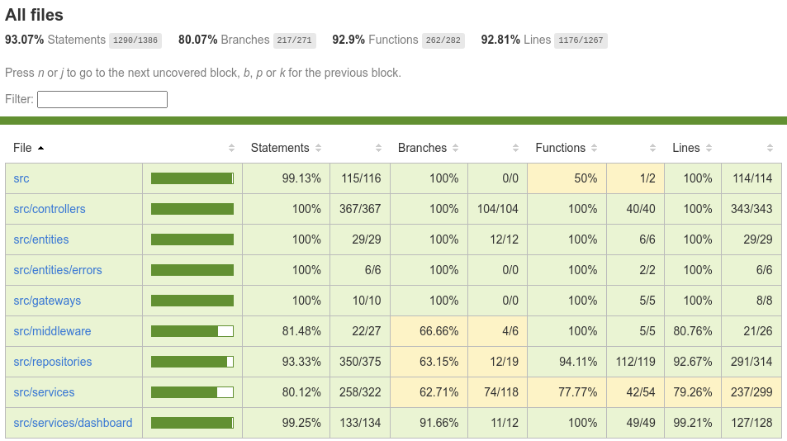

Figure 111: Code Coverage Report of Server Side Code

# 

# 

# 9.0 DEFECT TRACKING AND REPORT

Sprint 5 had no new bugs and didn’t include any bug fixes as there are no active defects in the system The team continued to focus on testing each user story thoroughly and as a result we were able to catch bugs before merging in and closing the user stories. The defect tracking report for the project can be viewed on the next page.

# 

# 10.0 QUALITY MEASUREMENTS

This section depicts and describes the various metrics being used, the cause of the results and how the results can be improved.

## 10.1 Metrics Used

The following metrics are being used:

* **Statement coverage**: Checks to see if each statement in the program has been executed while running the test suite.
* **Branch coverage:** Checks to see if all conditional branches (if statement and terinaries) are covered while running the test suite.
* **Function coverage:** Checks to see if every function in the source code was called at least once while running the test suite.
* **Line coverage:** Checks if each physical line in the source code has been executed at least once while running the test suite. This is mostly covered by statement coverage, which is generally superior because it ignores coding styles better, but we are including it for completeness of all generated metrics.
* **Linting errors:** Errors we receive if we run our automated linting package, ESLint. The types of errors and severity are defined by our .eslintrc file. This includes checks against many things, primarily language standards.
* **Formatting errors:** Errors we receive if we run our automated formatting package, prettier. This package has defined an opinionated formatting standard that can automatically be applied to most code, but some must still be manually formatted to follow the standard.

## 10.2 Cause of Results

There aren’t any formatting and linting errors because the CI/CD pipeline will fail if any are detected resulting in them immediately being fixed.

We continue to implement integration and unit tests for each user story which makes sure it is implemented properly and there are never any regressions on the applications functionality.

## 10.3 Improving the Results

Sprint 5 added no new testable code and no new tests so the code coverage remained the same, but in a place we are comfortable with.

|  | **Sprint 1** | **Sprint 2** | **Sprint 3** | **Sprint 4** | **Sprint 5** |
| --- | --- | --- | --- | --- | --- |
| Statement Coverage | 65.6% | 87.33% | 89.11% | 93.07% | 93.07% |
| Branch Coverage | 55.55% | 77.52% | 71.5% | 80.07% | 80.07% |
| Function Coverage | 41.66% | 81.7% | 88.63% | 92.9% | 92.9% |
| Line Coverage | 64.34% | 86.94% | 88.73% | 92.81% | 92.81% |
| Linting Errors | 0 | 0 | 0 | 0 | 0 |
| Formatting Errors | 0 | 0 | 0 | 0 | 0 |

Table 68: Test Coverage for Each Sprint

# 

# APPENDIX A: TEAM COLLABORATION AND COMMUNICATION

Stakeholders use a set of tools to collaborate and communicate throughout the project lifecycle.

## A.1 Collaboration

* **Google Suite (Docs, Drive, Sheets)**:

G Suite is a collection of business, productivity, collaboration, and education software developed and powered by Google. The primary G Suite tools include Gmail, Drive, Docs, Sheets, Slides, Forms, Calendar, Google+, Sites, Hangouts, and Keep. [2] Google Suite is used for documentation since it is widely accessible and available to all development team members.

* **GitHub:** GitHub is a code hosting platform for version control and collaboration. It lets you and others work together on projects from anywhere. We use github to be able to work on different sections of the code at the same time and have a version control. [3]

## A.2. Communication

* **Discord:** Discord is a free voice, video, and text chat app that's used by tens of millions of people ages 13+ to talk and hang out with their communities and friends. [6] Discord is used for communication and meetings among development team members. Voice and text channels are named according to the different development team groups (i.e. back end, front end and UI design).
* **Slack:** Slack is a messaging app for business that connects people to the information they need. By bringing people together to work as one unified team, Slack transforms the way organizations communicate. [5] Slack is used to communicate with the product owners when clarification is needed or to schedule meetings.
* **Zoom:** Zoom is a cloud-based video conferencing platform that can be used for video conferencing meetings, audio conferencing, webinars, meeting recordings, and live chat. [1] Zoom is used for meetings with the product owners.

## A.3 Tools

* **Issue and project tracking tool:** Jira

<https://www.atlassian.com/software/jira>.

Jira is a software application used for issue tracking and project management. The tool has become widely used by agile development teams to track bugs, stories, epics, and other tasks. [4]

* **Diagram modeling tool:** Draw.io

<https://app.diagrams.net/>

Draw.io is an online diagram editor that enables you to create flowcharts, UML, entity relation, network diagrams, mockups and more.

* **User interface design and prototyping tool:** Figma

<https://www.figma.com/>

Figma is a UI and UX design application, with excellent design, prototyping, and code-generation tools. It's arguably the industry's leading interface design tool, with robust features which support teams working on every phase of the design process.

# APPENDIX B: GLOSSARY

* **Application Programming Interface (API):** An application programming interface (API) is a computing interface which defines interactions between multiple software intermediaries. It defines the kinds of calls or requests that can be made, how to make them, the data formats that should be used, the conventions to follow, etc. [7]
* **Logical Layered Architecture:** Layered architecture is an architecture pattern that promotes high cohesion and low coupling through separation of concerns by layers. Each layer depends on the layer below it.
* **UML Domain Model:** A conceptual view of the domain represented through UML classes and relationships. [8]
* **Risk Management:** Practice of identifying, evaluating, and preventing or mitigating risks to a project that have the potential to impact the desired outcomes.
* **Database:** Databases store aggregations of data records or files that contain information, such as sales transactions, customer data, financials and product information. [9]
* **UI prototype:** User interface prototyping is an iterative analysis technique in which users are actively involved in the mocking-up of the UI for a system. [10]
* **UI/UX mockup :** A mockup is a static wireframe that includes more stylistic and visual UI details to present a realistic model of what the final page or application will look like. [11]
* **CI/CD pipeline:** Series of steps that must be performed in order to deliver a new version of software. Continuous integration/continuous delivery (CI/CD) pipelines are a practice focused on improving software delivery using either a DevOps or site reliability engineering (SRE) approach. [12]

# REFERENCES

1. Barron, Sophia. “Everything You Need to Know about Using Zoom.” *Owl Labs Blog*, <https://resources.owllabs.com/blog/zoom#:~:text=Zoom%20is%20a%20cloud%2Dbased,meeting%20recordings%2C%20and%20live%20chat>.
2. Decker, Allie. “The Ultimate Guide to G Suite.” *HubSpot Blog*, 31 Mar. 2019, <https://blog.hubspot.com/marketing/google-suite#:~:text=G%20Suite%20is%20a%20collection,Google%20Apps%20for%20Your%20Domain%E2%80%9D>.
3. “Hello World.” *GitHub Docs*, <https://docs.github.com/en/get-started/quickstart/hello-world>.
4. “Jira.” *ProductPlan*, 9 Feb. 2021, <https://www.productplan.com/glossary/jira/>.
5. Slack. “What Is Slack?” *Slack Help Center*, <https://slack.com/help/articles/115004071768-What-is-Slack-#:~:text=Slack%20is%20a%20messaging%20app,transforms%20the%20way%20organizations%20communicate>.
6. “What Is Discord: A Guide for Parents and Educators.” *Discord*, <https://discord.com/safety/360044149331-What-is-Discord#:~:text=Discord%20is%20a%20free%20voice,with%20their%20communities%20and%20friends.&text=The%20vast%20majority%20of%20servers,touch%20and%20spend%20time%20together>.
7. Business Standard. “What Is API, API Definition, API News.” *Business Standard*, <https://www.business-standard.com/about/what-is-api>.
8. *UML Class Diagrams as a Conceptual Models*, <http://www.cs.sjsu.edu/~pearce/modules/lectures/ooa/domain/domainModels.htm>
9. Lutkevich, Ben, and Adam Hughes. “What Is a Database? Definition from Searchdatamanagement.” *SearchDataManagement*, TechTarget, 27 Sept. 2021, <https://searchdatamanagement.techtarget.com/definition/database#:~:text=Computer%20databases%20typically%20store%20aggregations,data%2C%20financials%20and%20product%20information.&text=They%20collect%20information%20on%20people,can%20be%20observed%20and%20analyzed>.
10. *User Interface (UI) Prototypes: An Agile Introduction*, <http://agilemodeling.com/artifacts/uiPrototype.htm>.
11. “Wireframes vs Mockups: Determining the Right Level of Fidelity for Your Project.” *Wireframes vs Mockups Explained | Lucidchart Blog*, 27 Feb. 2020, <https://www.lucidchart.com/blog/wireframes-vs-mockups>.
12. “What Is a CI/CD Pipeline?” *Red Hat - We Make Open Source Technologies for the Enterprise*, <https://www.redhat.com/en/topics/devops/what-cicd-pipeline>.
13. P. D. Jayawardene, “4+1 architectural view model in software,” Medium, 17-Nov-2021. [Online]. Available: <https://medium.com/javarevisited/4-1-architectural-view-model-in-software-ec407bf27258> . [Accessed: 14-Apr-2022].